**Module 10: Container Orchestration Tool - Kubernetes**

Submitted by: Abhijit Lalasaheb Zende

Date of Submission: 19/10/2024

Date of resubmission: 24/10/2024

Batch No: SA200706

Submitted to: Vikul Mentor

***#On all pages with screenshot the last screenshot is first one while first is last#***

**1. L1 – Install and Configure Kubernetes cluster using Kubeadm on AWS.**

Ans.

Step 1: Launch Three t2.medium Ubuntu 22.04 Instances:

1. Use AWS cloud provider to launch **three EC2 t2.medium Ubuntu 22.04 instances**:
   1. One instance will act as the **Kubernetes Master** node.
   2. The other two will serve as **Worker** nodes.

Step 2: Configure all necessary Kubernetes tools:

1. Install and Configure all necessary Kubernetes tools like **kubeadm, kubelet, kubectl**, etc on all three nodes(Kubernetes Maste node*1 + Kubernetes Worker node*2)
2. You can do above by following the official Kubernetes documentation

<https://kubernetes.io/docs/tasks/tools/>

1. For guided tour of installation you can follow below link: <https://github.com/SA-AWS-DevOps-July24/Training_Documents/blob/main/Kubernetes/Kubernetes_Installation_Config.txt>
   1. **Preliminary Steps on All Nodes (Master and Workers)**
      1. **Update System and Set Hostnames**

```

sudo apt update -y

sudo hostnamectl set-hostname <node-name>

reboot

```

* + 1. **Disable Swap**

```

sudo swapoff -a

sudo sed -i '/ swap / s/^\(.*\)$/#\1/g' /etc/fstab

```

* + 1. **Install Docker and Containerd**

```

sudo apt install docker.io -y

sudo modprobe overlay br_netfilter

sudo tee /etc/modules-load.d/containerd.conf <<EOF

overlay

br_netfilter

EOF

sudo tee /etc/sysctl.d/kubernetes.conf <<EOF

net.bridge.bridge-nf-call-ip6tables = 1

net.bridge.bridge-nf-call-iptables = 1

net.ipv4.ip_forward = 1

EOF

sudo sysctl --system

sudo apt install -y apt-transport-https curl

curl -fsSL https://download.docker.com/linux/ubuntu/gpg | sudo apt-key add -

sudo add-apt-repository "deb [arch=amd64] https://download.docker.com/linux/ubuntu $(lsb_release -cs) stable"

sudo apt update -y

sudo apt install -y containerd.io

sudo mkdir -p /etc/containerd

sudo containerd config default | sudo tee /etc/containerd/config.toml

sudo systemctl restart containerd

```

* + 1. **Install Kubernetes Components**

```

sudo mkdir -p -m 755 /etc/apt/keyrings

curl -fsSL https://pkgs.k8s.io/core:/stable:/v1.29/deb/Release.key | sudo gpg --dearmor -o /etc/apt/keyrings/kubernetes-apt-keyring.gpg

echo 'deb [signed-by=/etc/apt/keyrings/kubernetes-apt-keyring.gpg] https://pkgs.k8s.io/core:/stable:/v1.29/deb/ /' | sudo tee /etc/apt/sources.list.d/kubernetes.list

sudo apt-get update

sudo apt-get install -y kubelet kubeadm kubectl

sudo systemctl enable kubelet

```

* 1. **On Master node:**
     1. **Initialize Kubernetes Cluster**

**```**

sudo kubeadm config images pull

sudo kubeadm init --pod-network-cidr=10.244.0.0/16

mkdir -p $HOME/.kube

sudo cp -i /etc/kubernetes/admin.conf $HOME/.kube/config

sudo chown $(id -u):$(id -g) $HOME/.kube/config

**```**

* + 1. **Deploy Network Plugin**

**```**

kubectl apply -f https://github.com/coreos/flannel/raw/master/Documentation/kube-flannel.yml

kubectl get nodes

kubectl get pods --all-namespaces

**```**

* + 1. **Generate Join Command**

**```**

kubeadm token create --print-join-command

**```**

* 1. **On Worker Nodes**
     1. **Join Cluster**

**```**

kubeadm join <master-ip>:6443 --token <token> --discovery-token-ca-cert-hash <hash>

**```**

* + 1. **Verify Node Status (From Master)**

**```**

kubectl get nodes

**```**

* 1. **Final Steps (Optional)**
     1. **Label worker nodes from the master:**

**```**

kubectl label node <worker-node-name> node-role.kubernetes.io/worker=worker

**```**

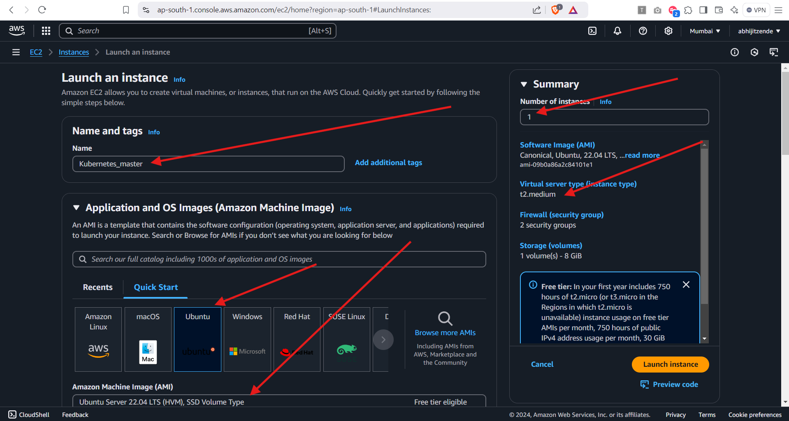

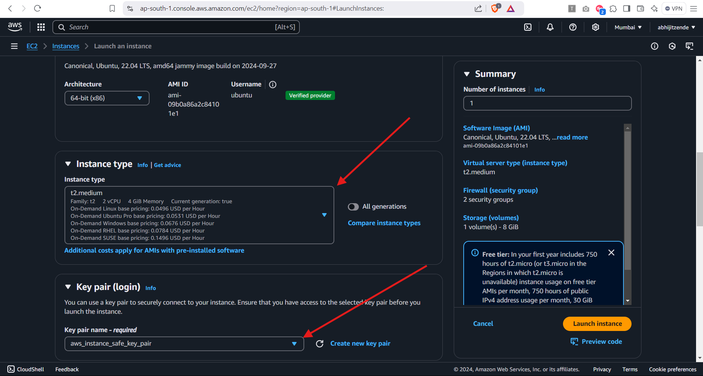

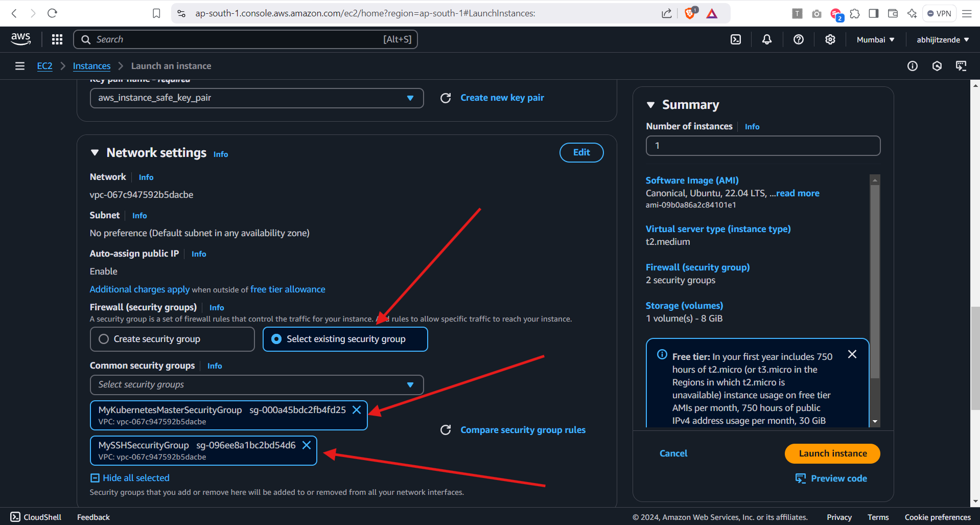

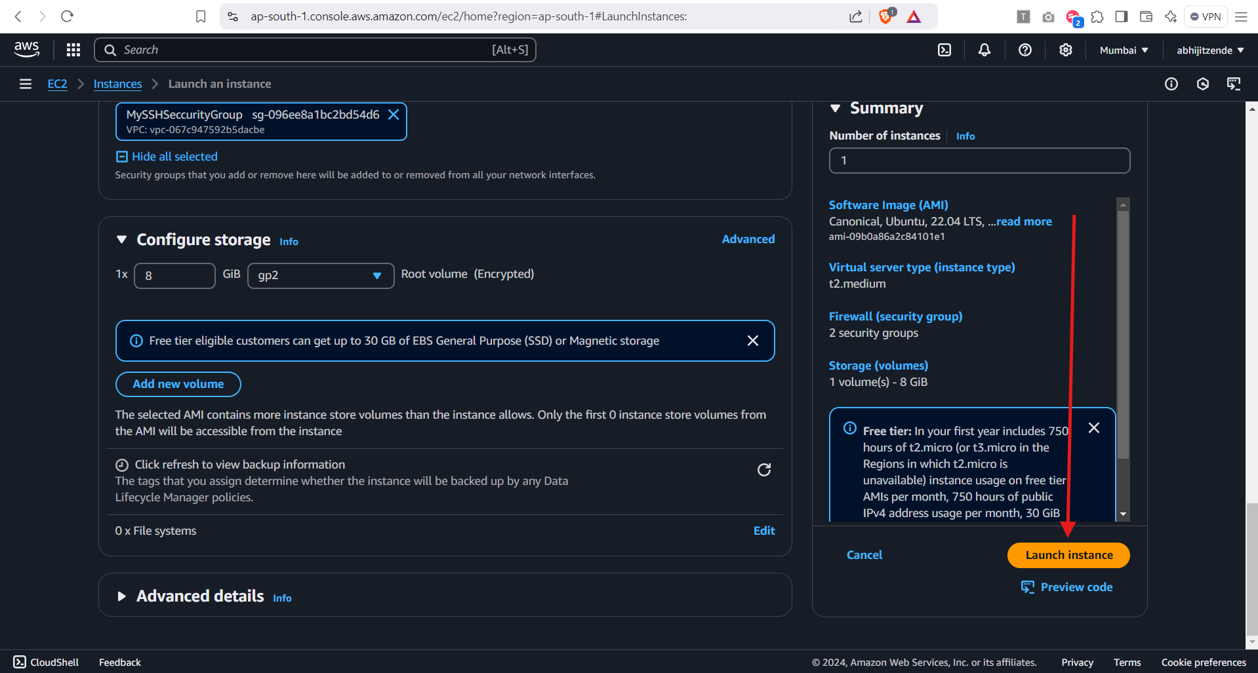

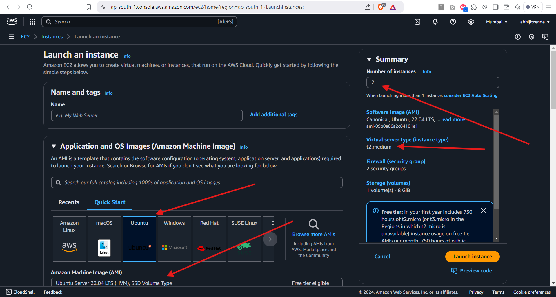

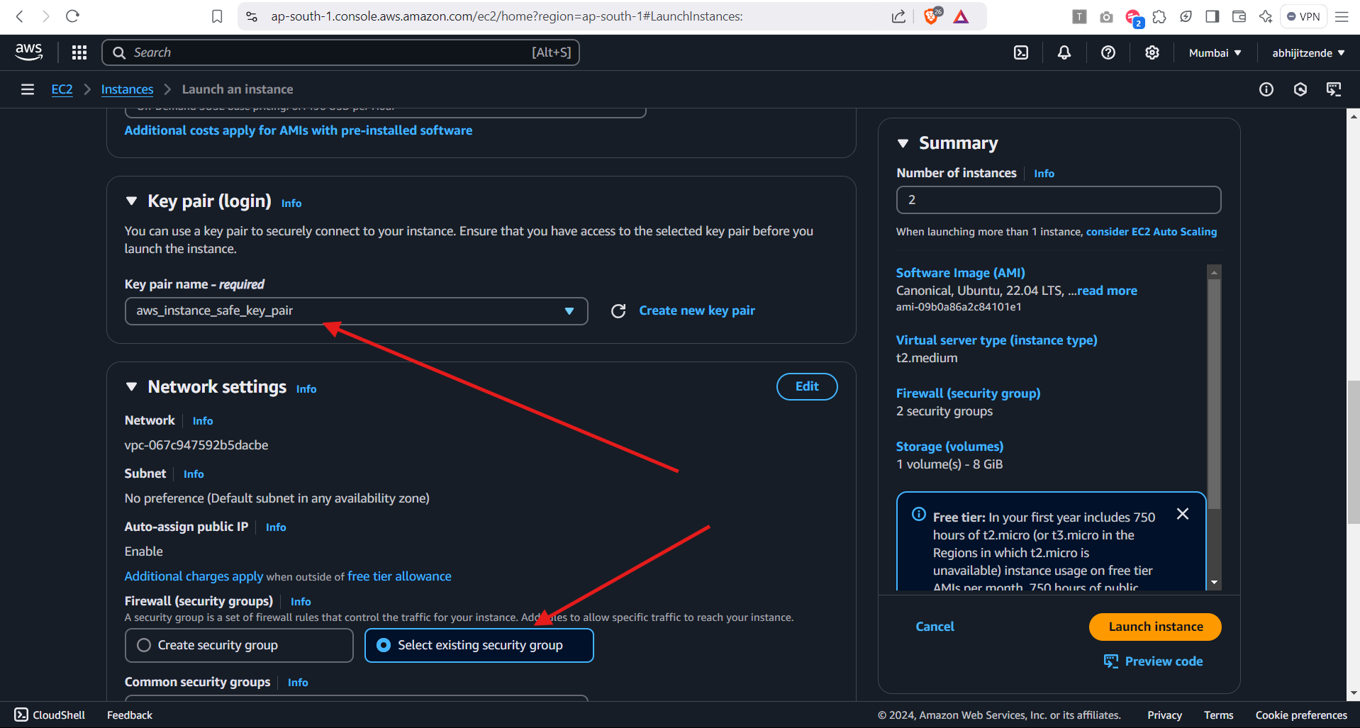

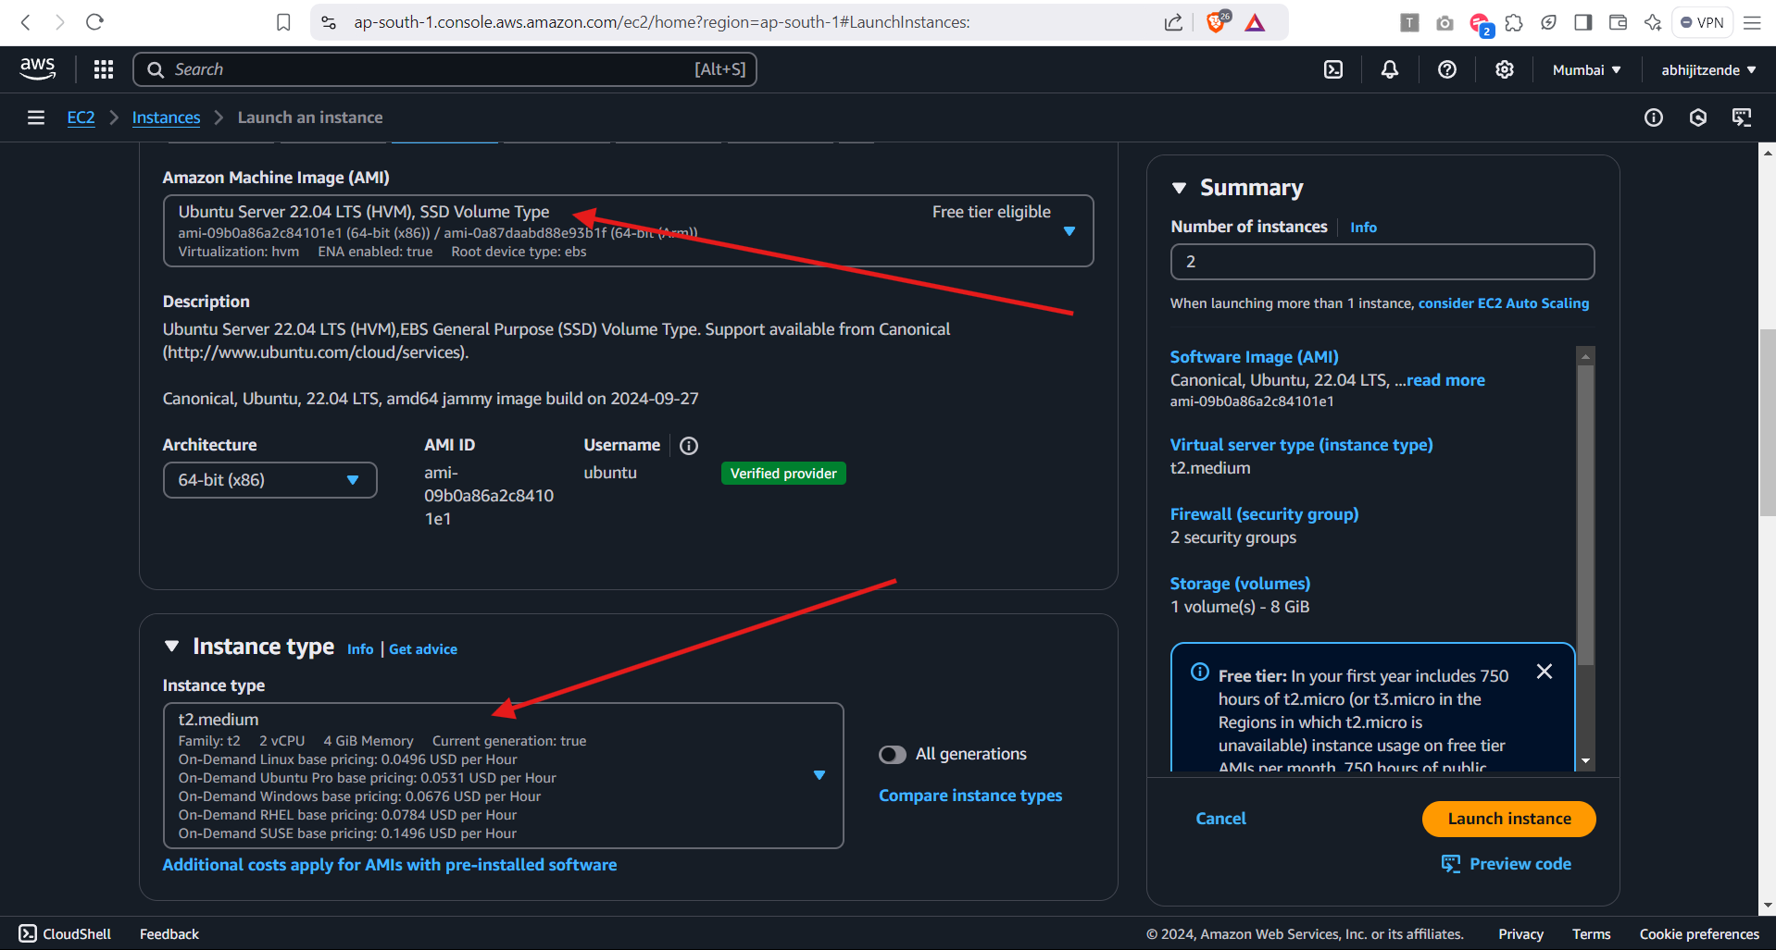

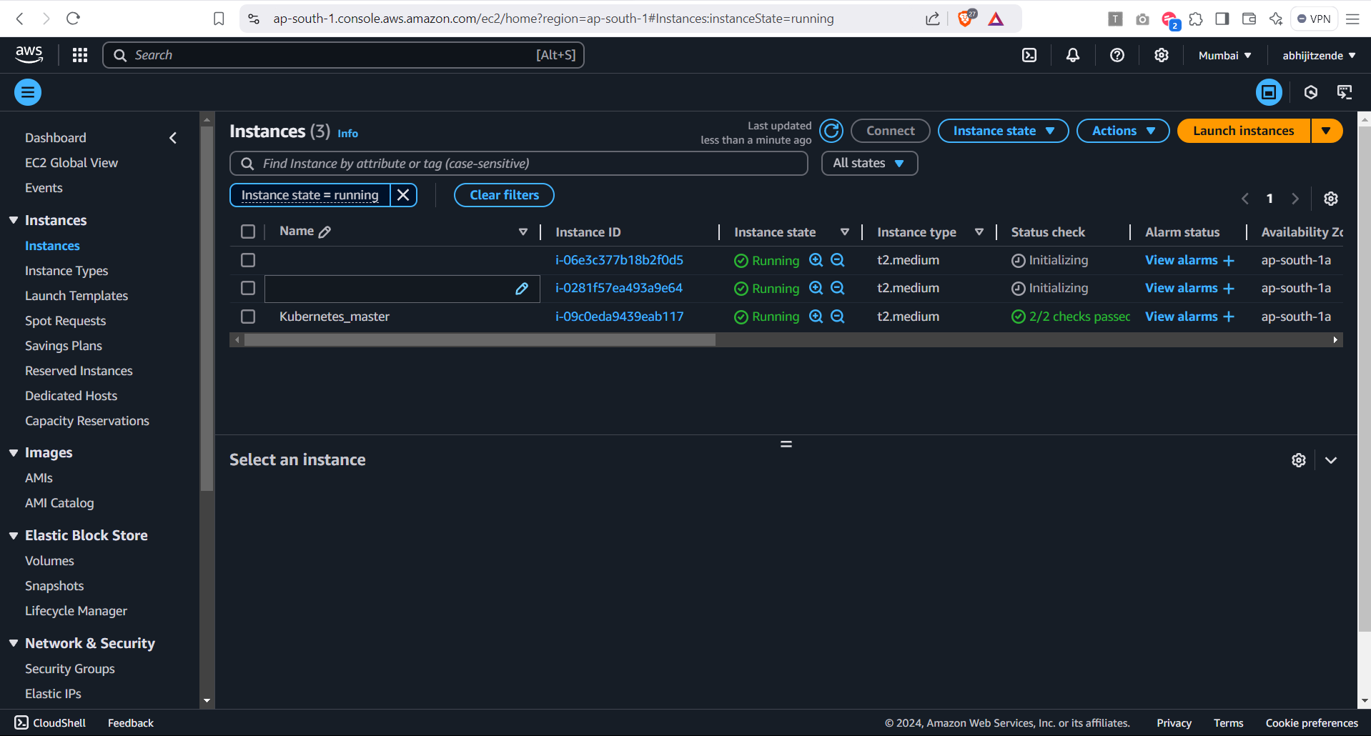

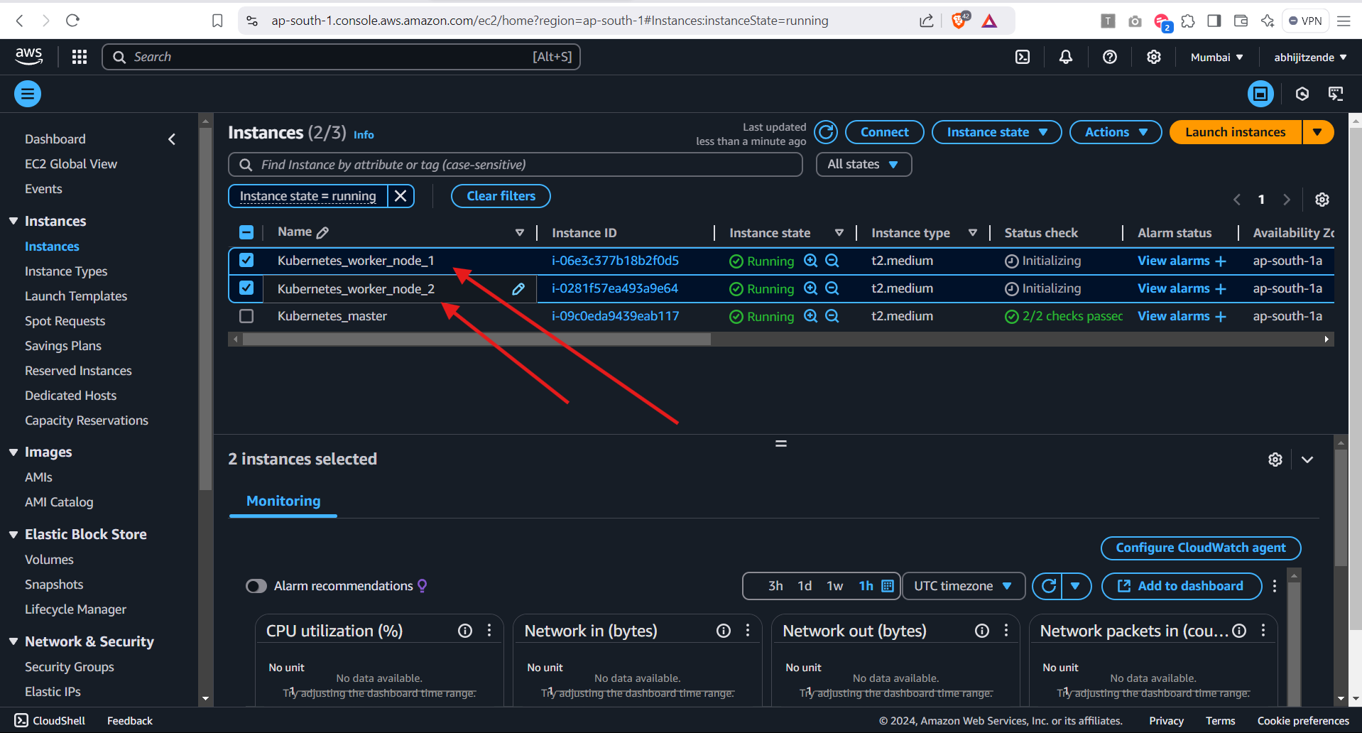

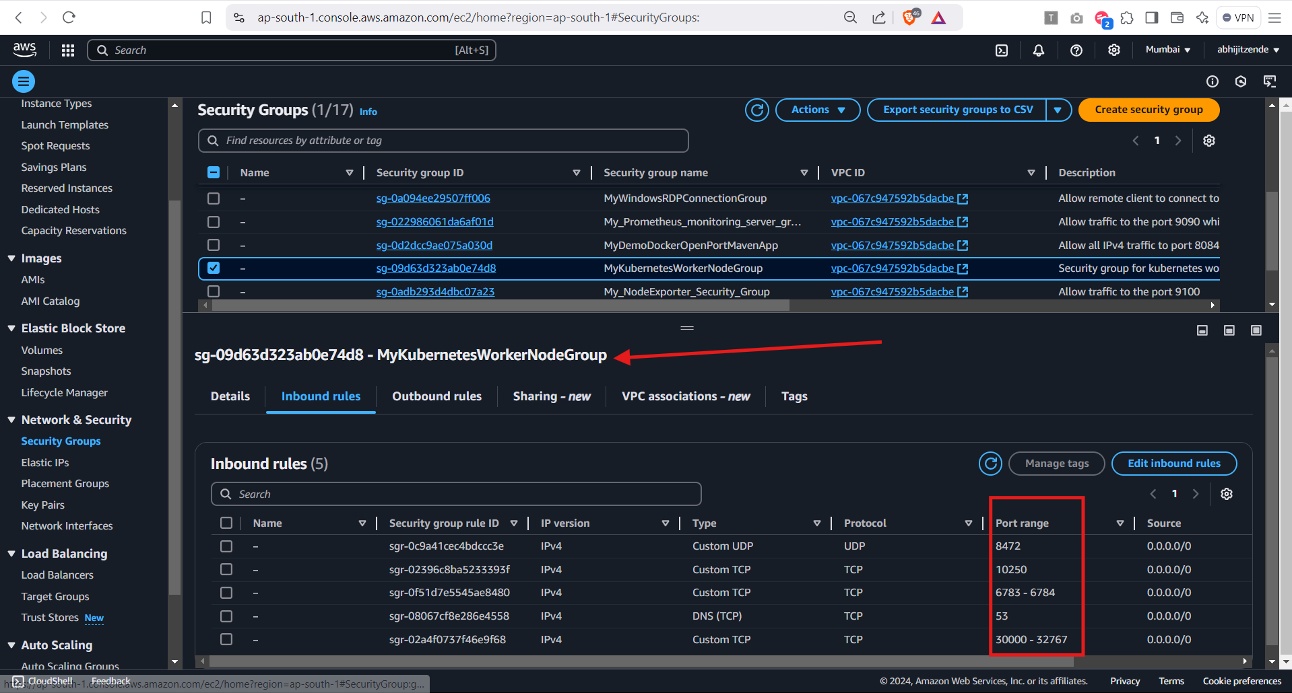

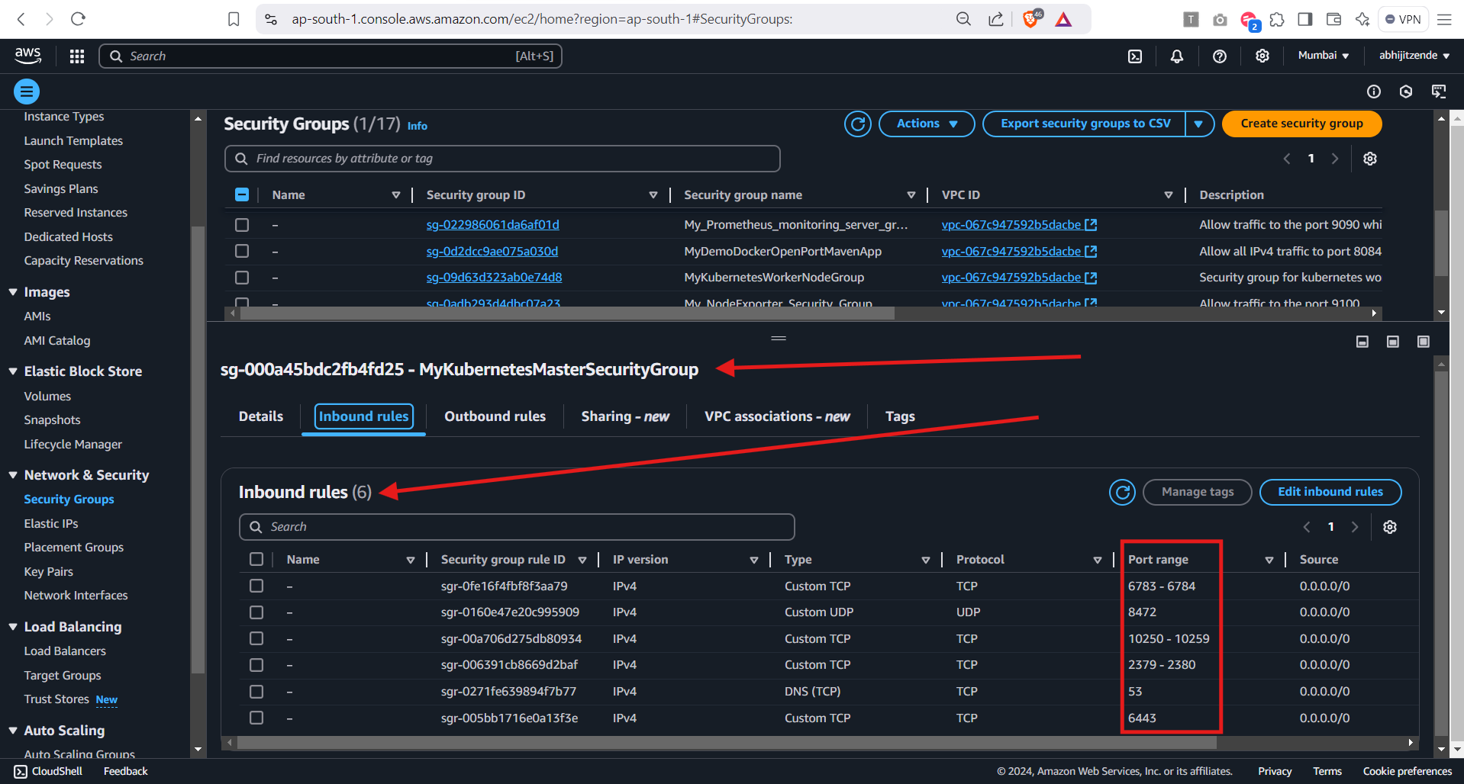

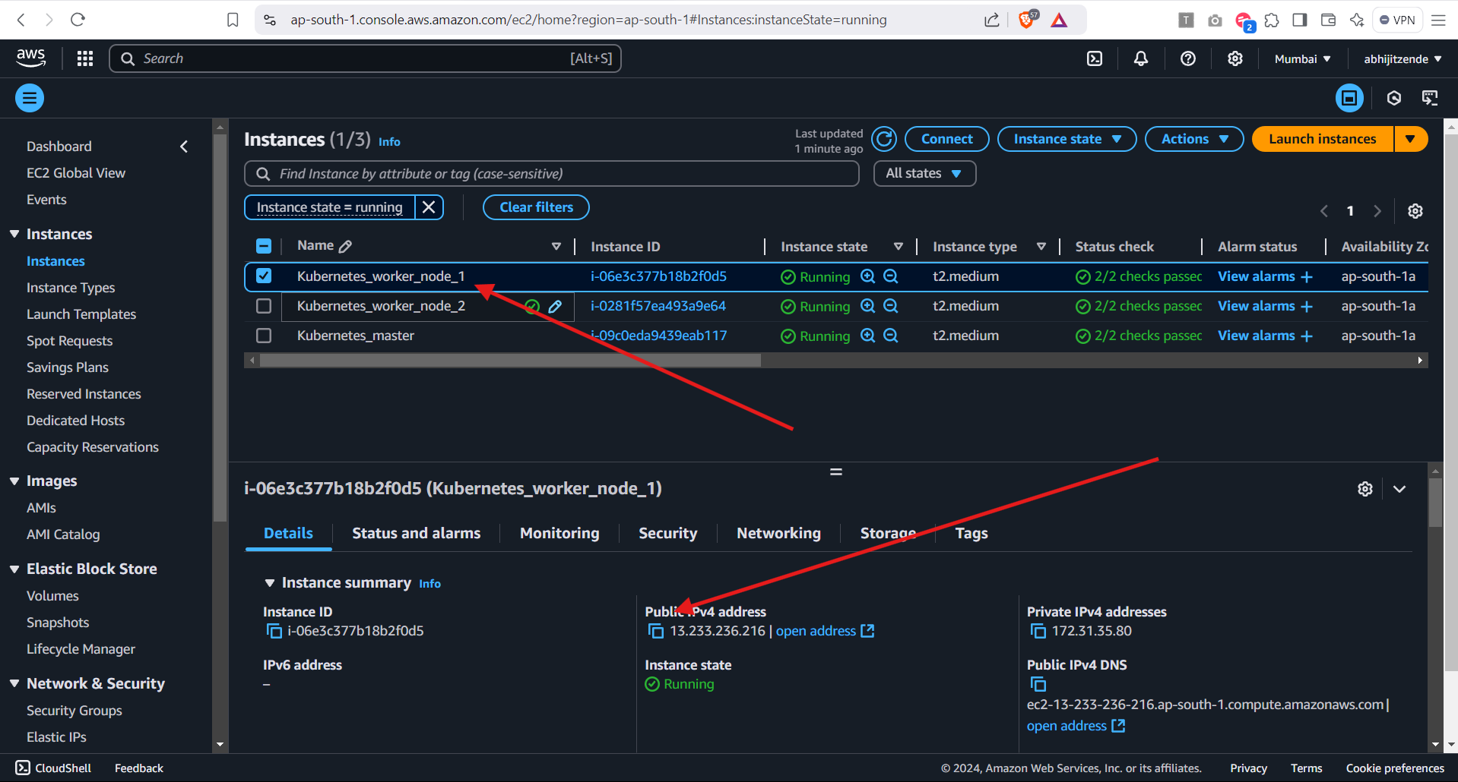

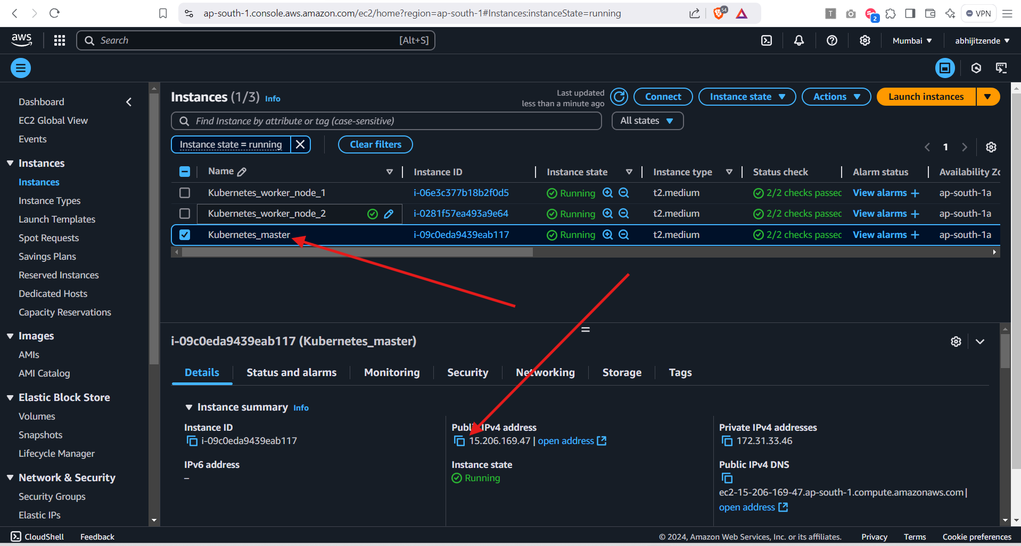

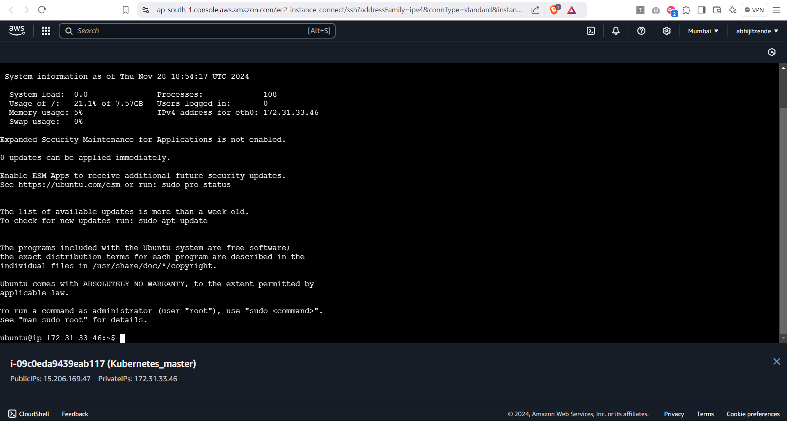

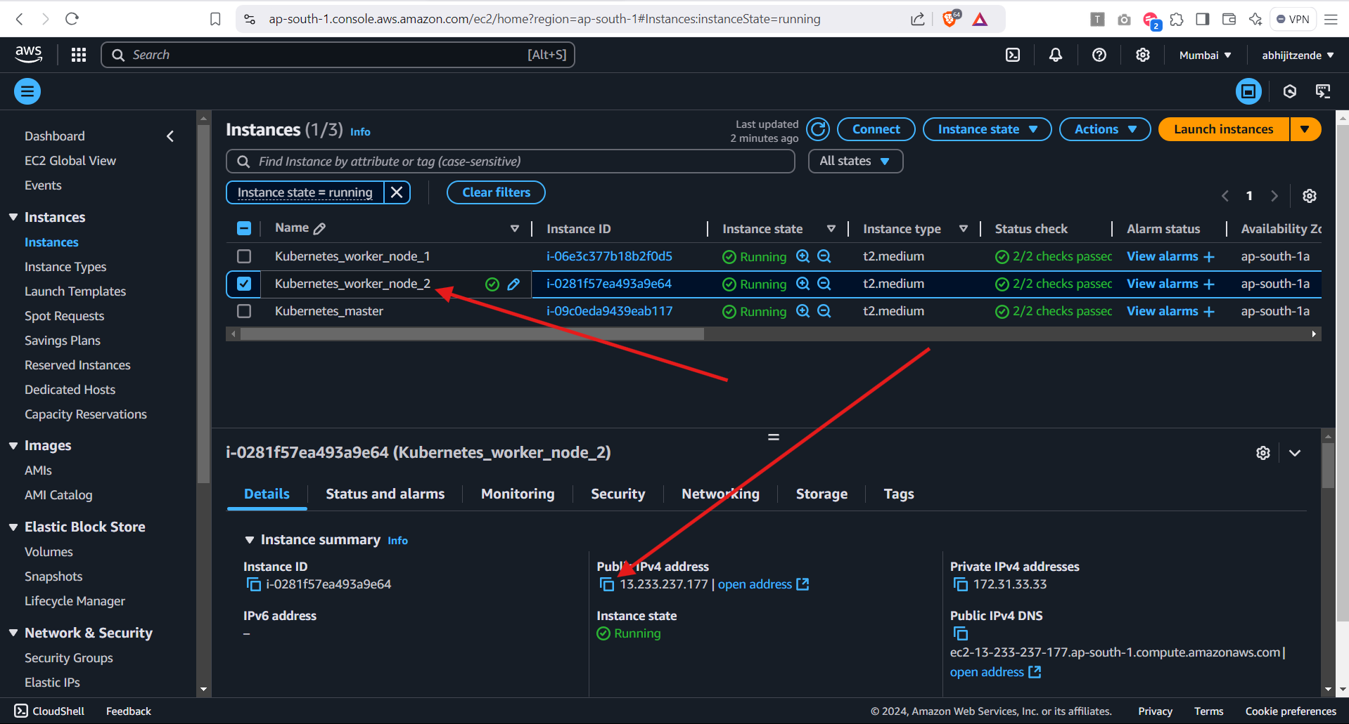

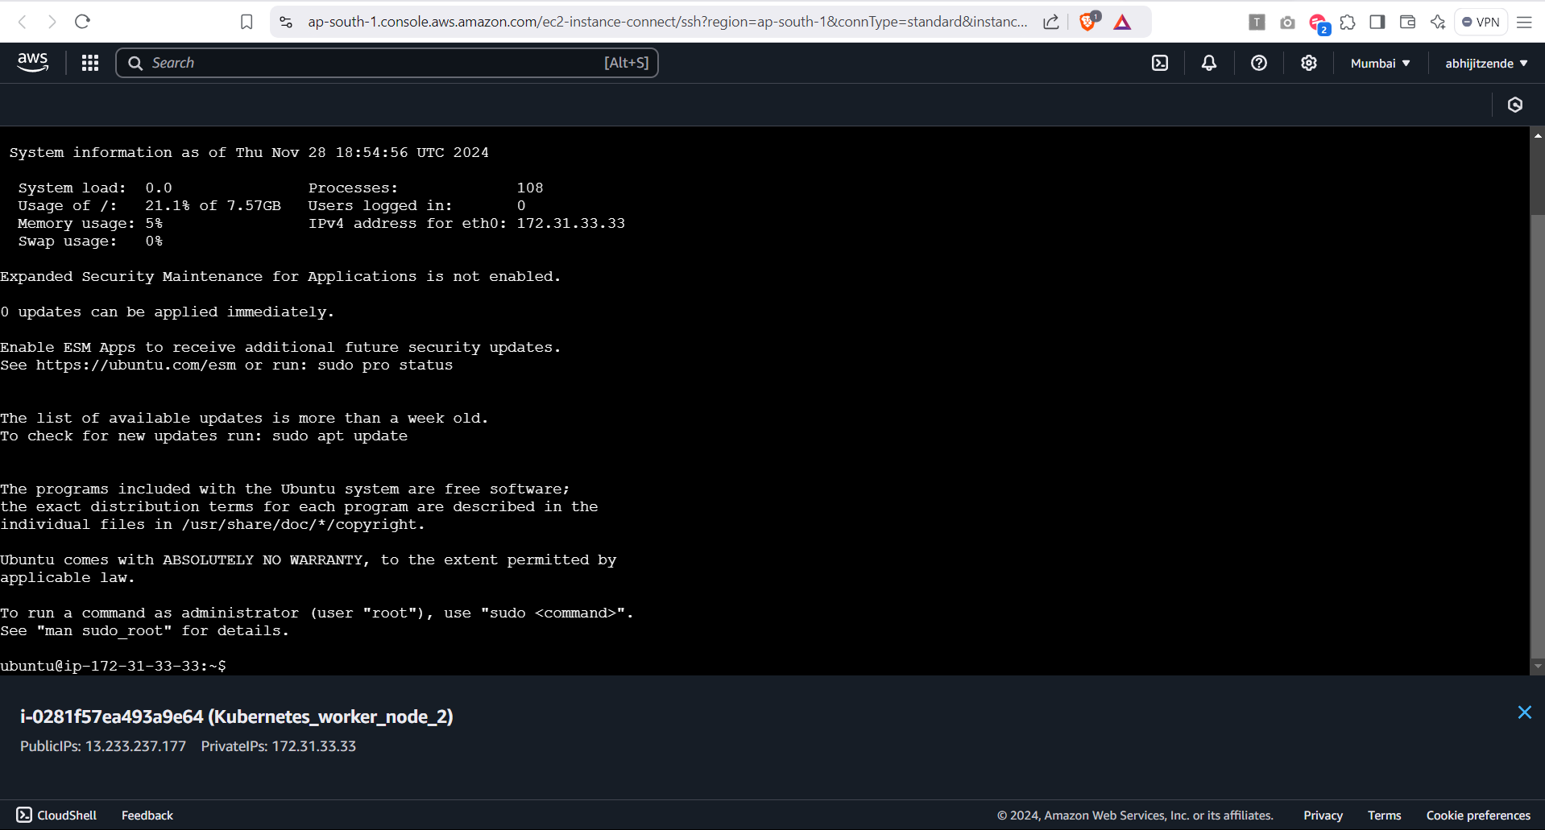

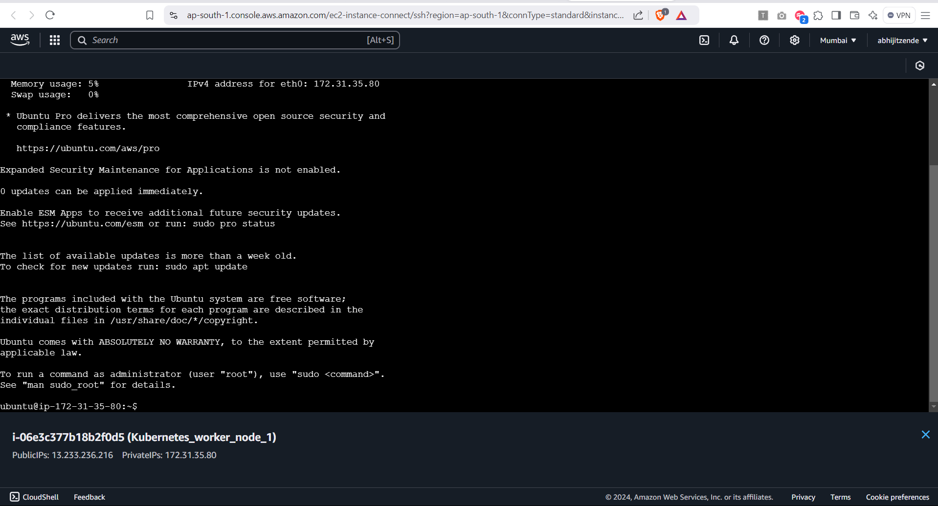

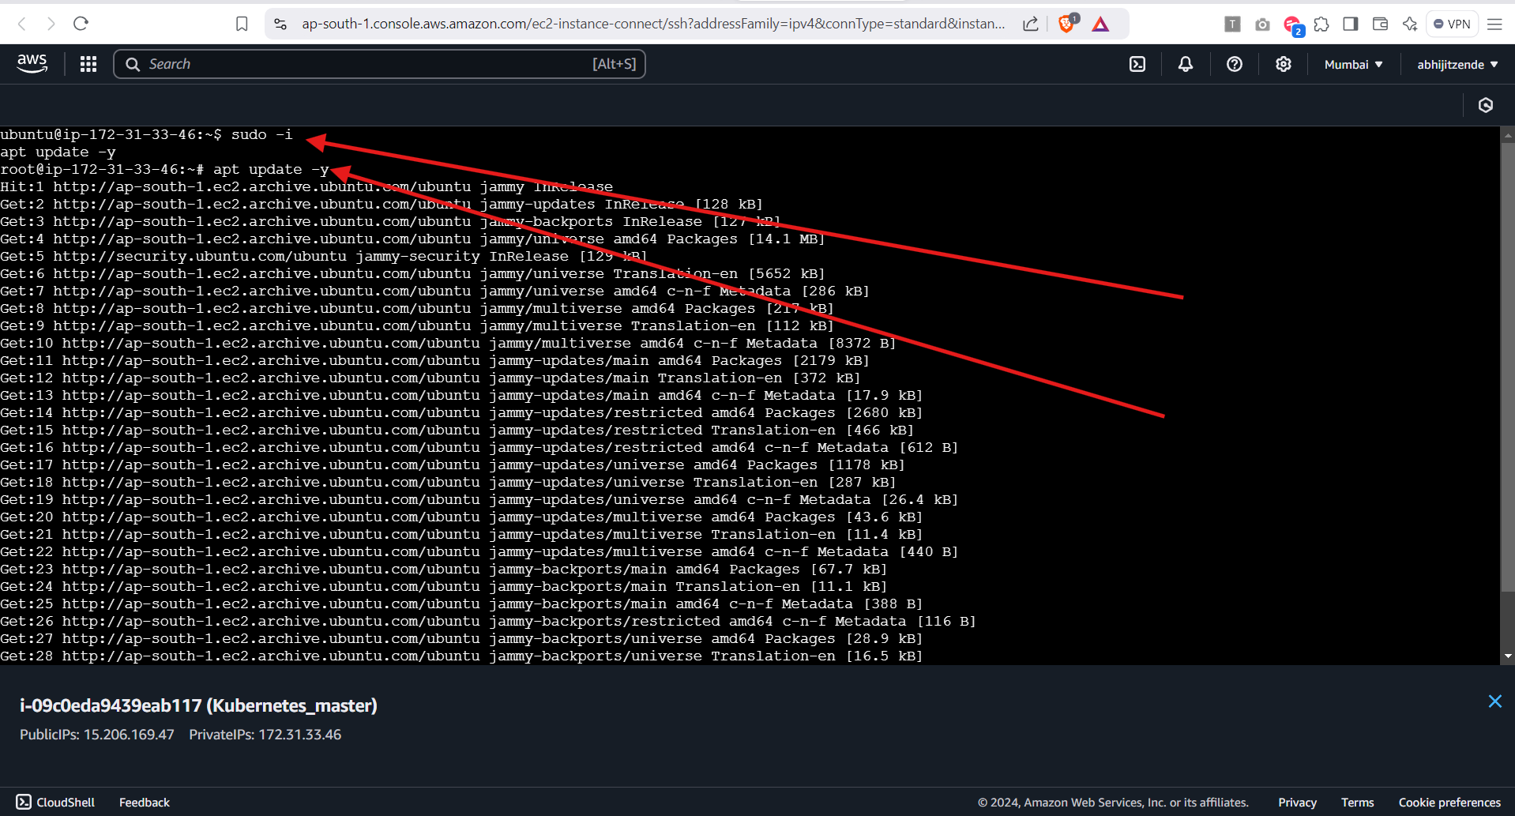

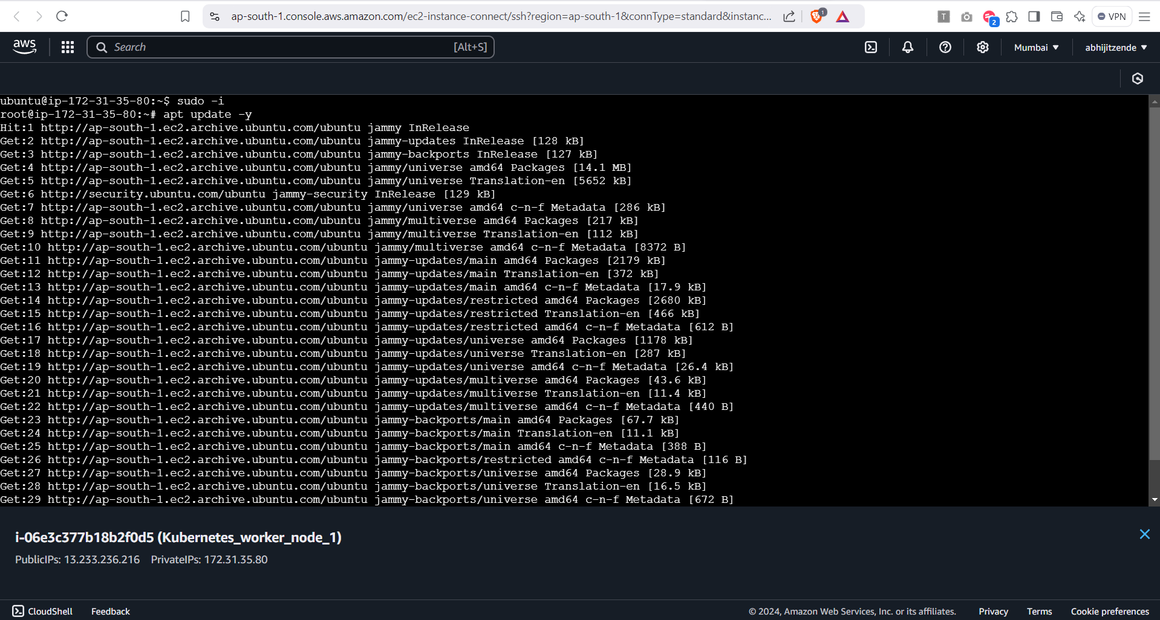

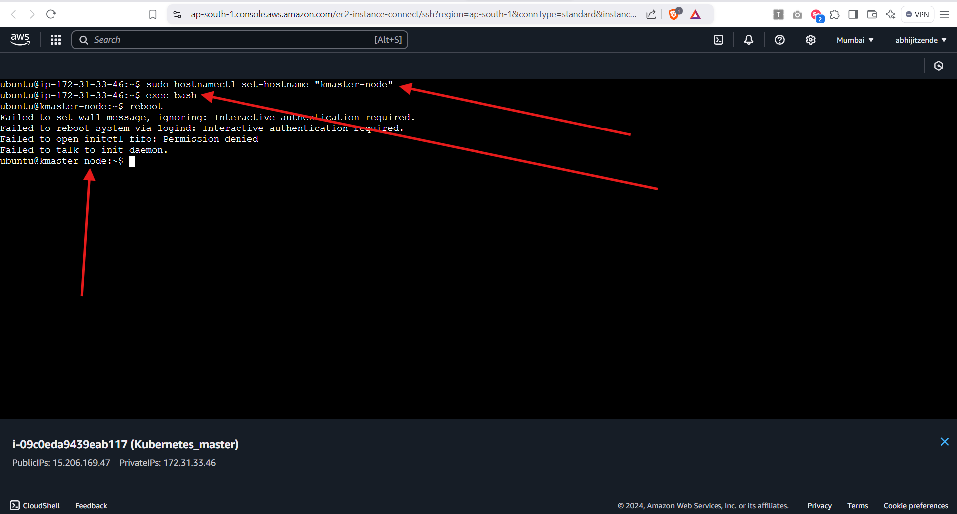

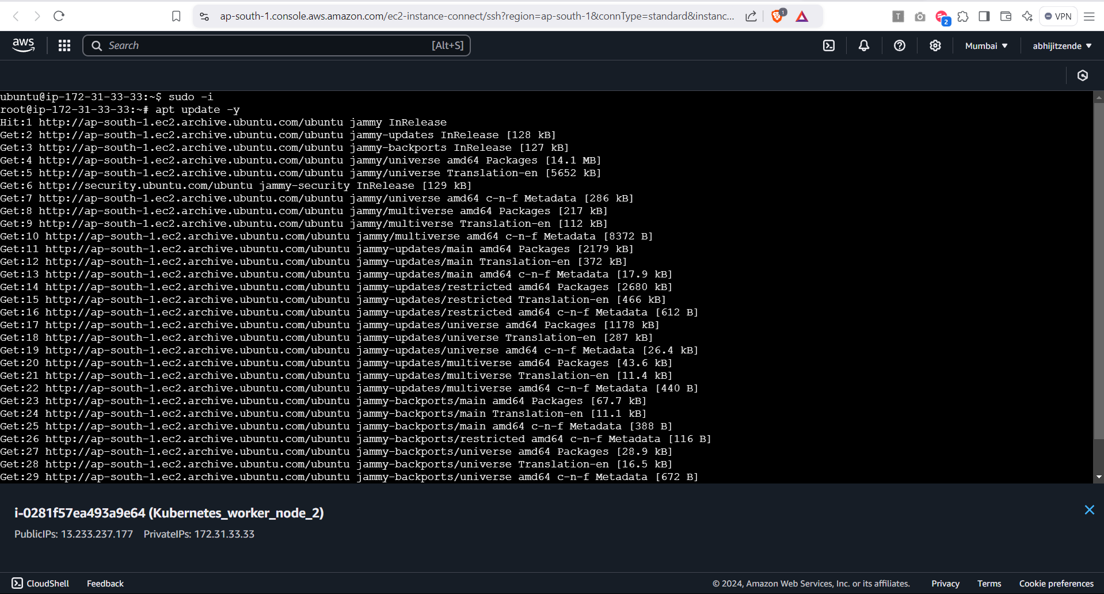

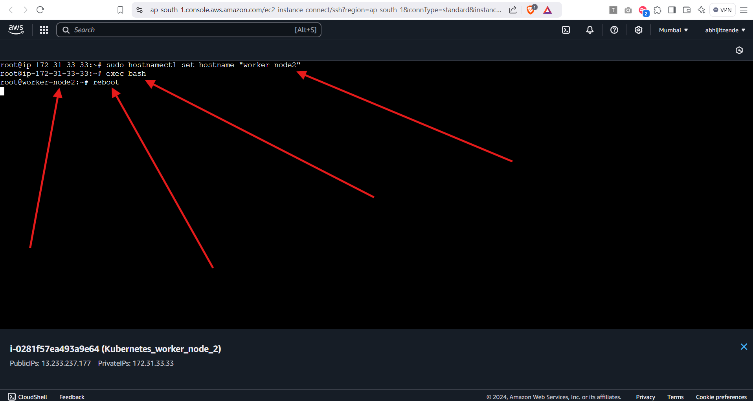

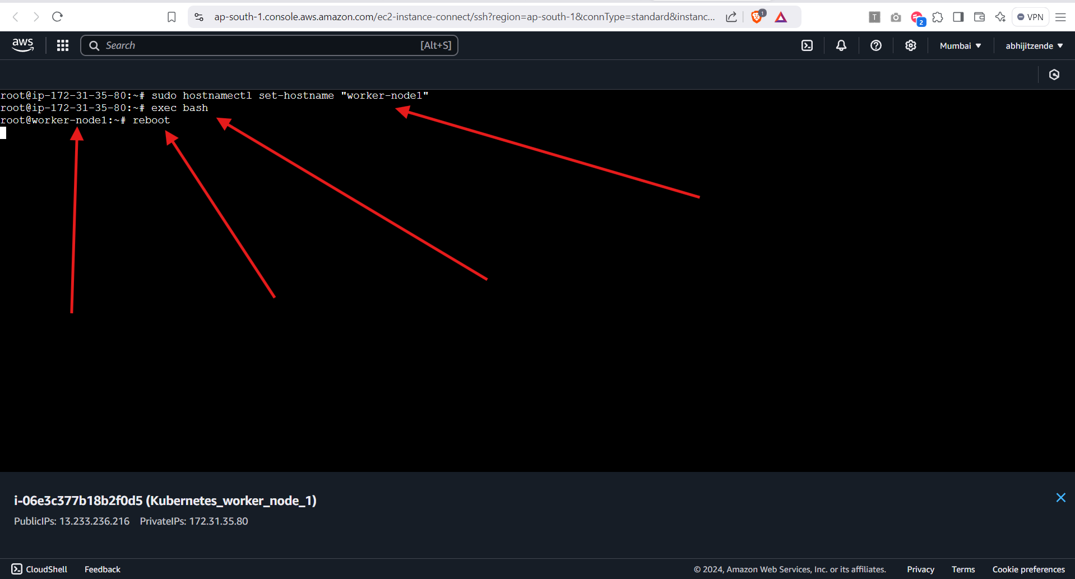

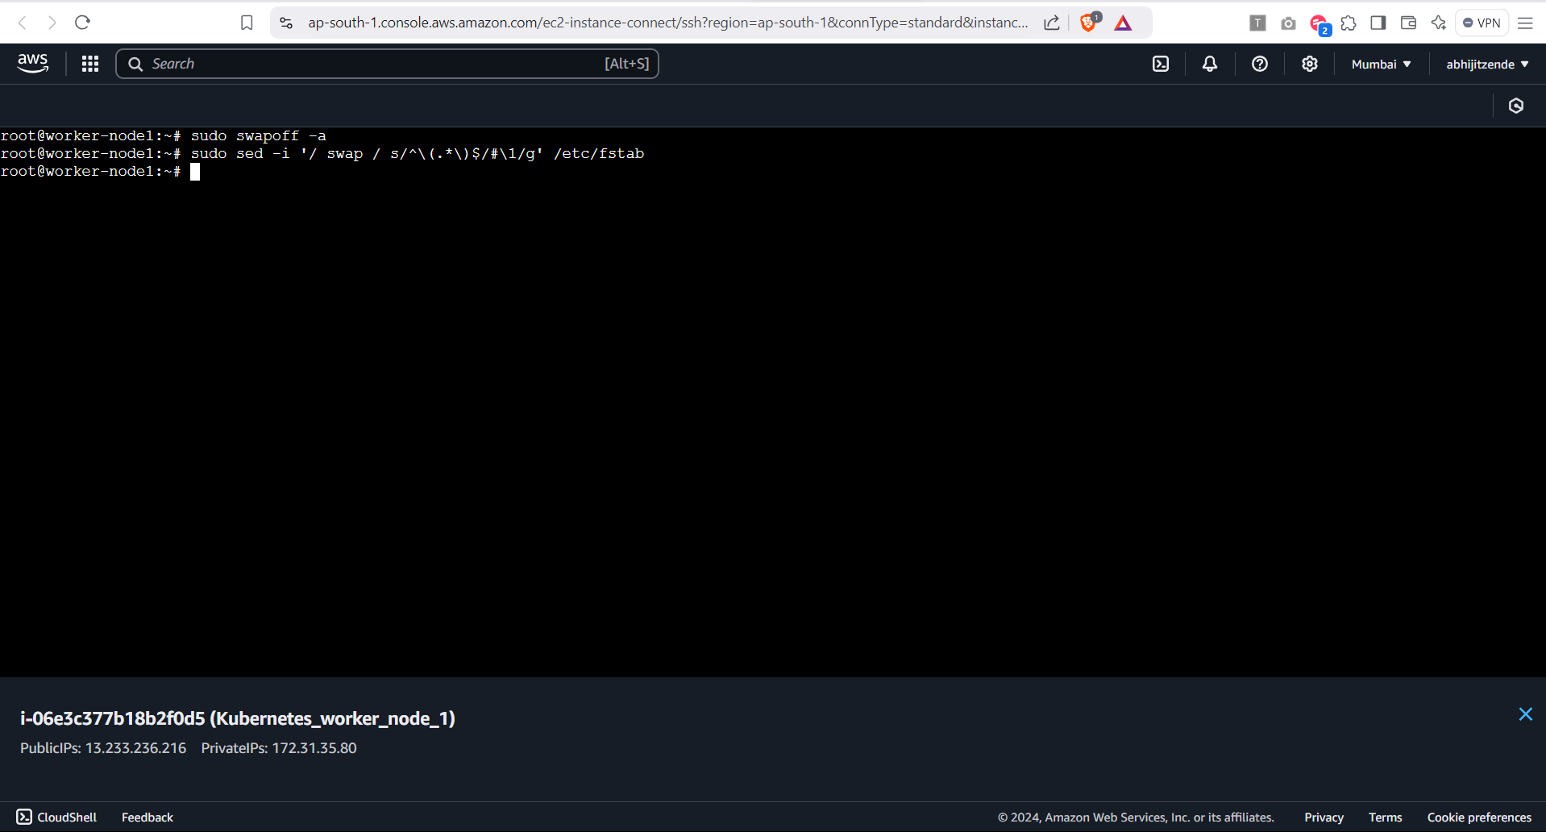

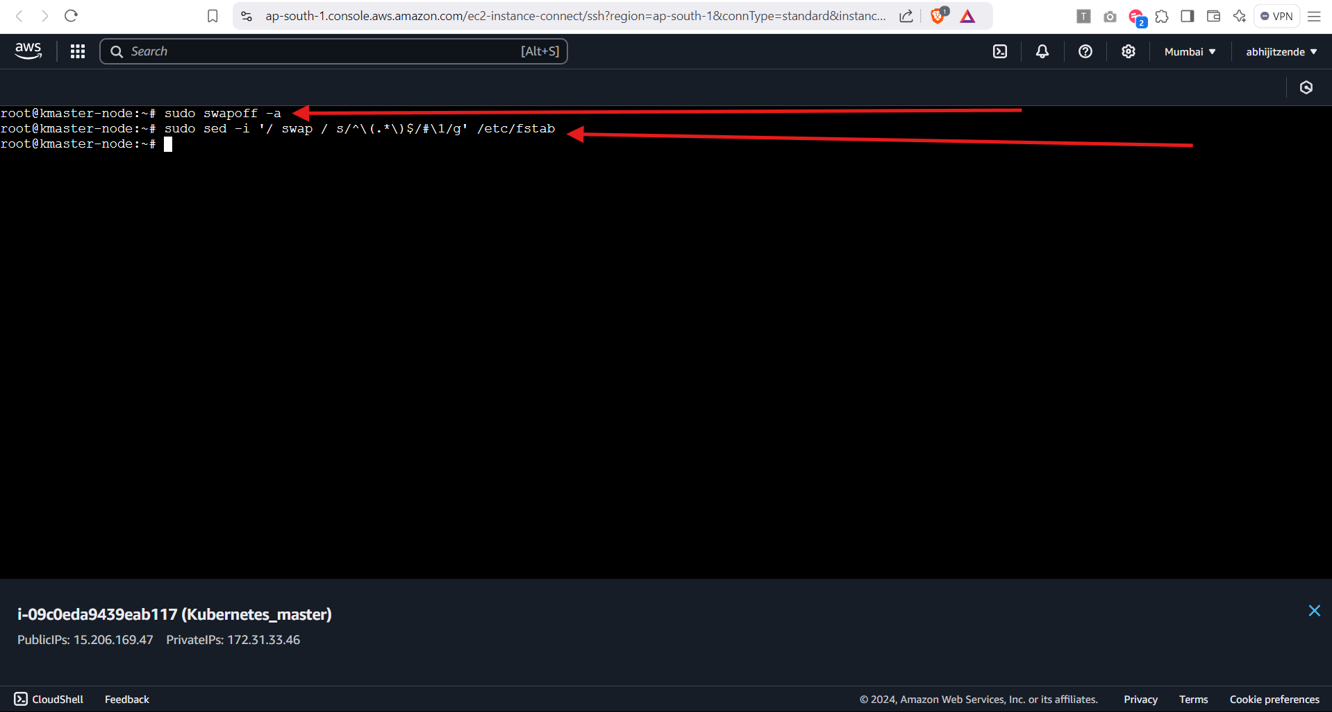

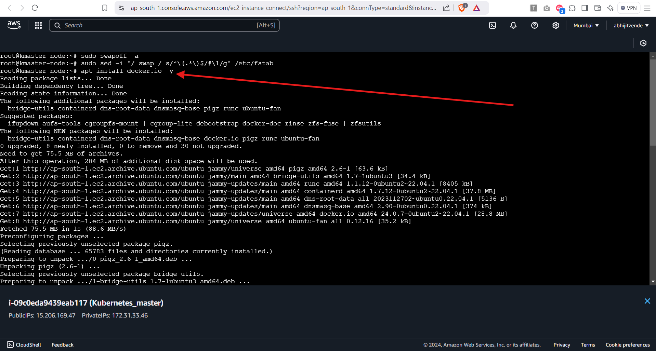

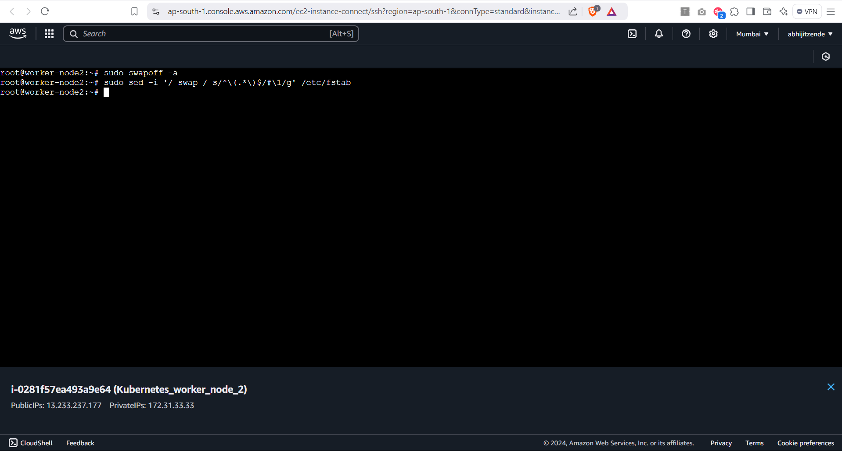

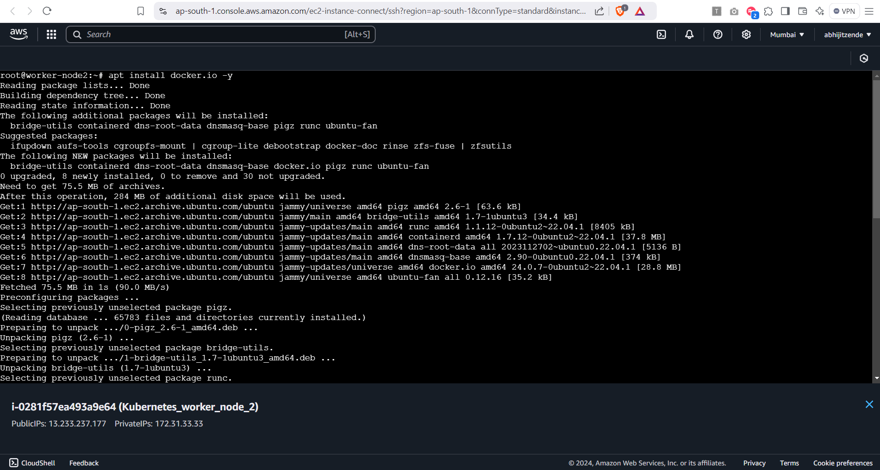

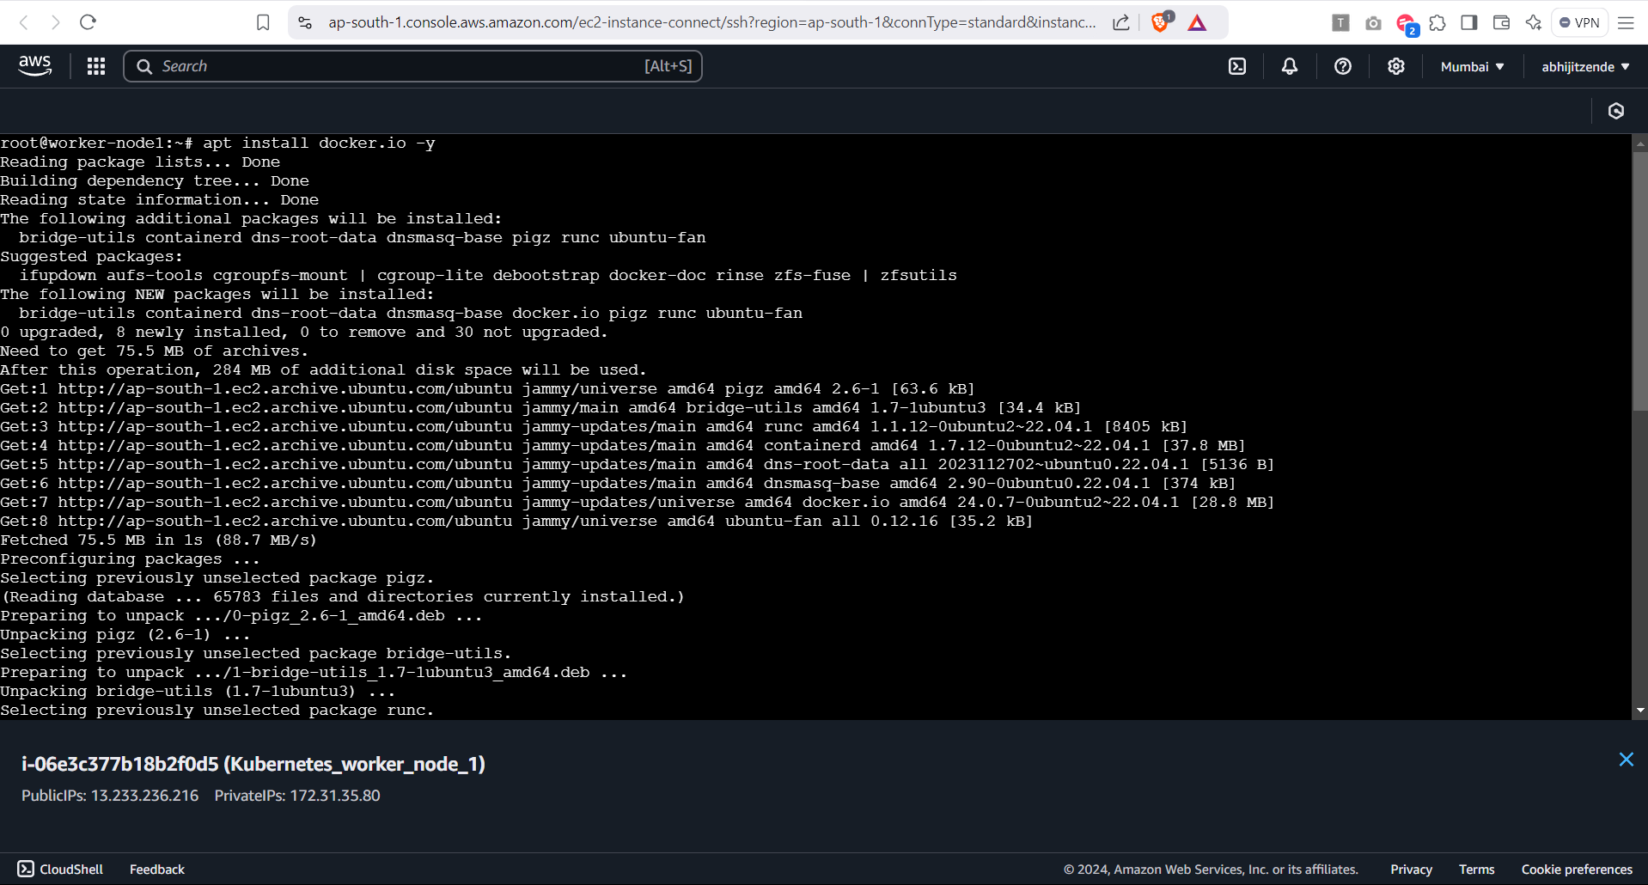

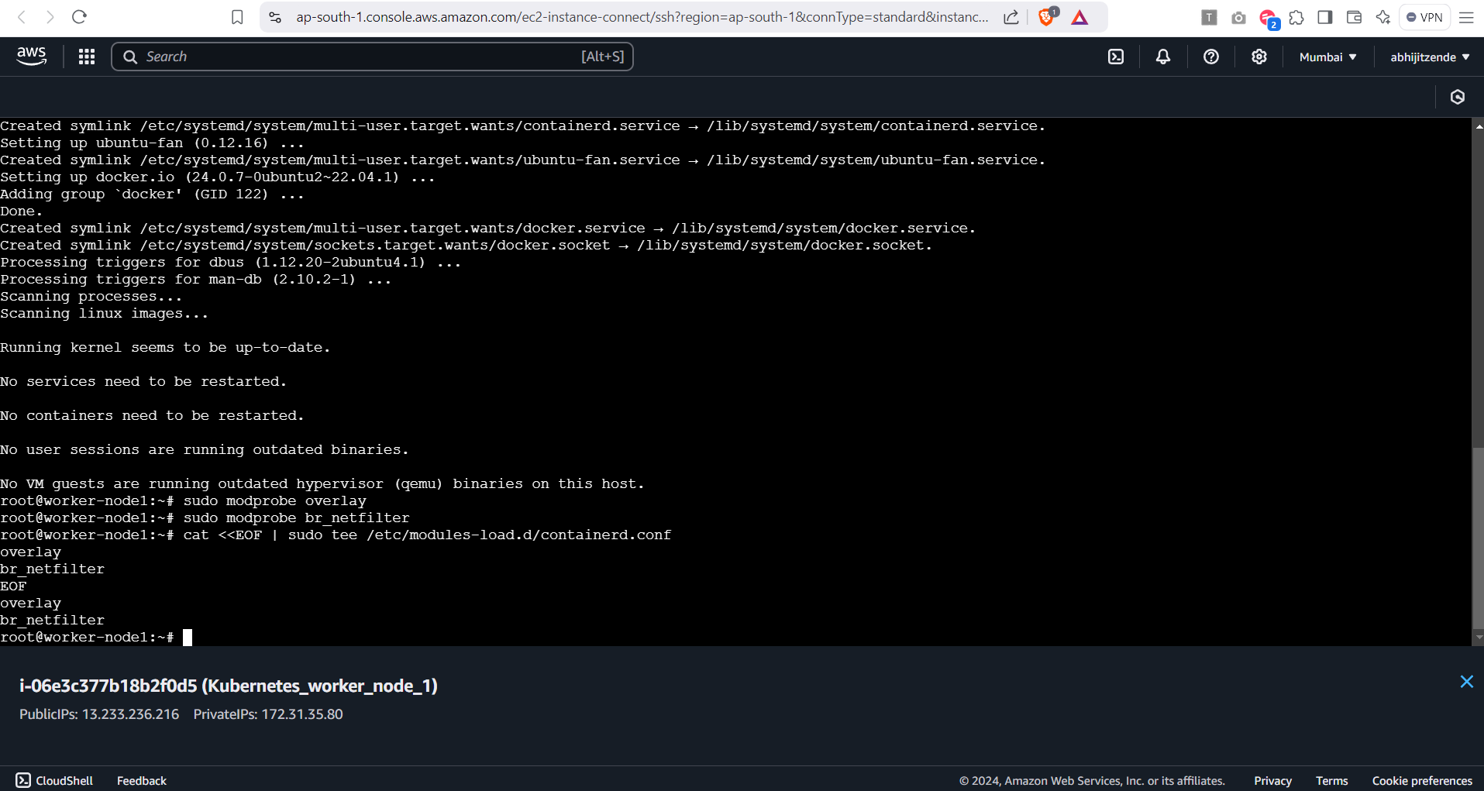

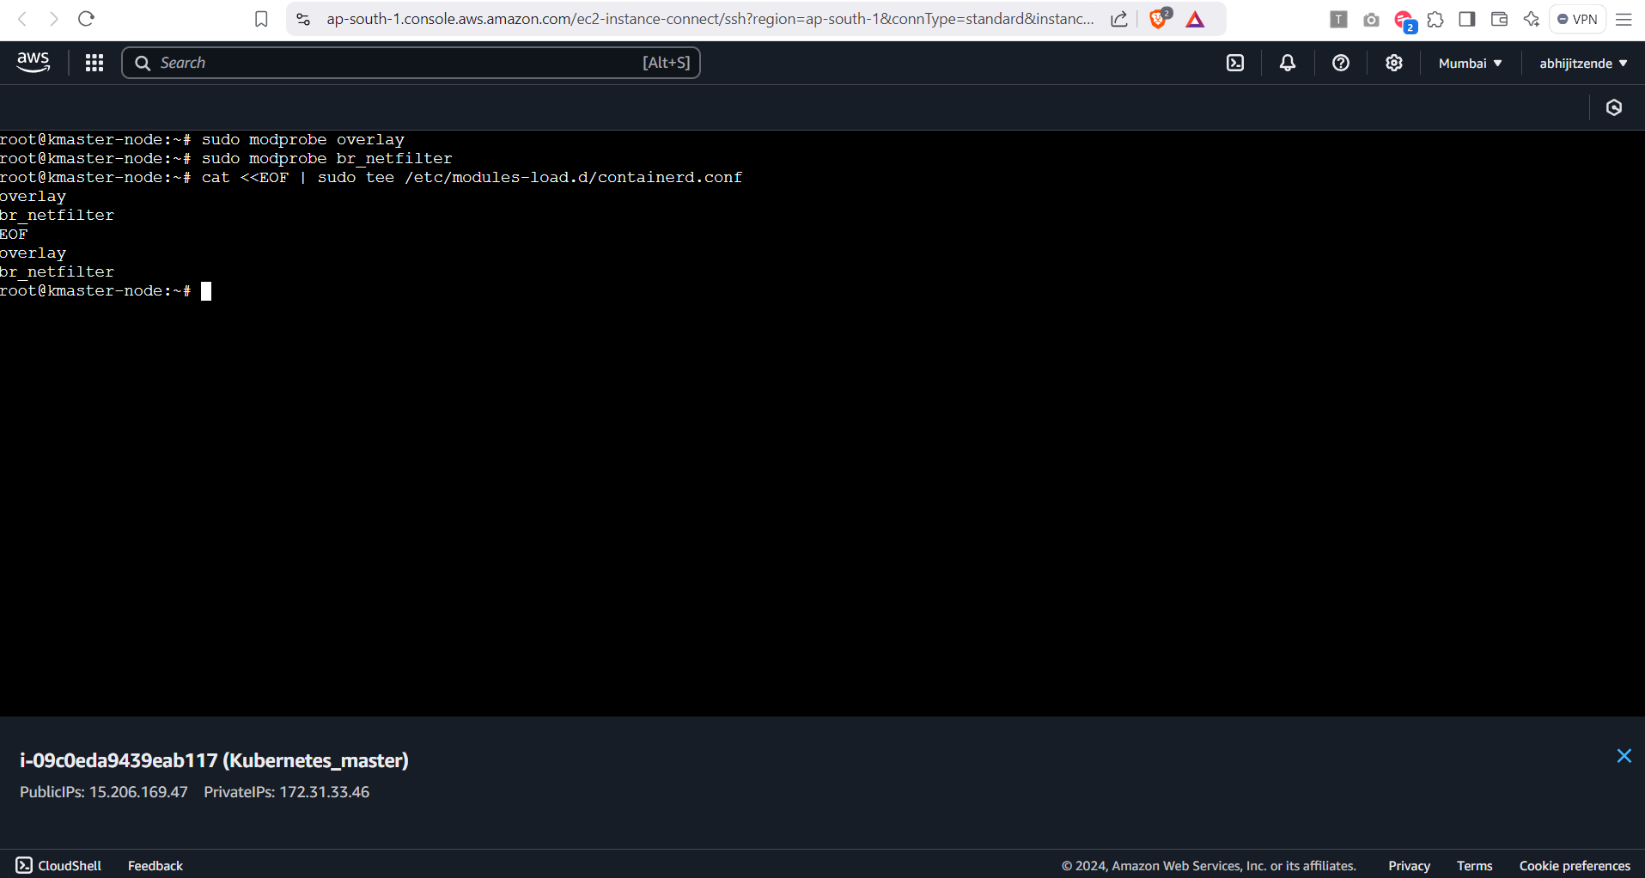

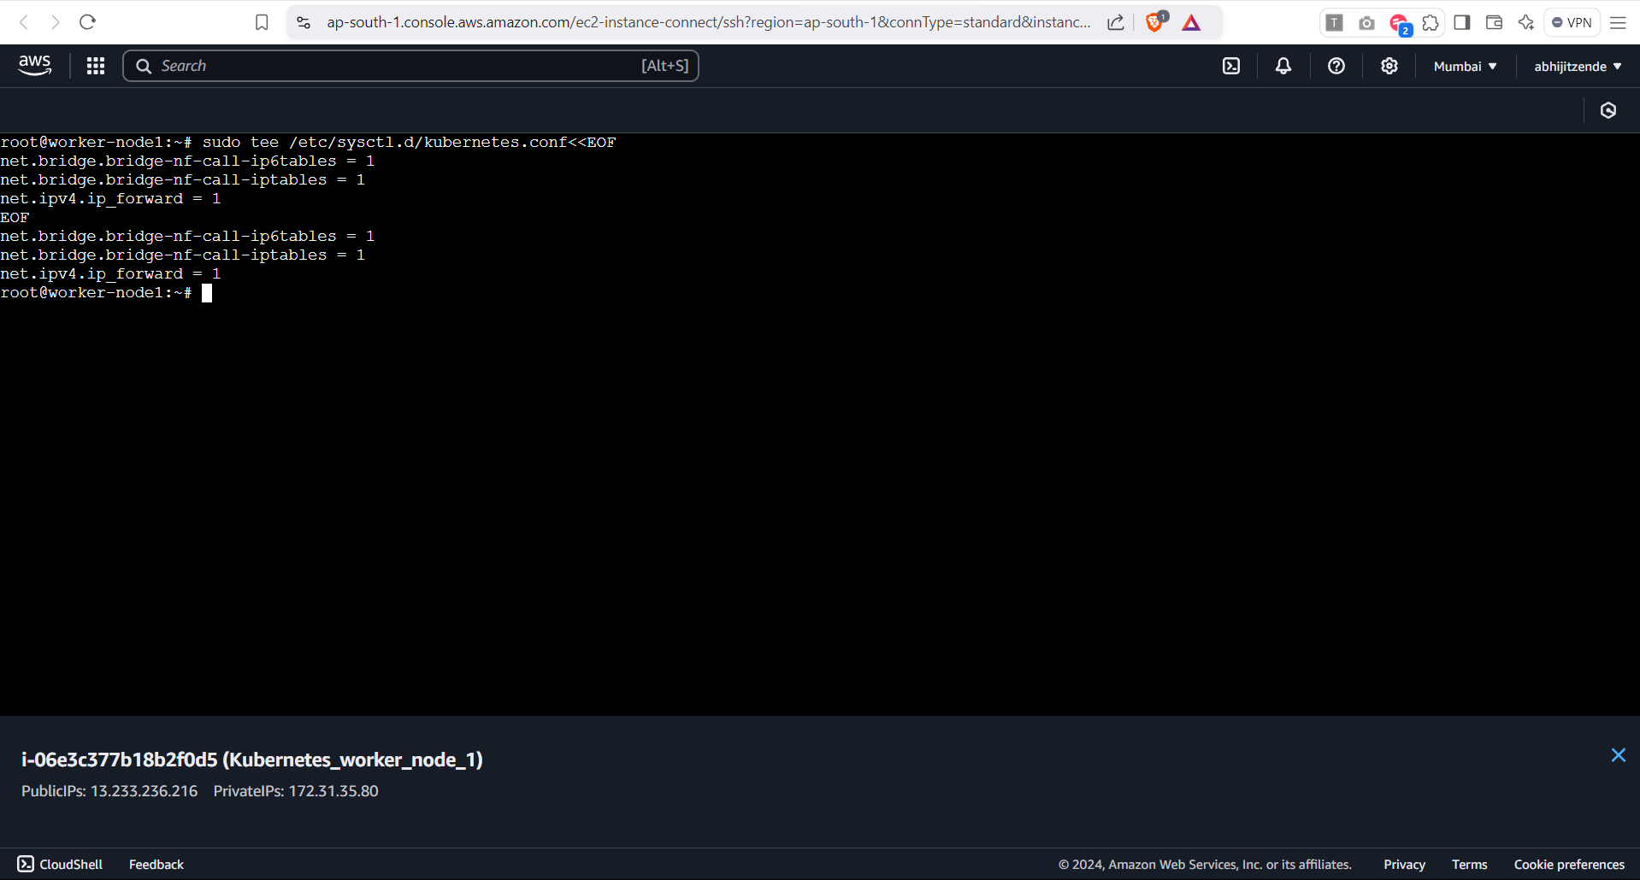

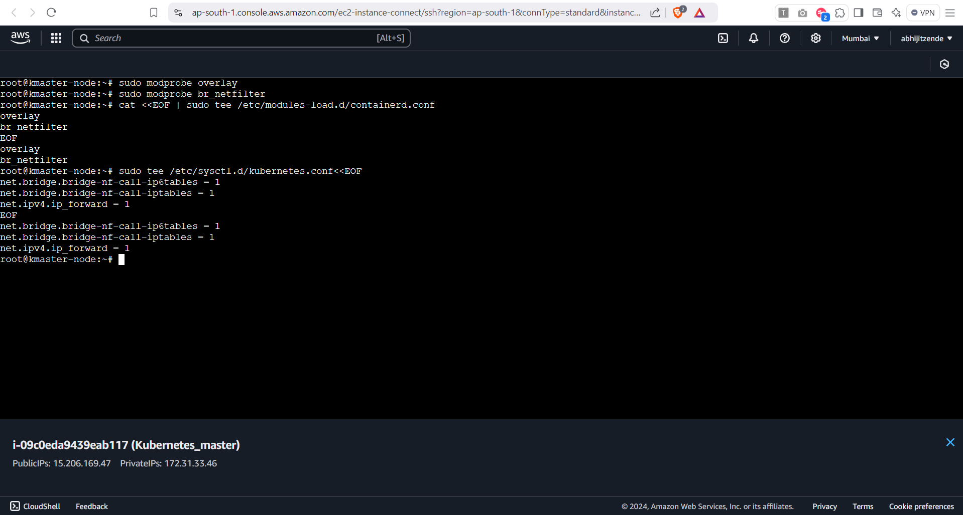

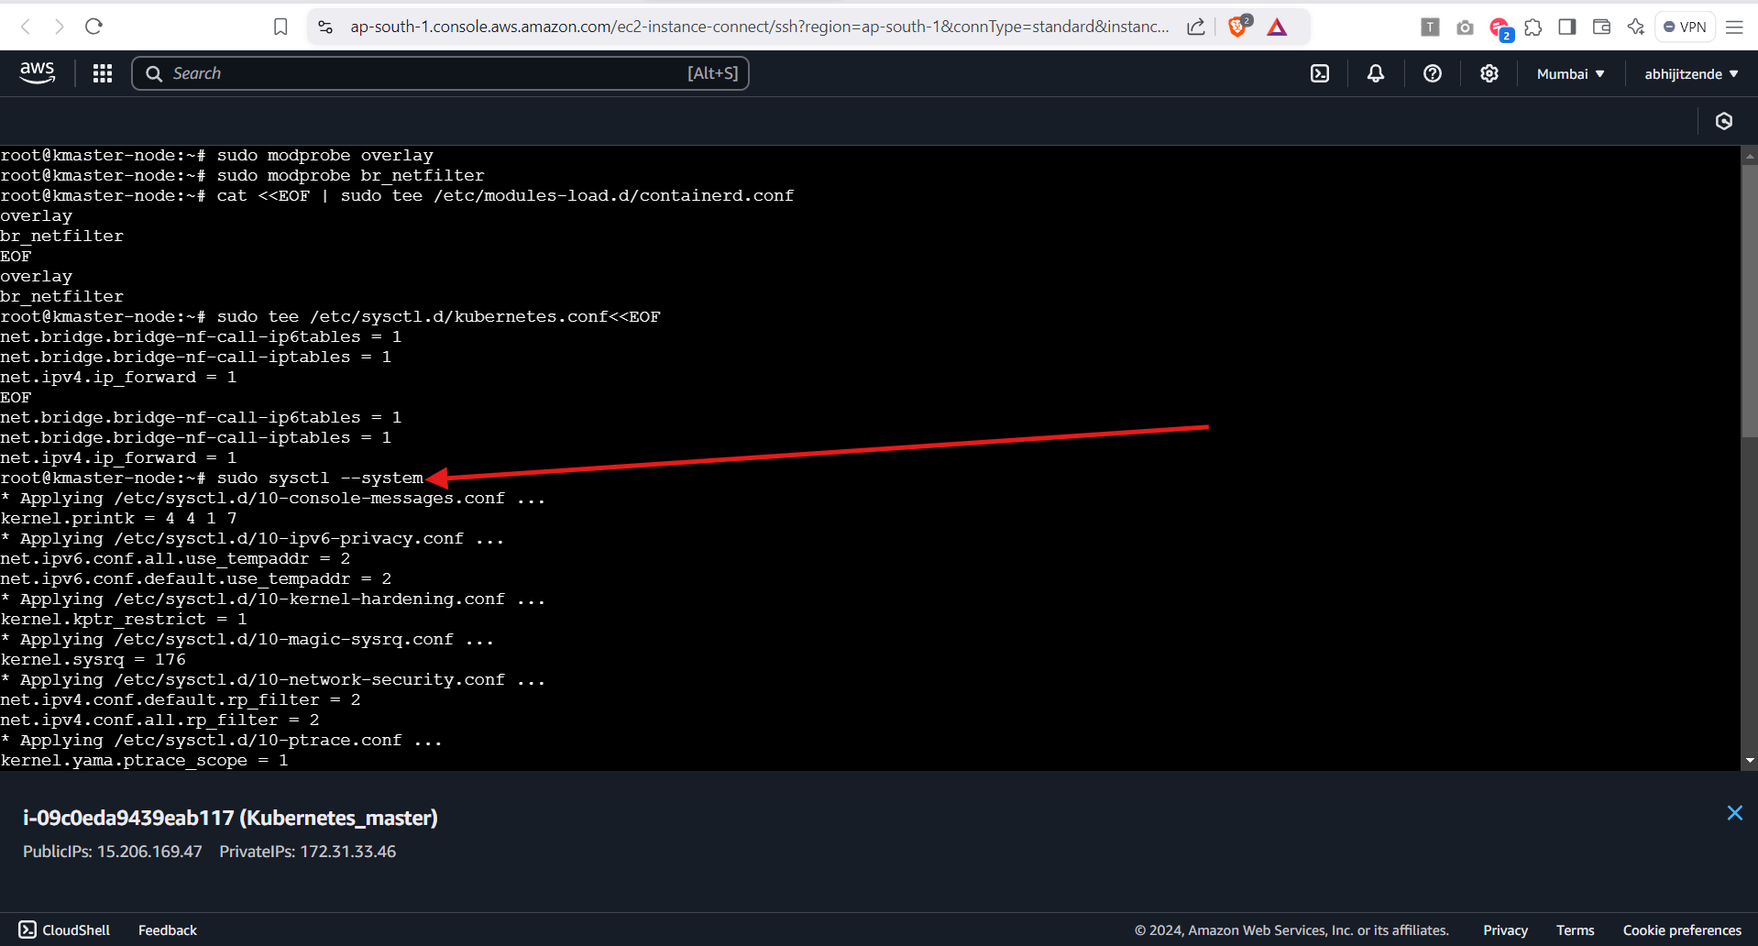

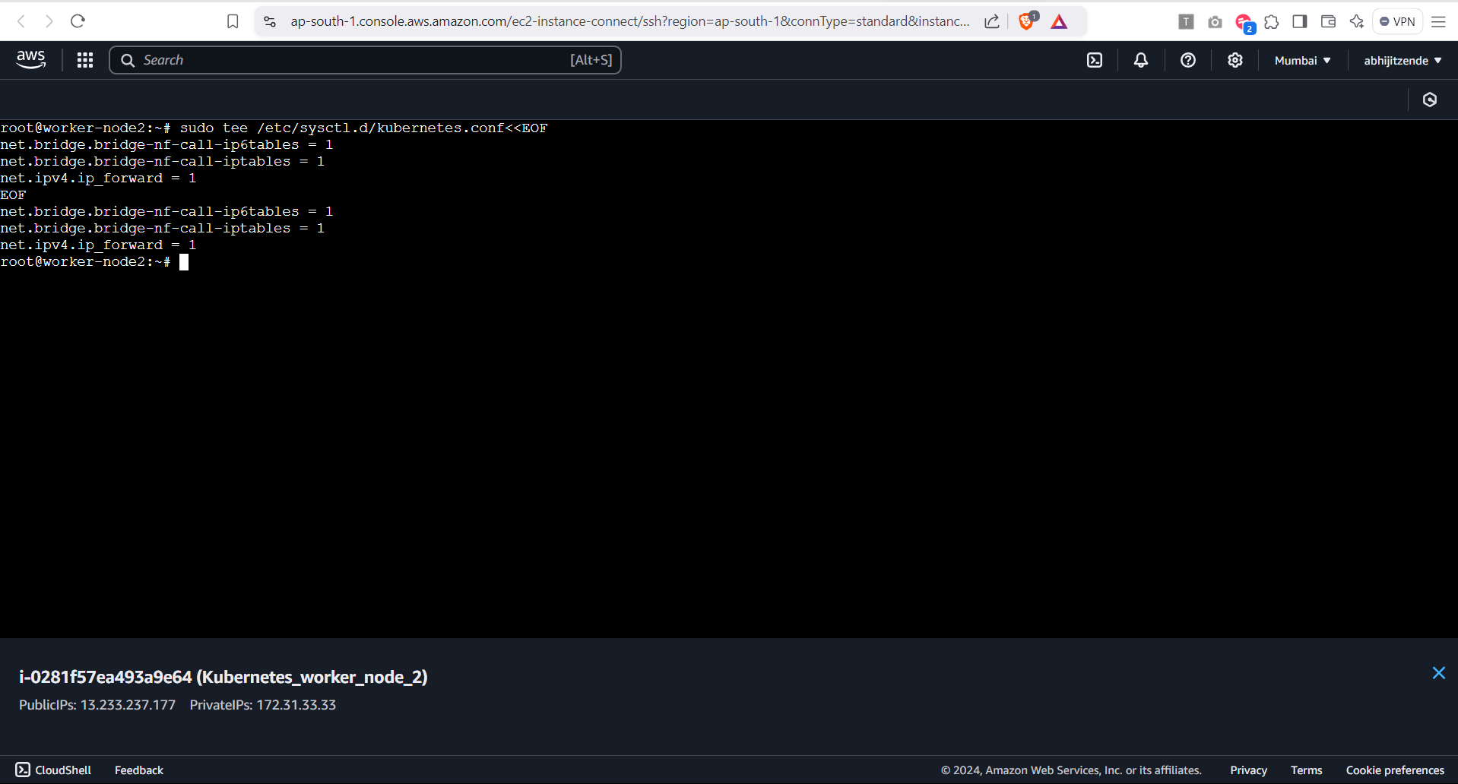

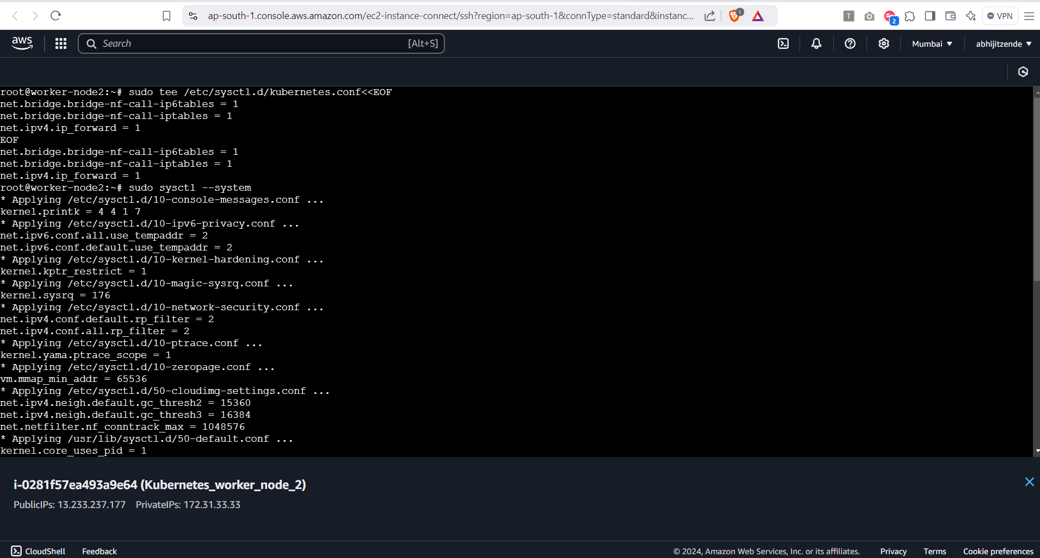

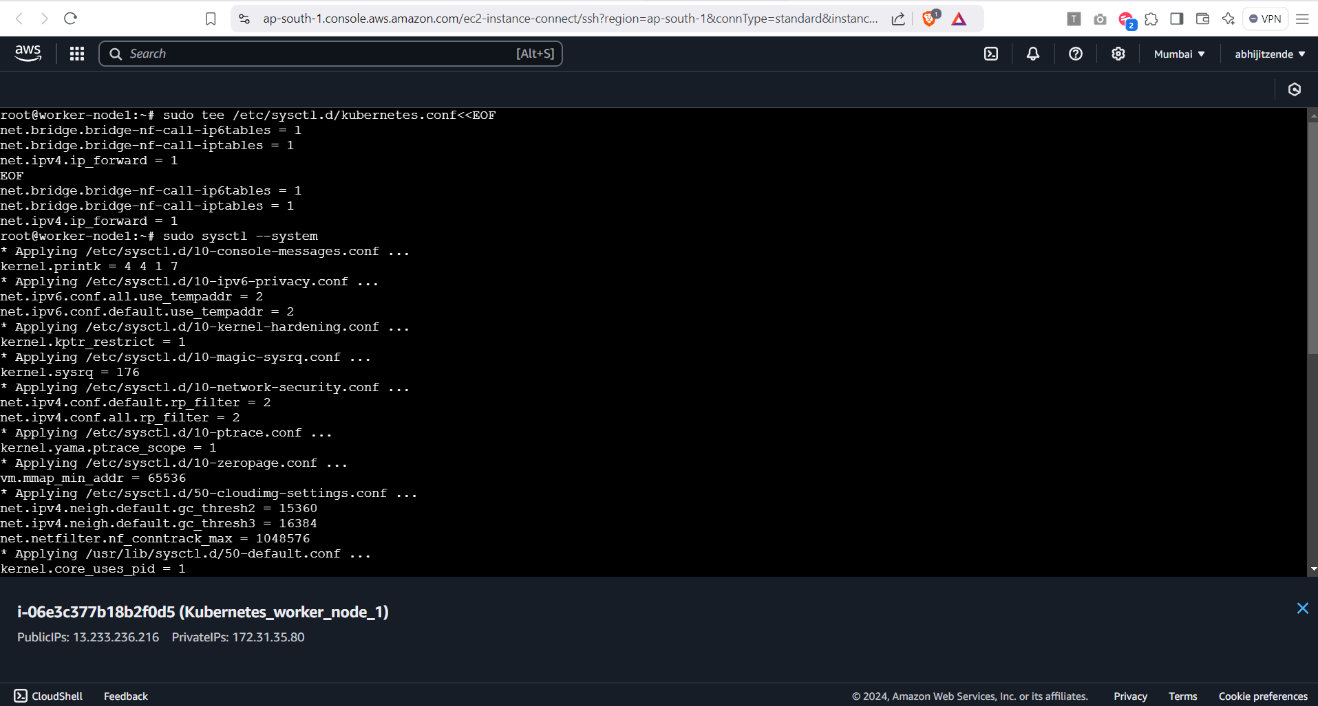

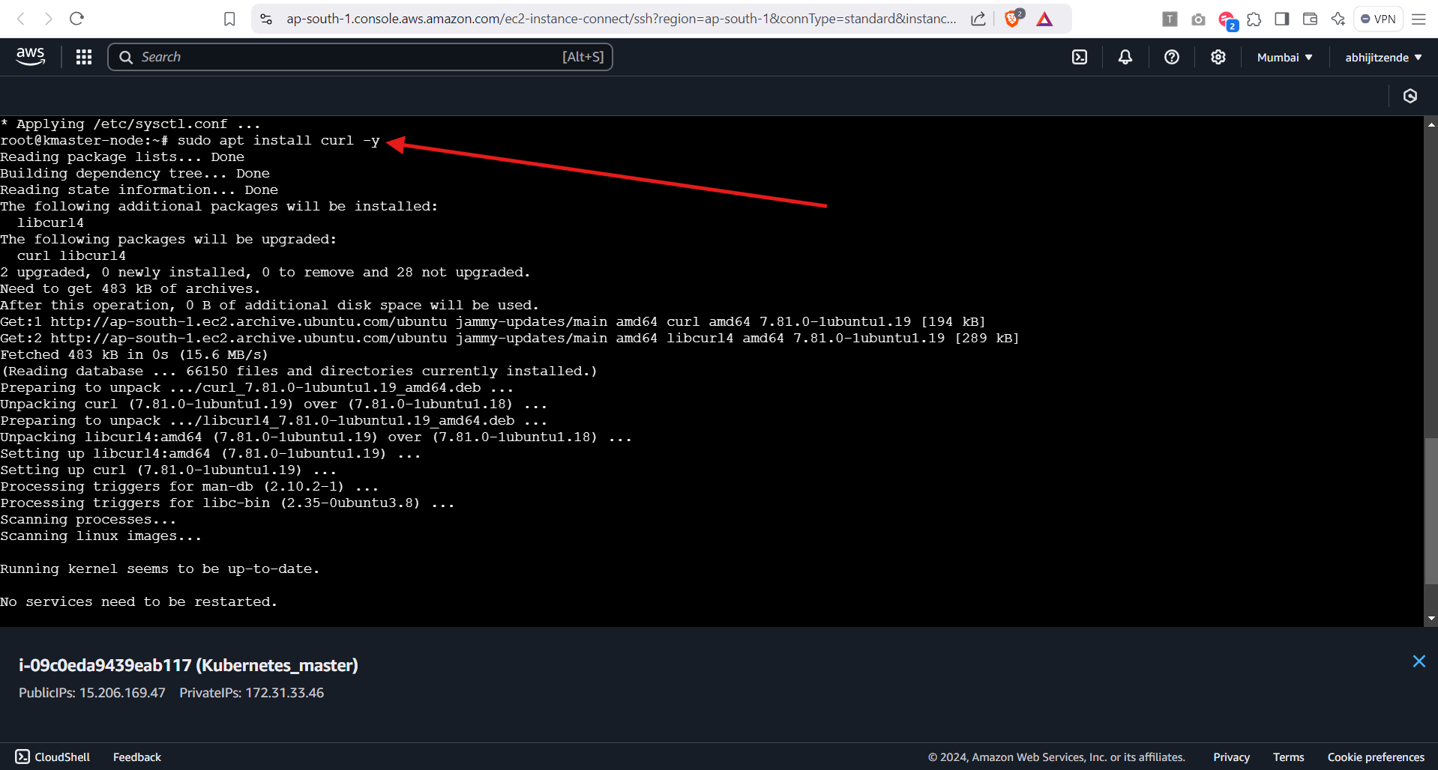

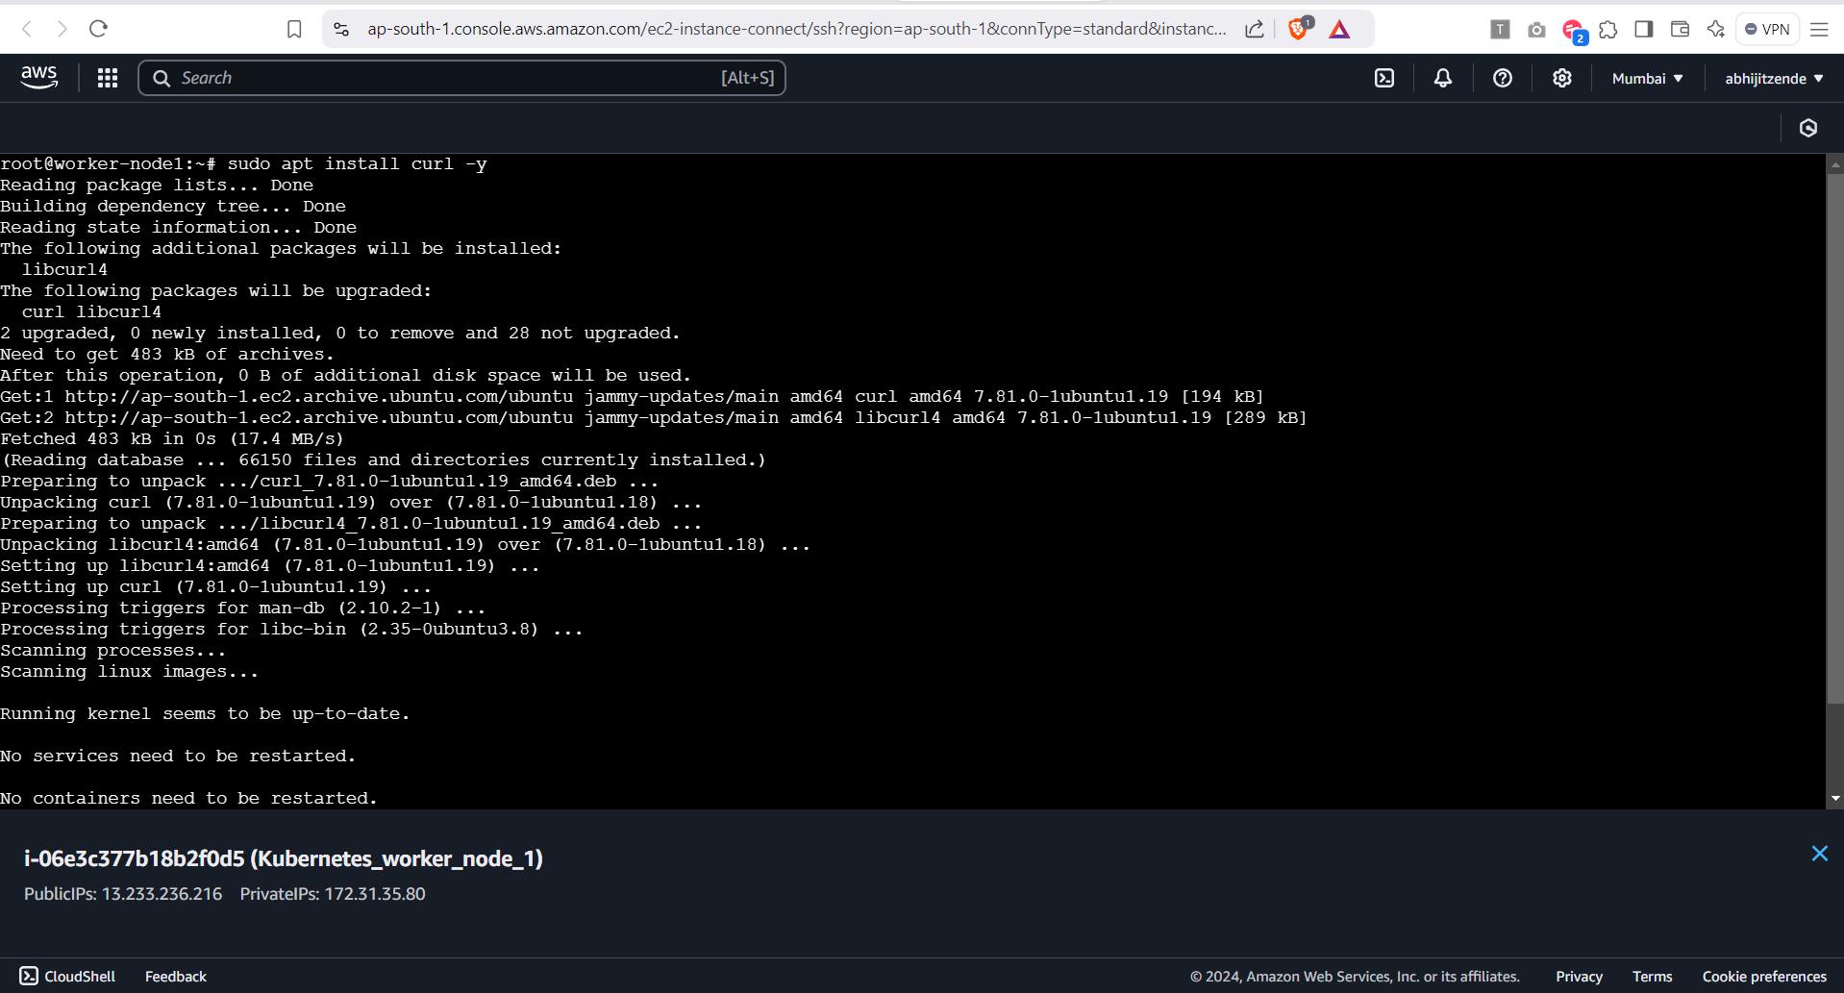

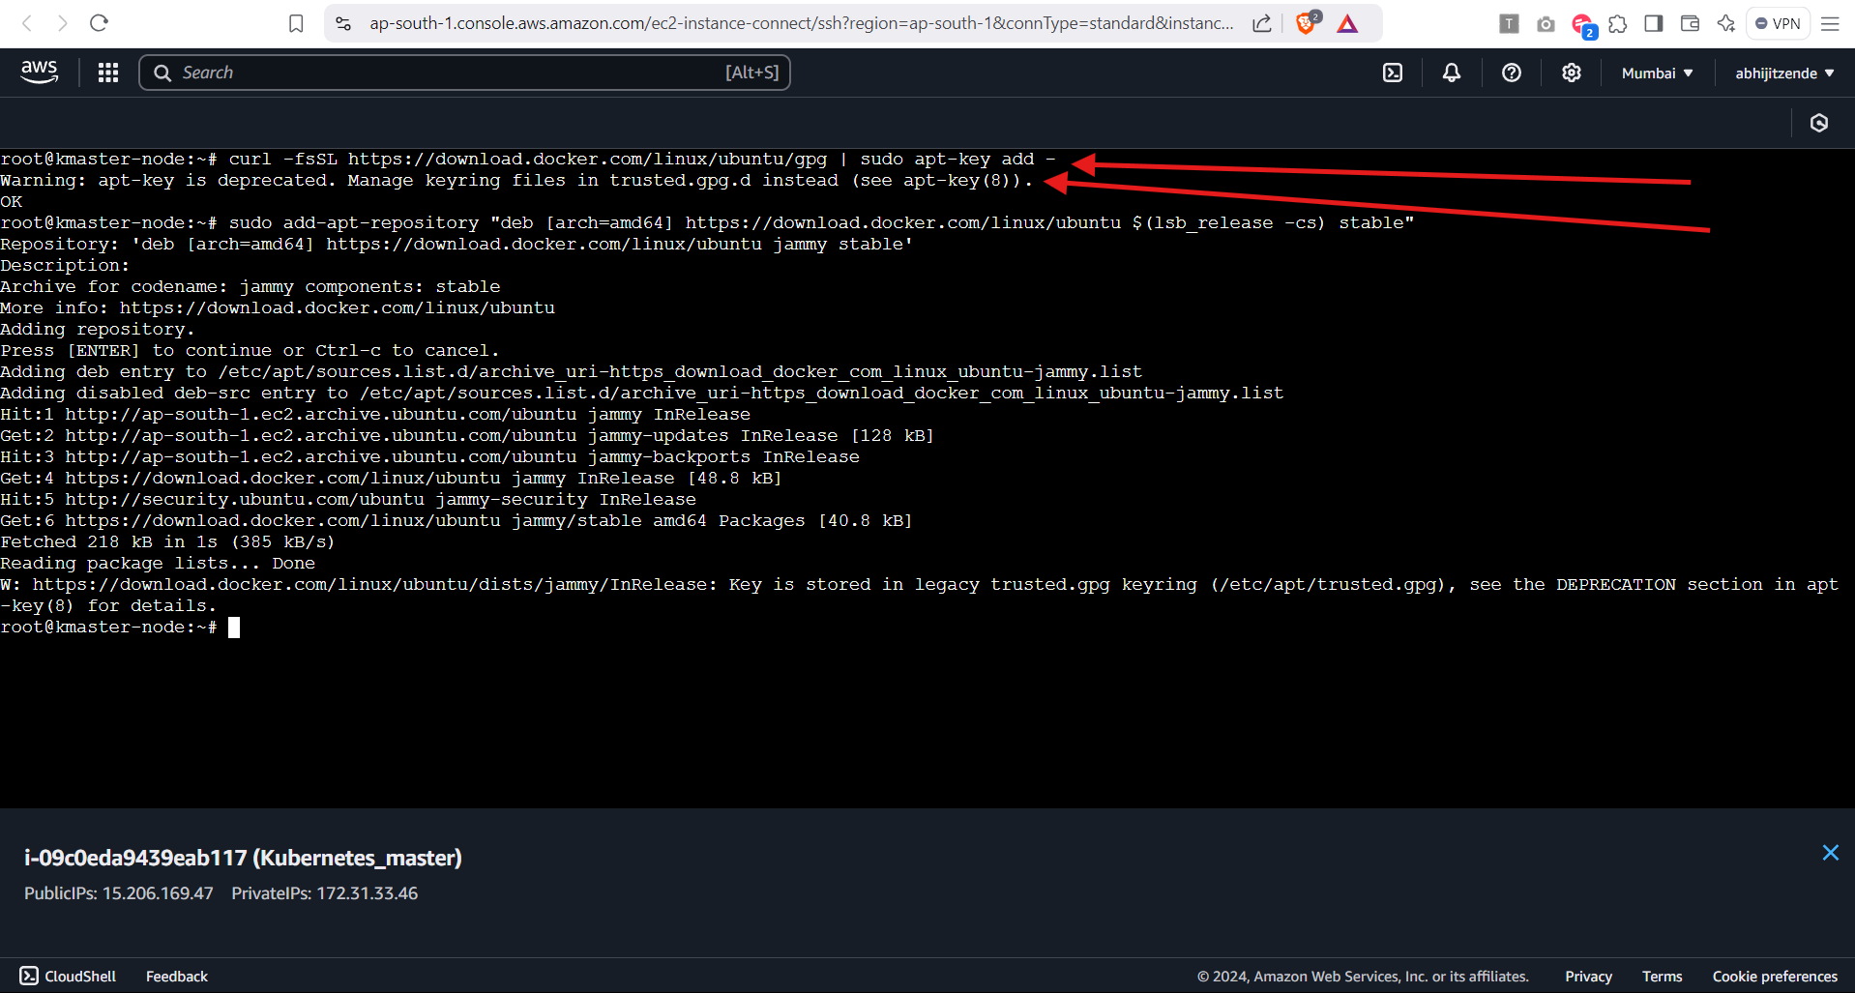

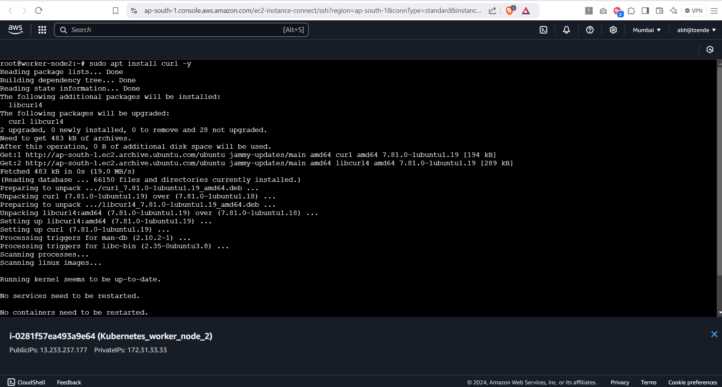

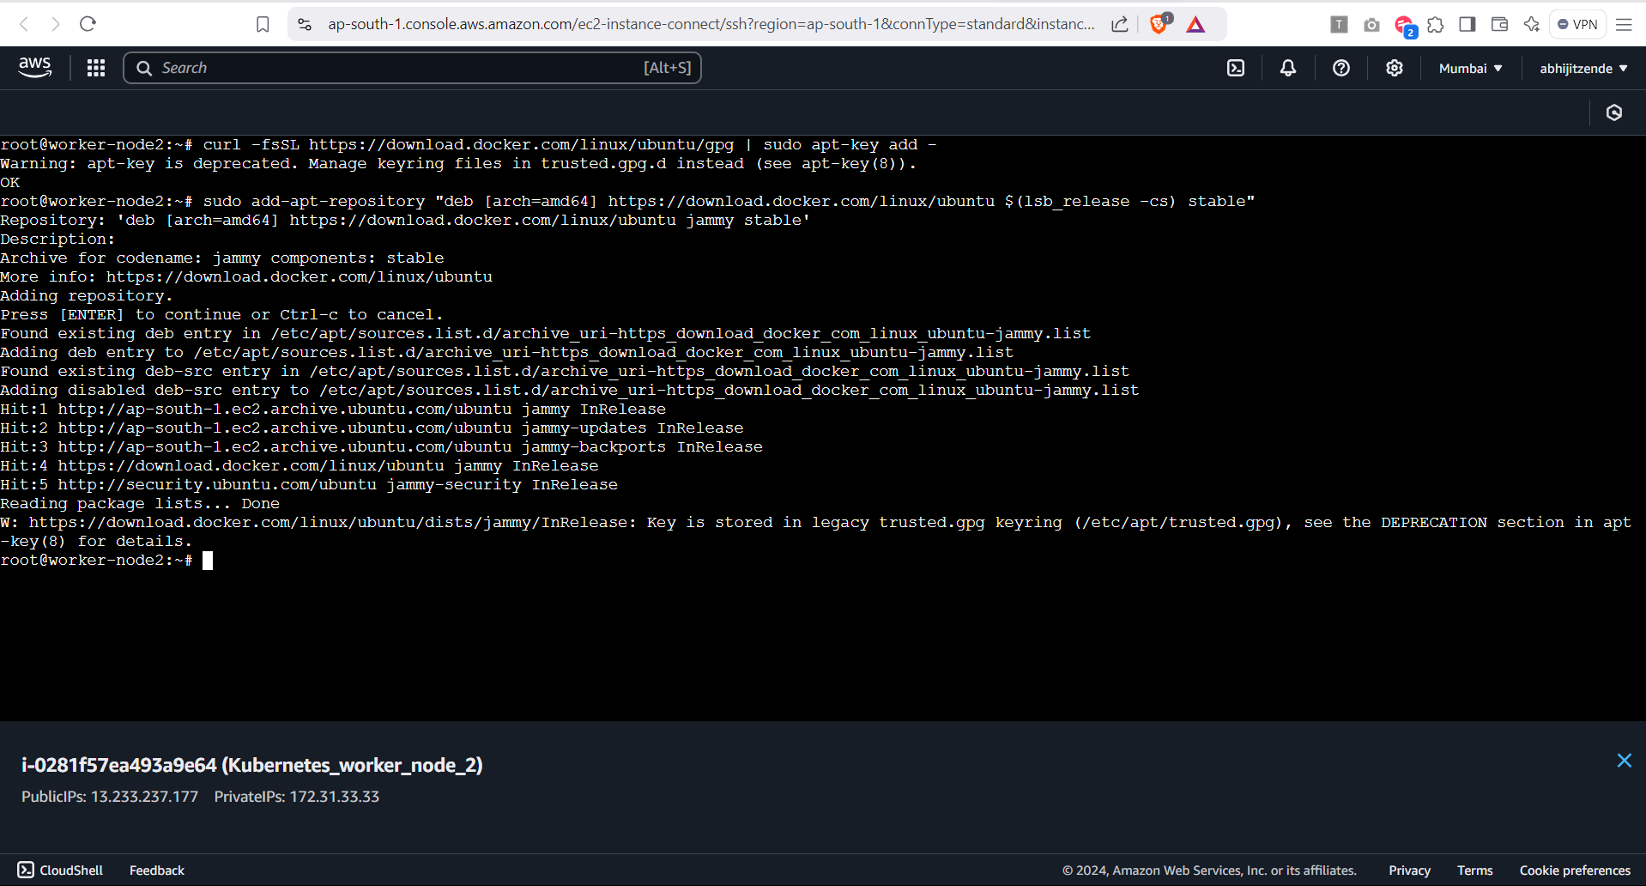

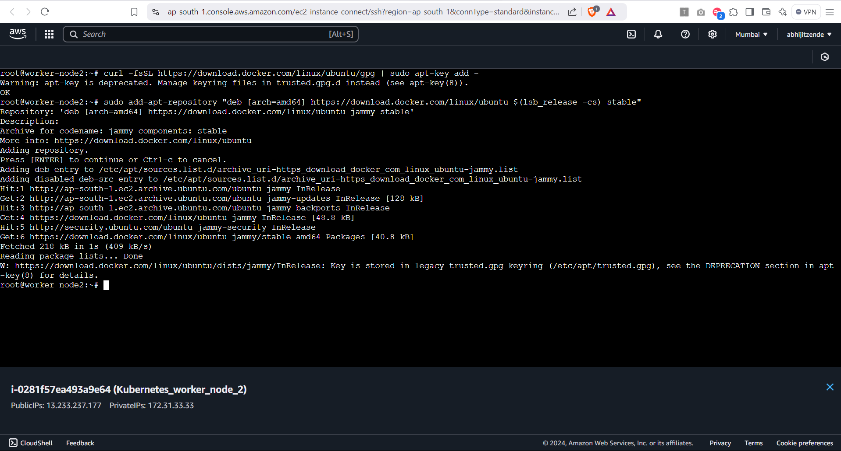

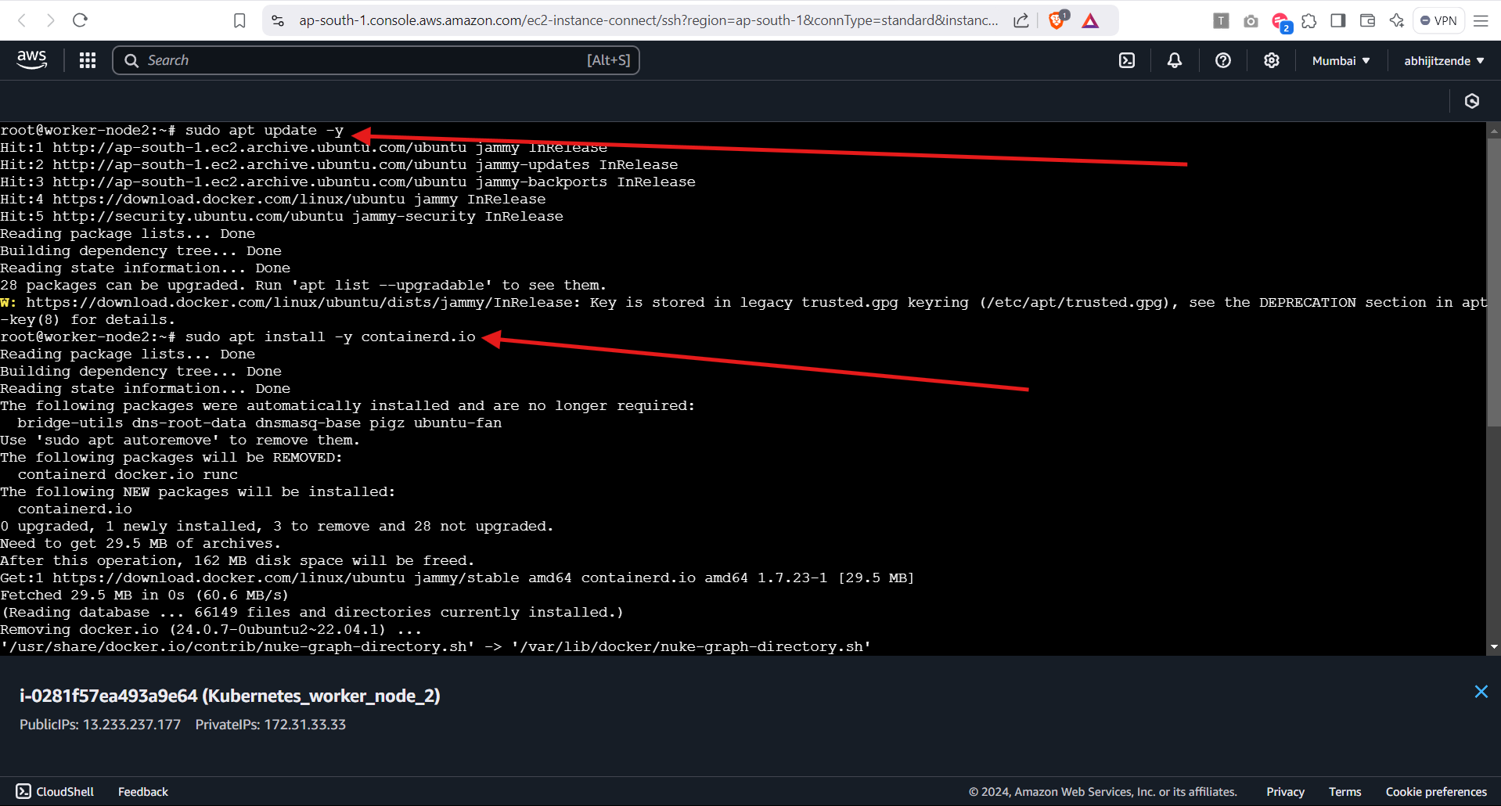

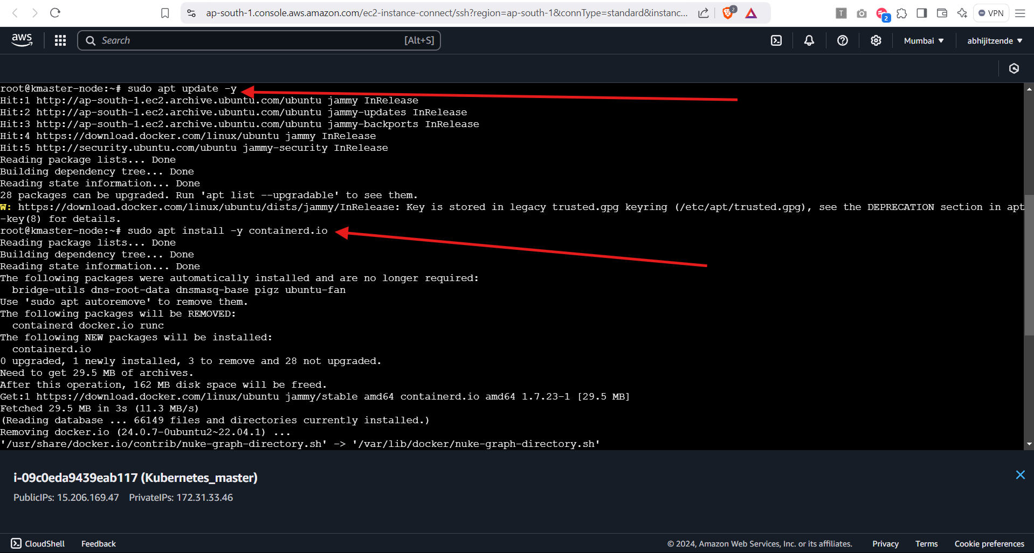

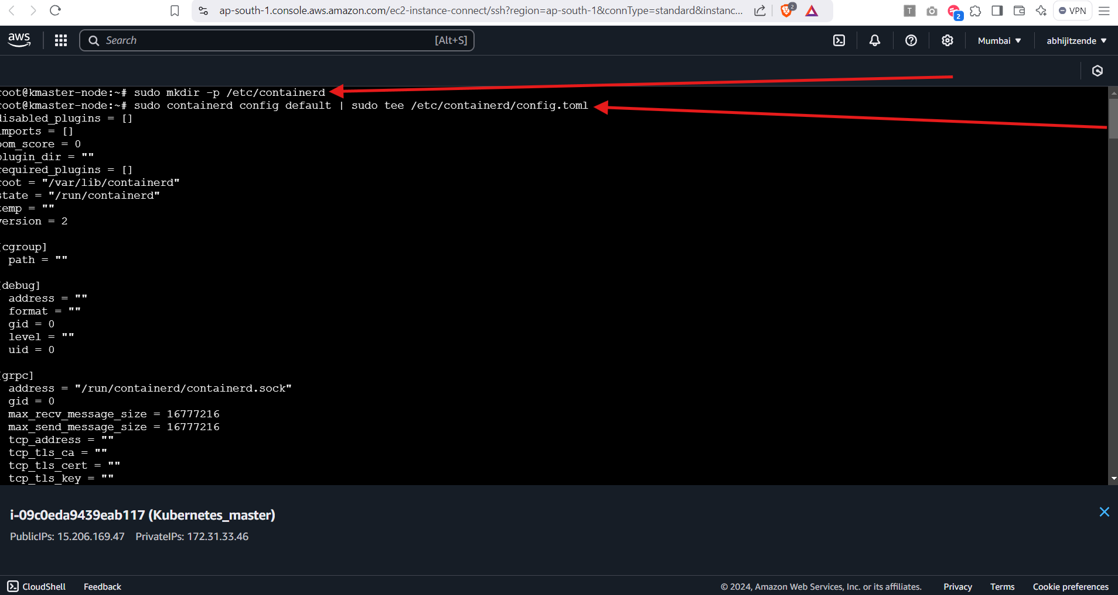

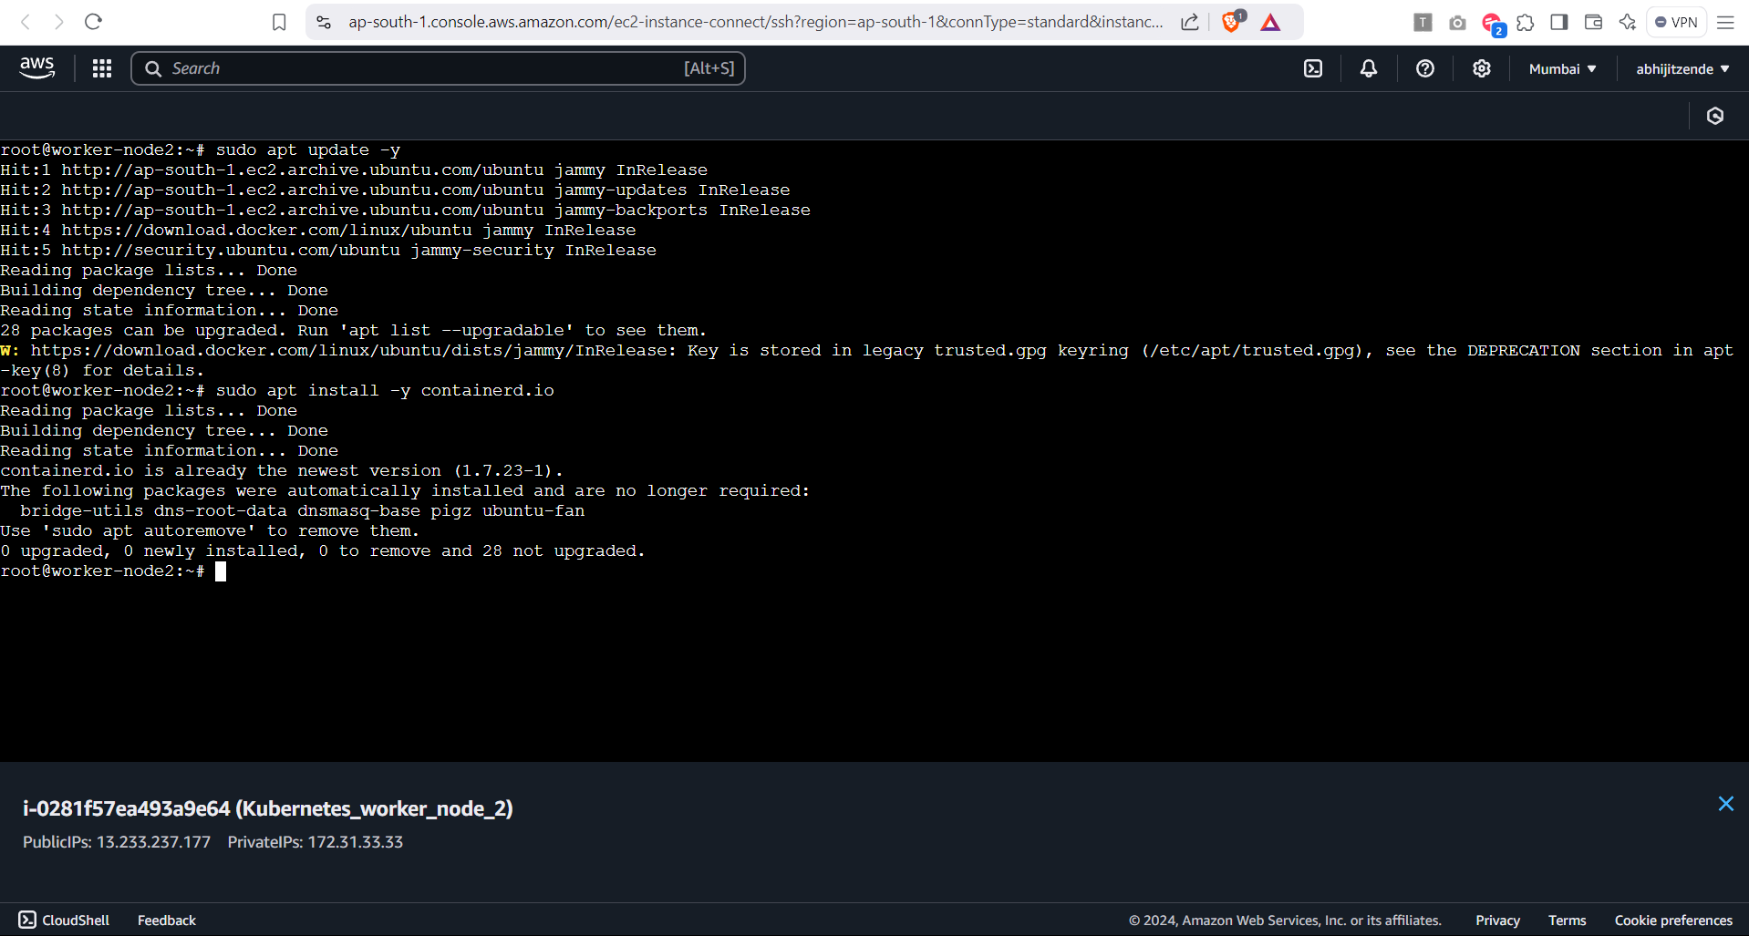

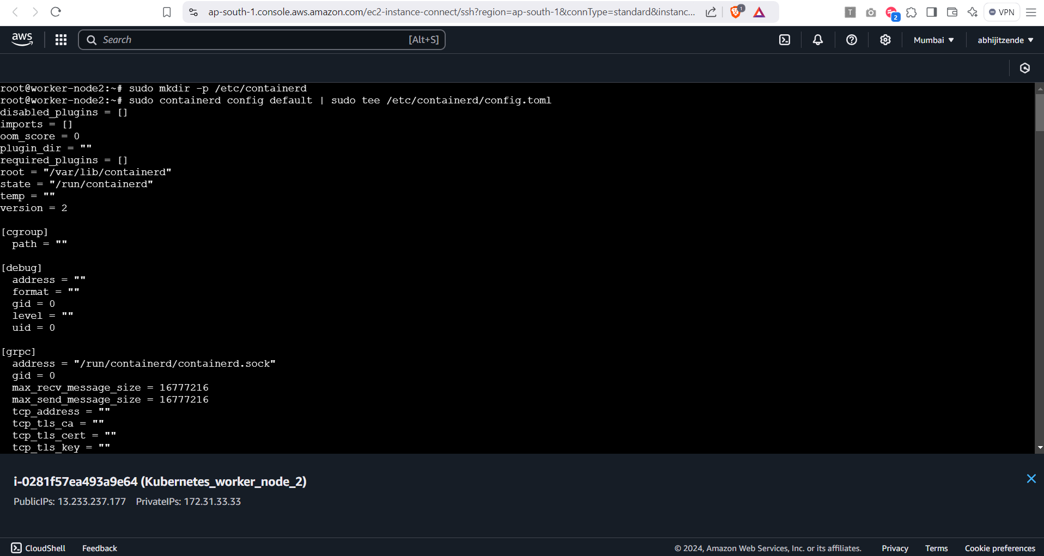

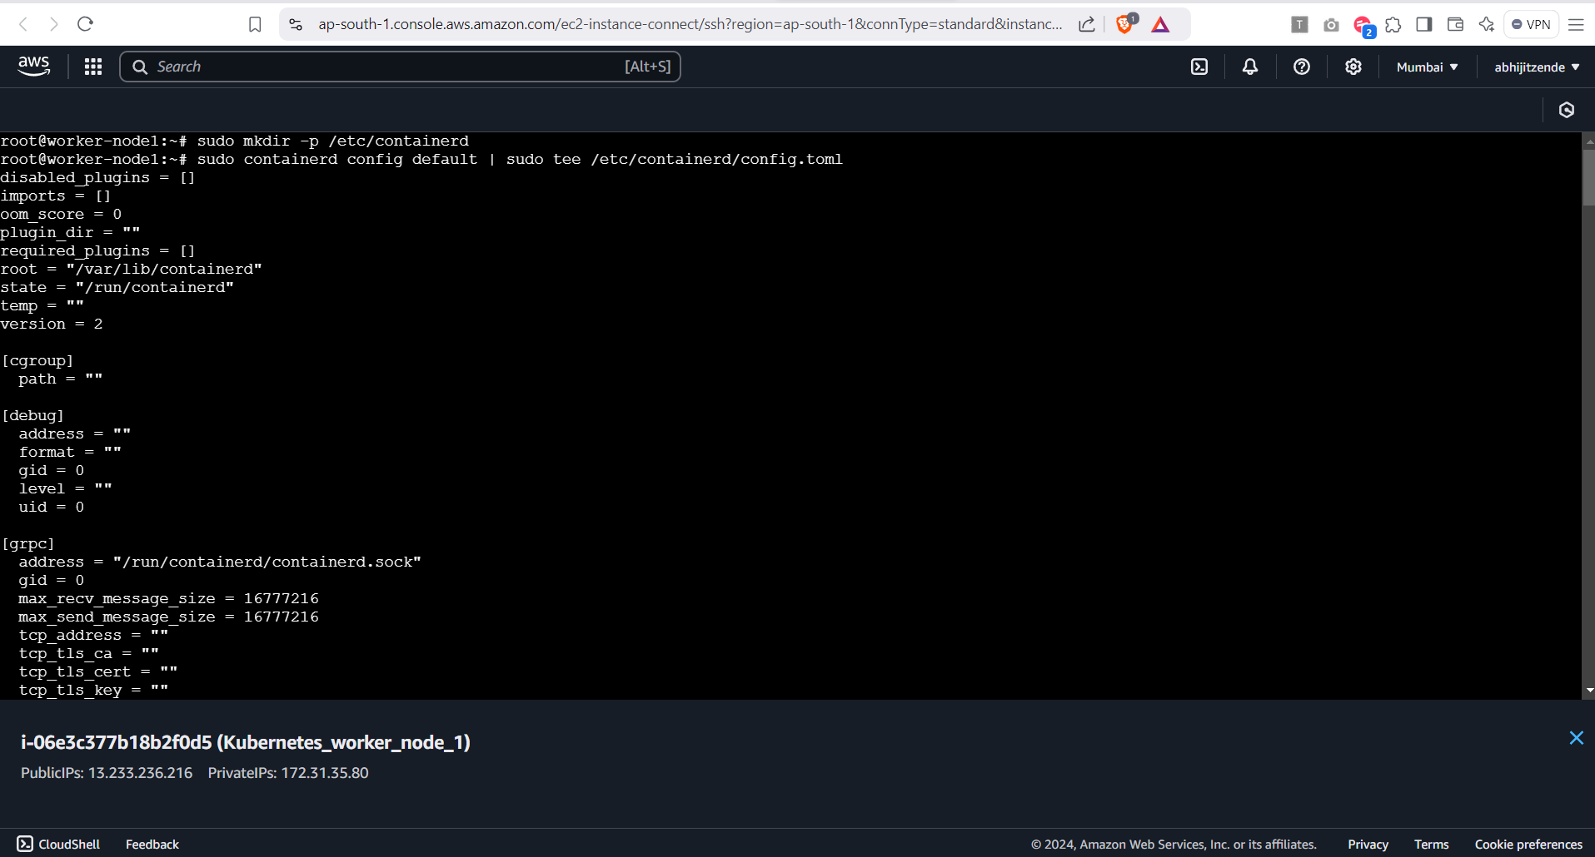

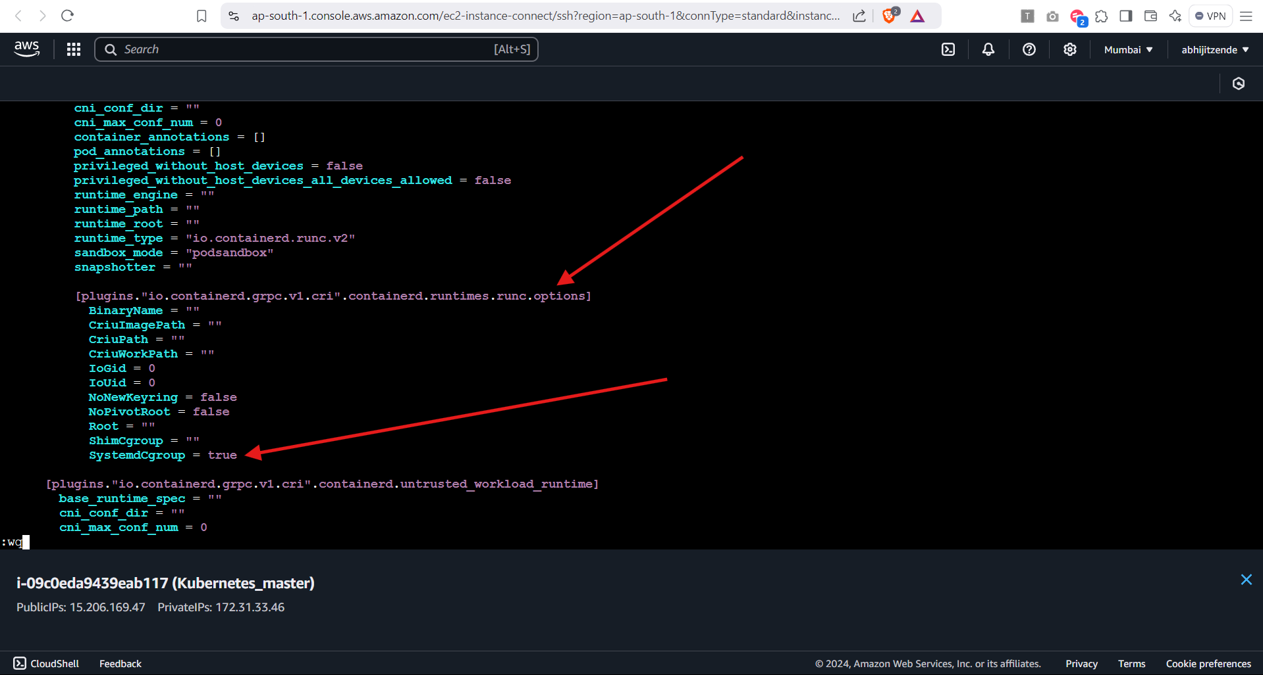

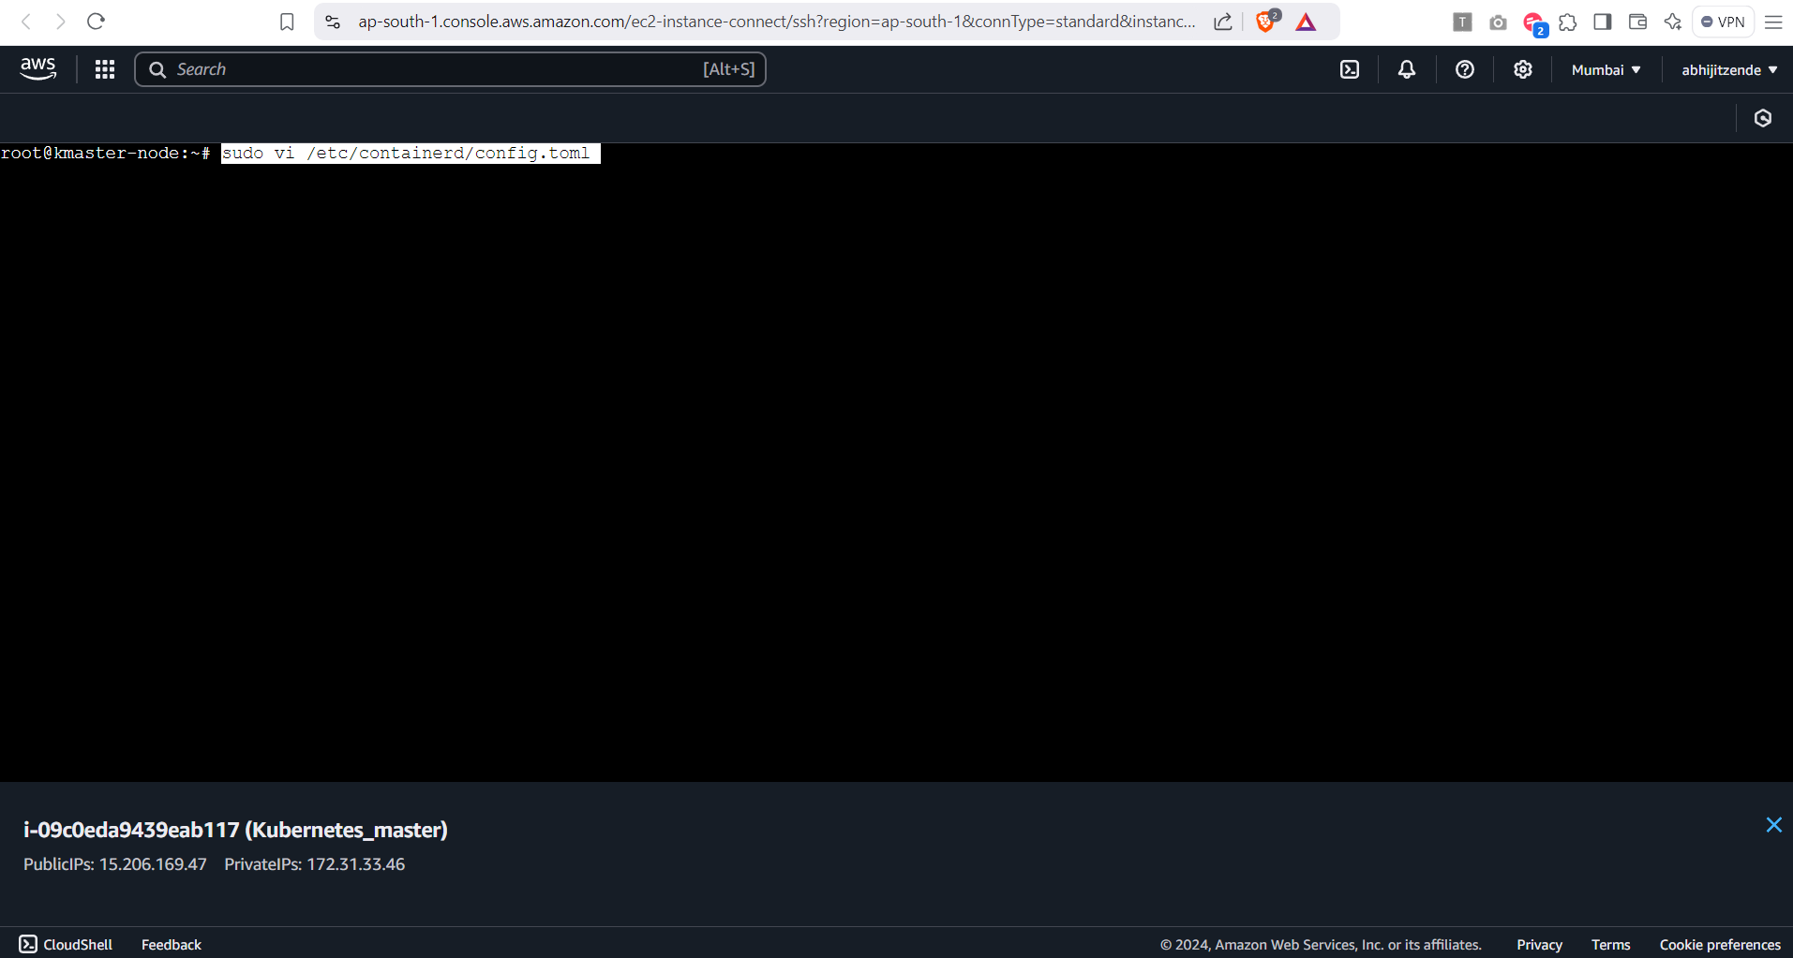

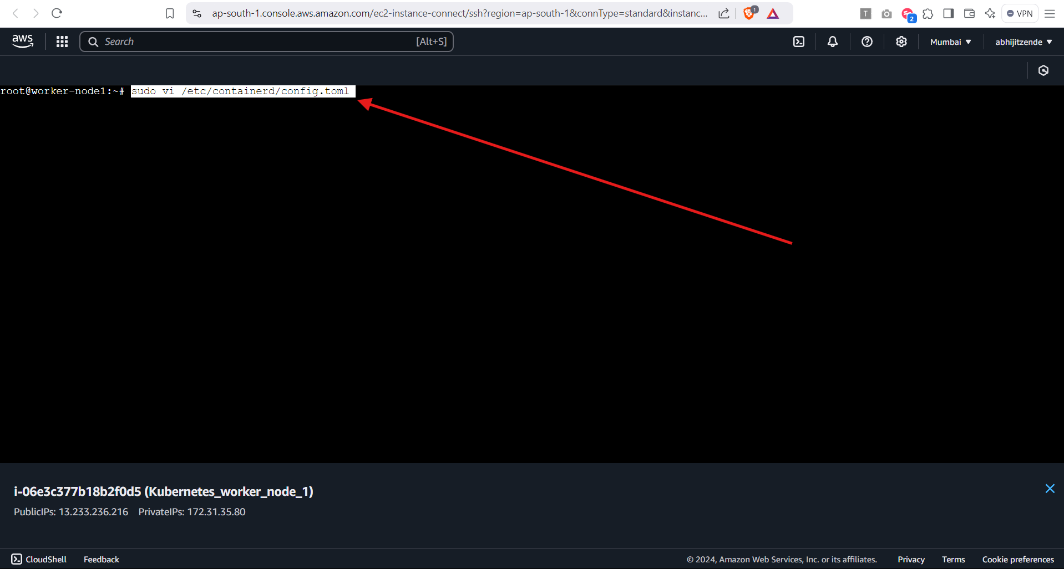

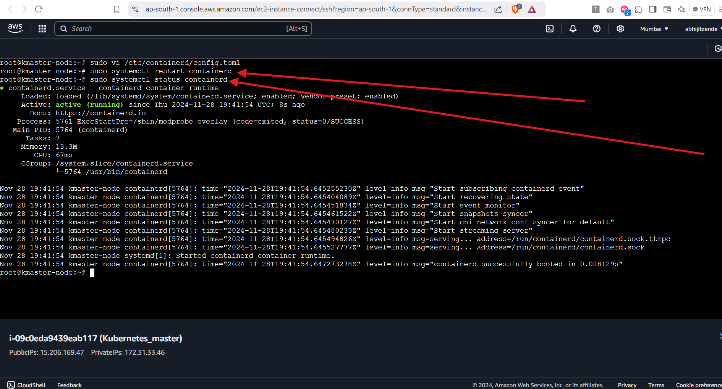

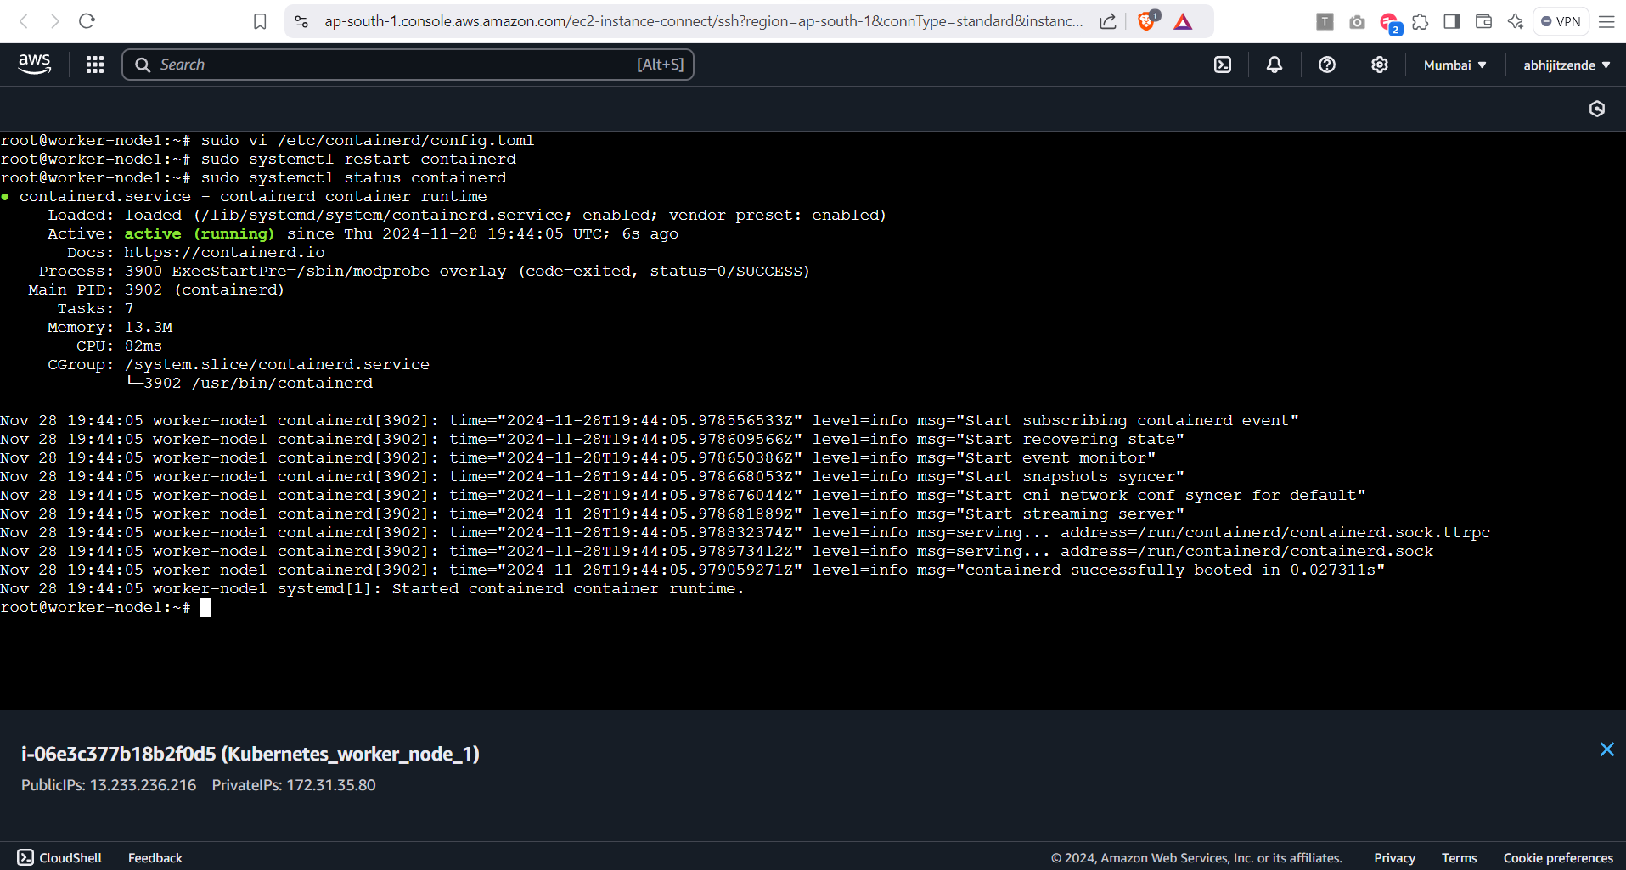

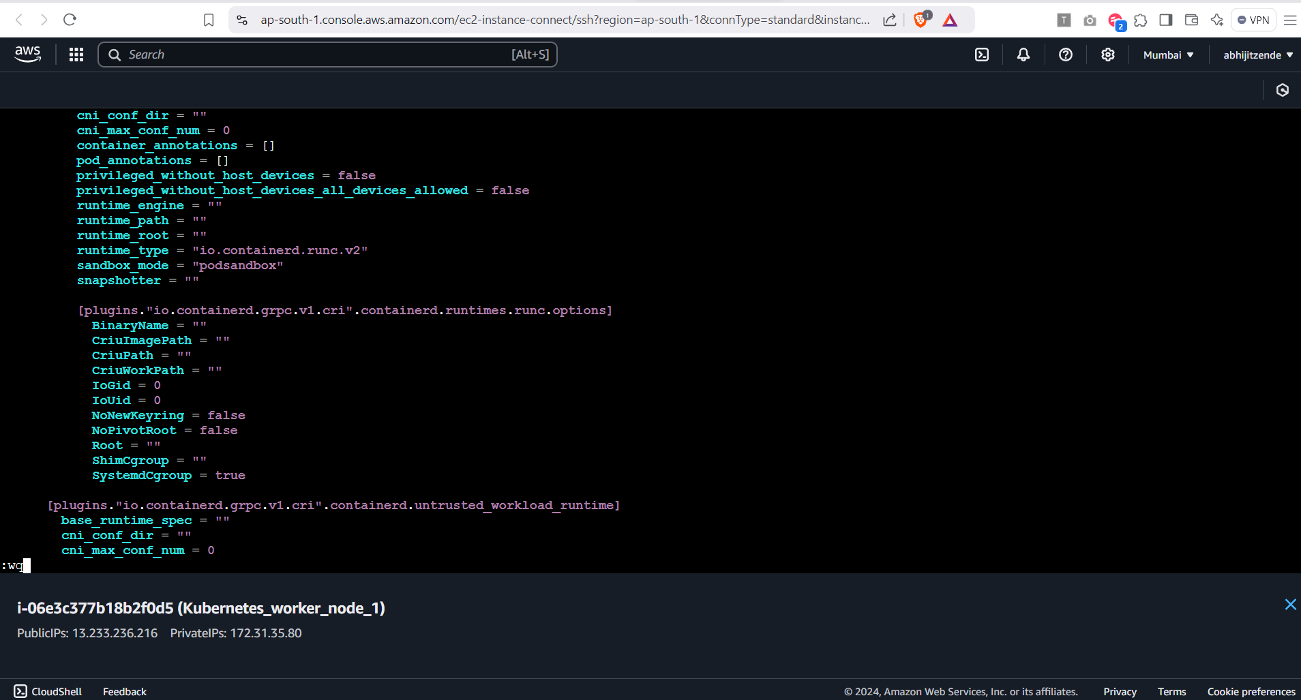

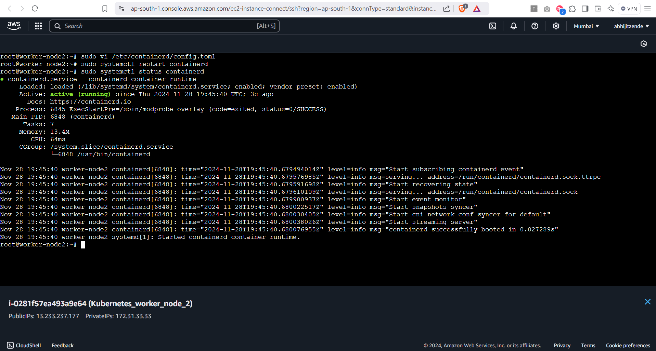

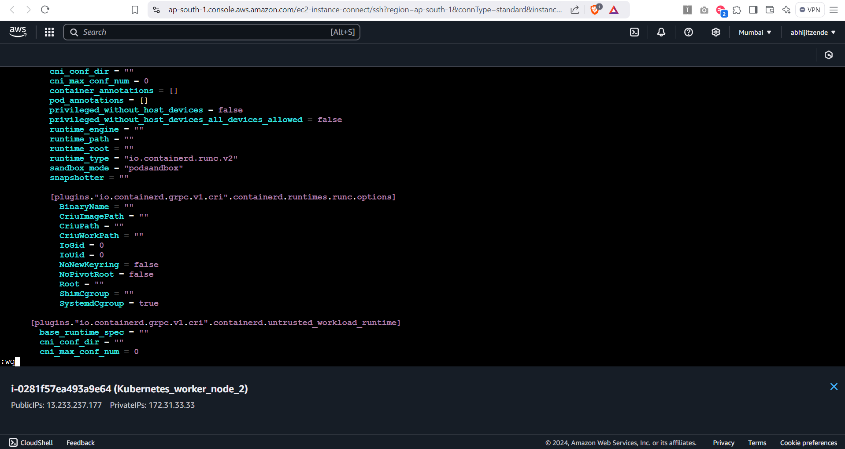

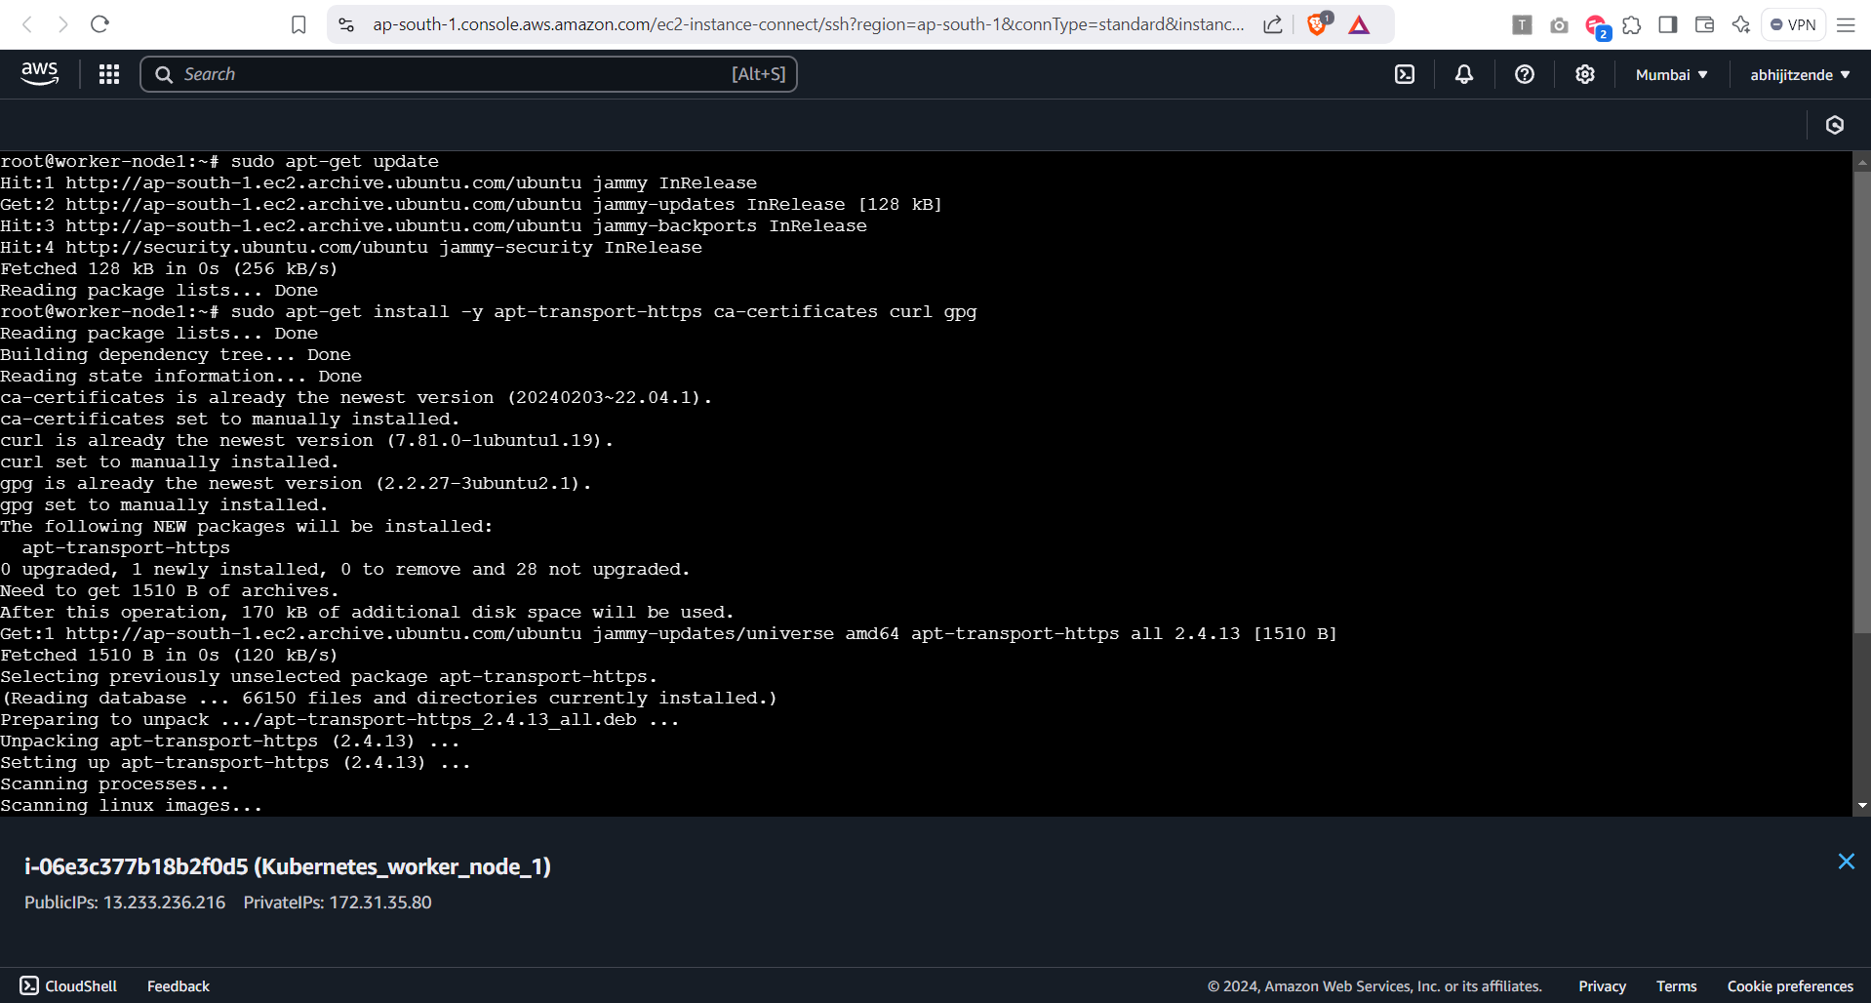

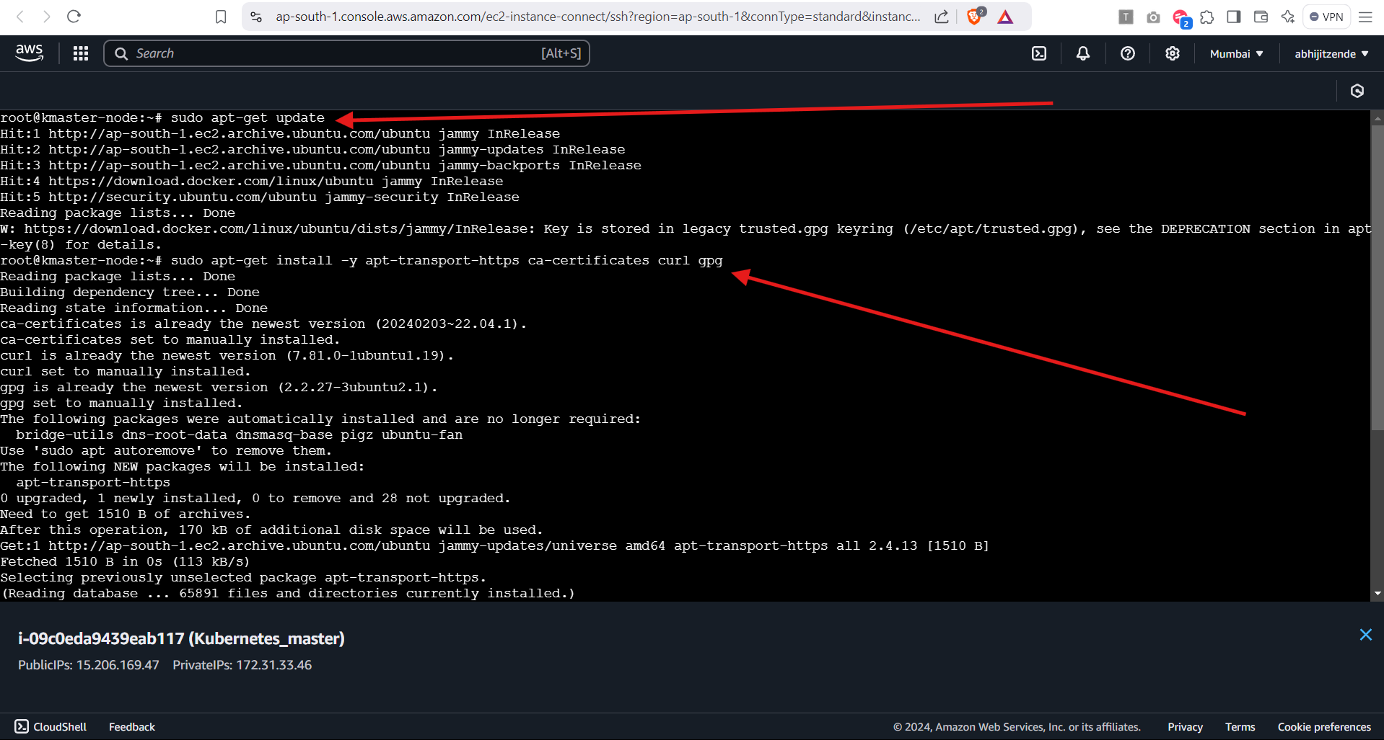

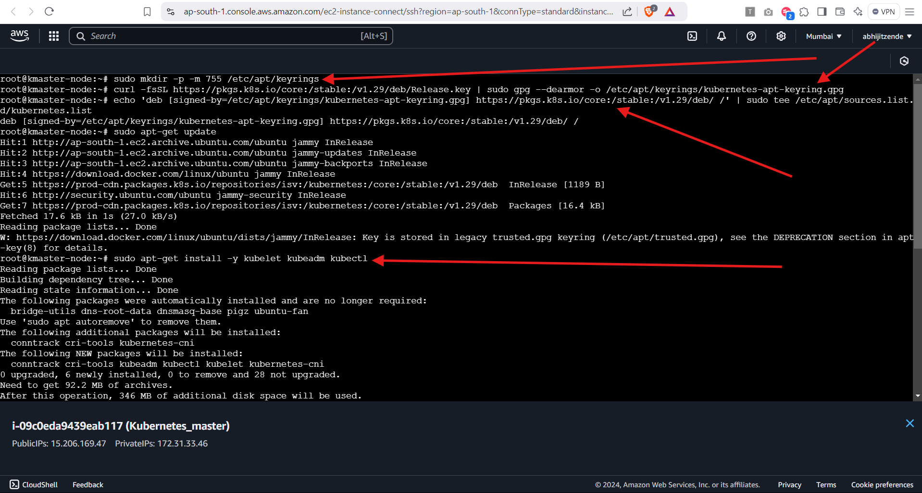

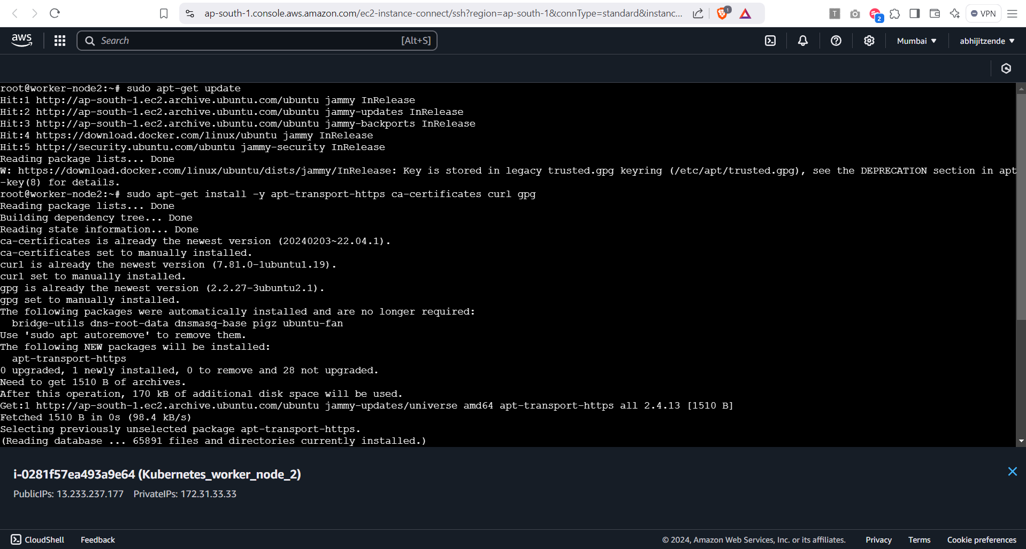

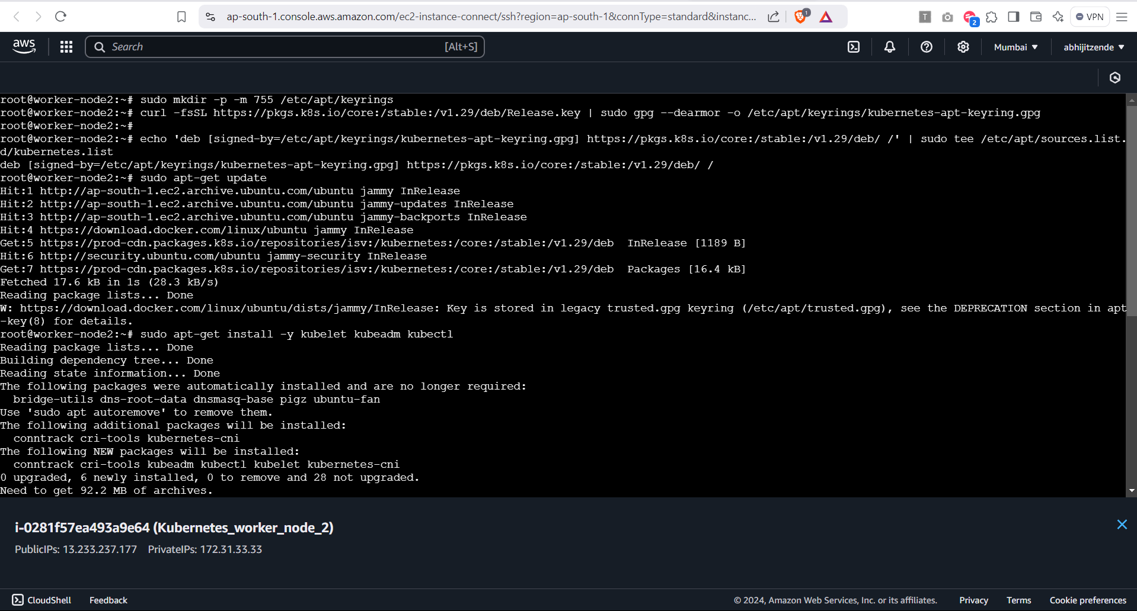

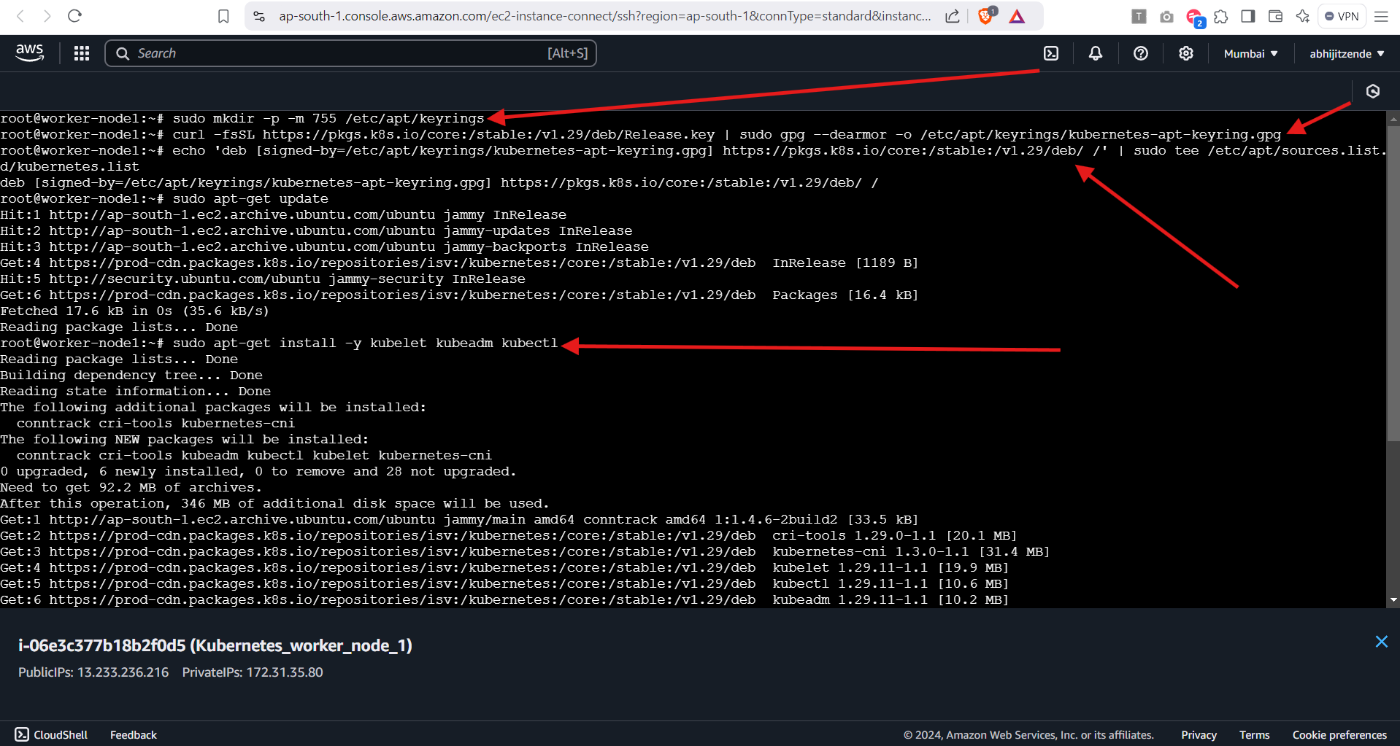

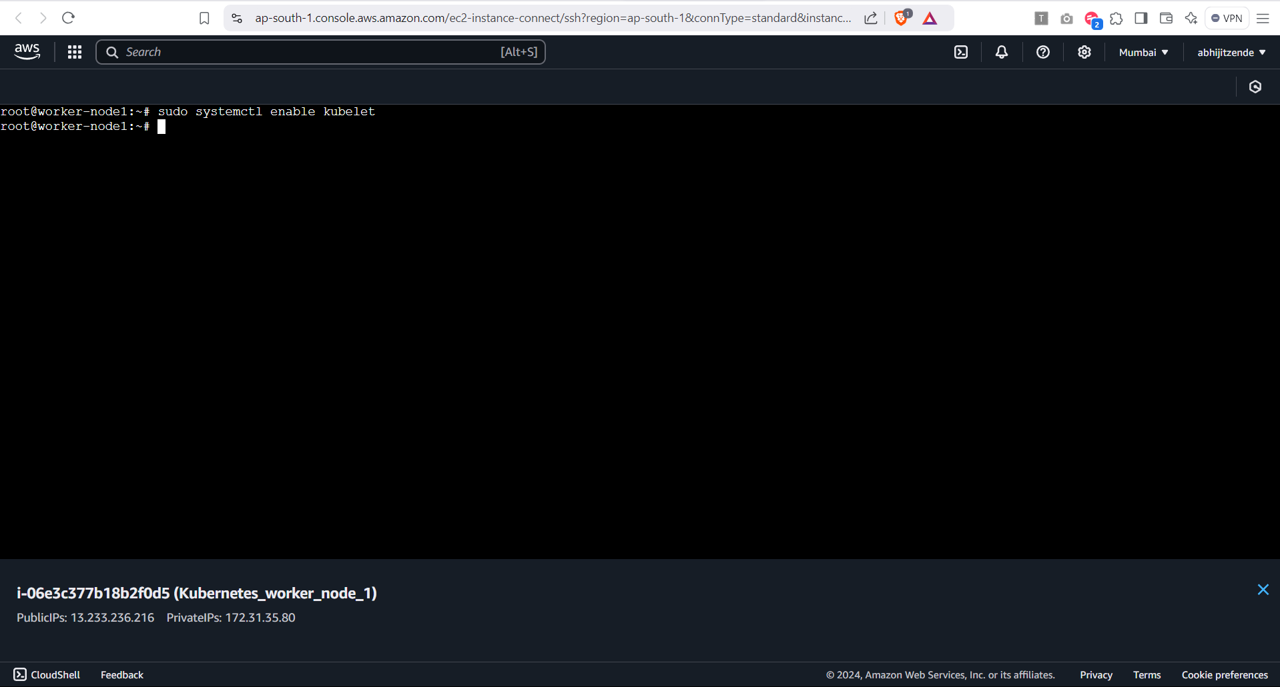

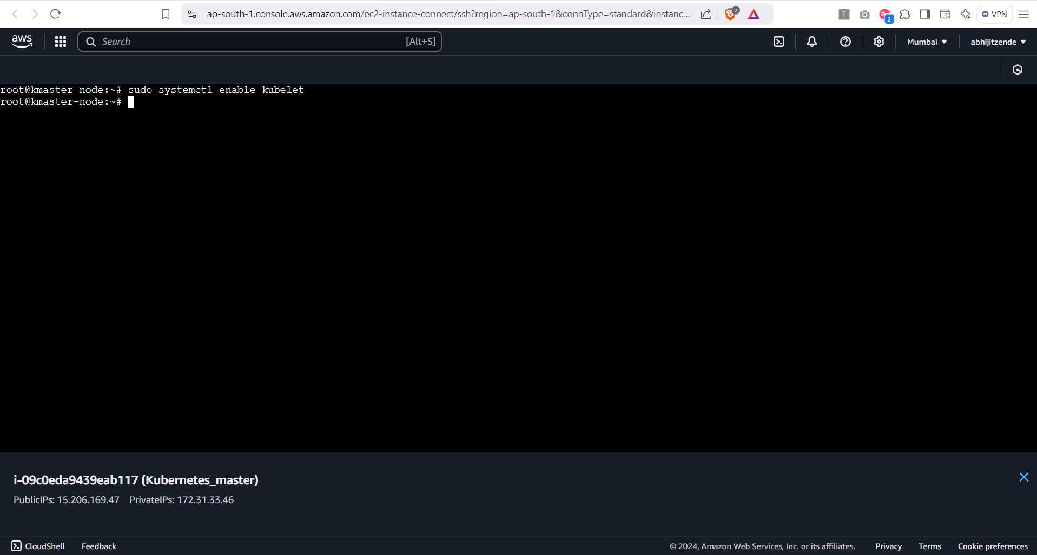

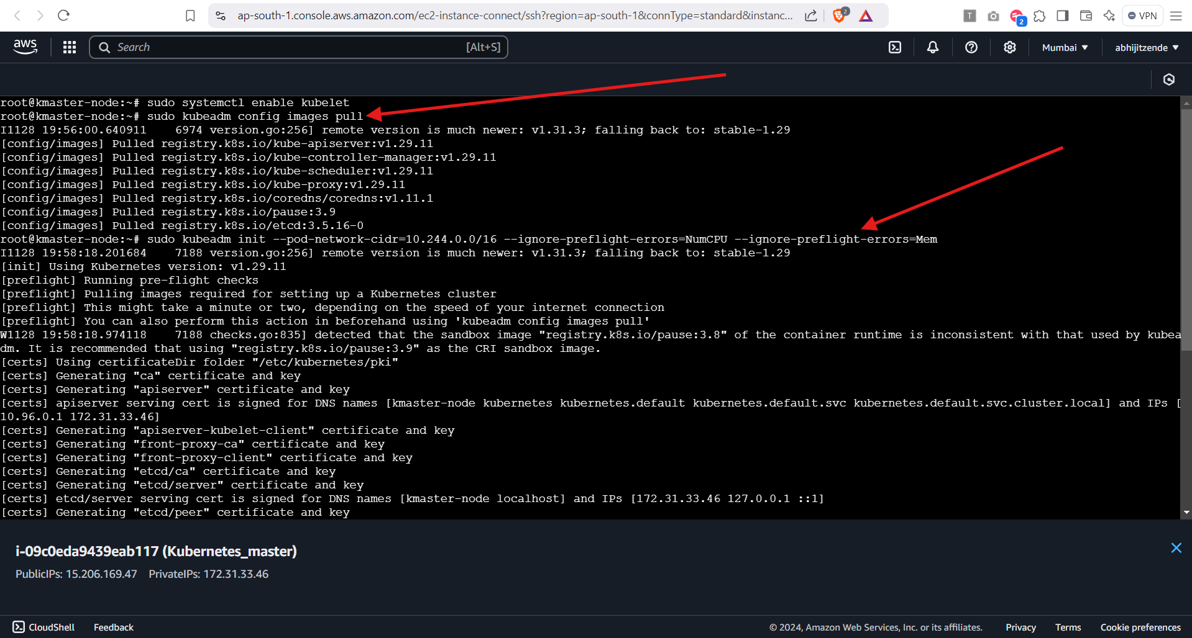

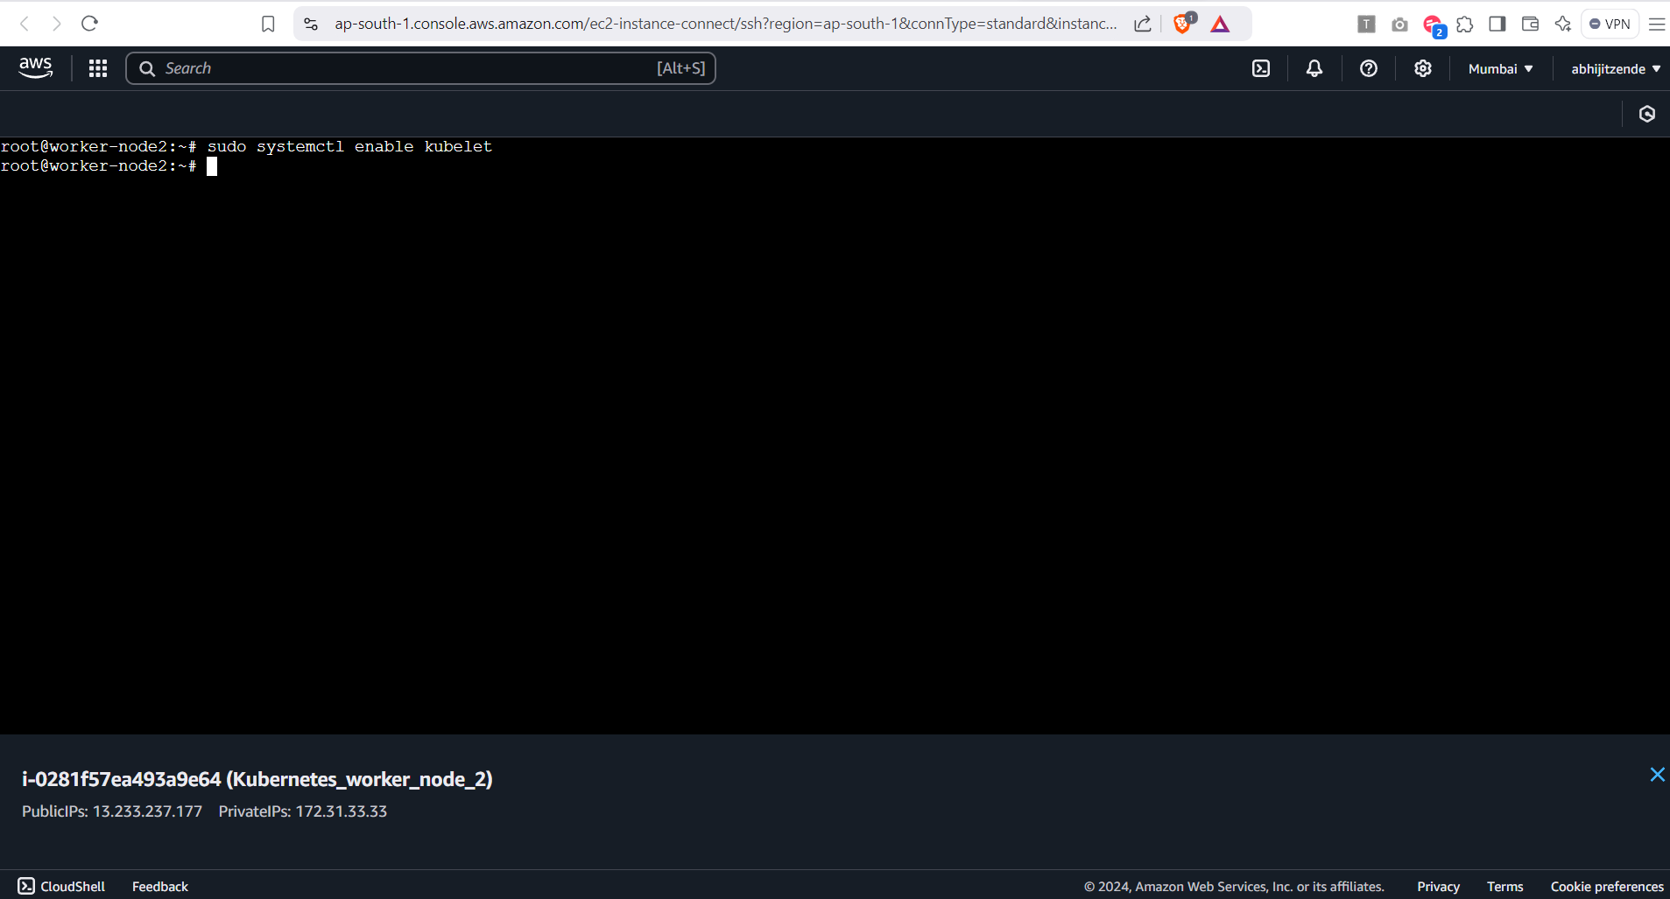

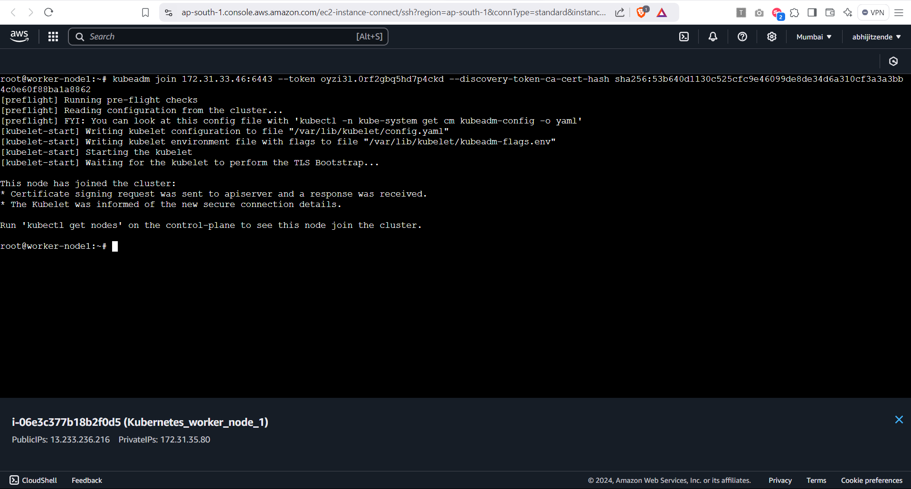

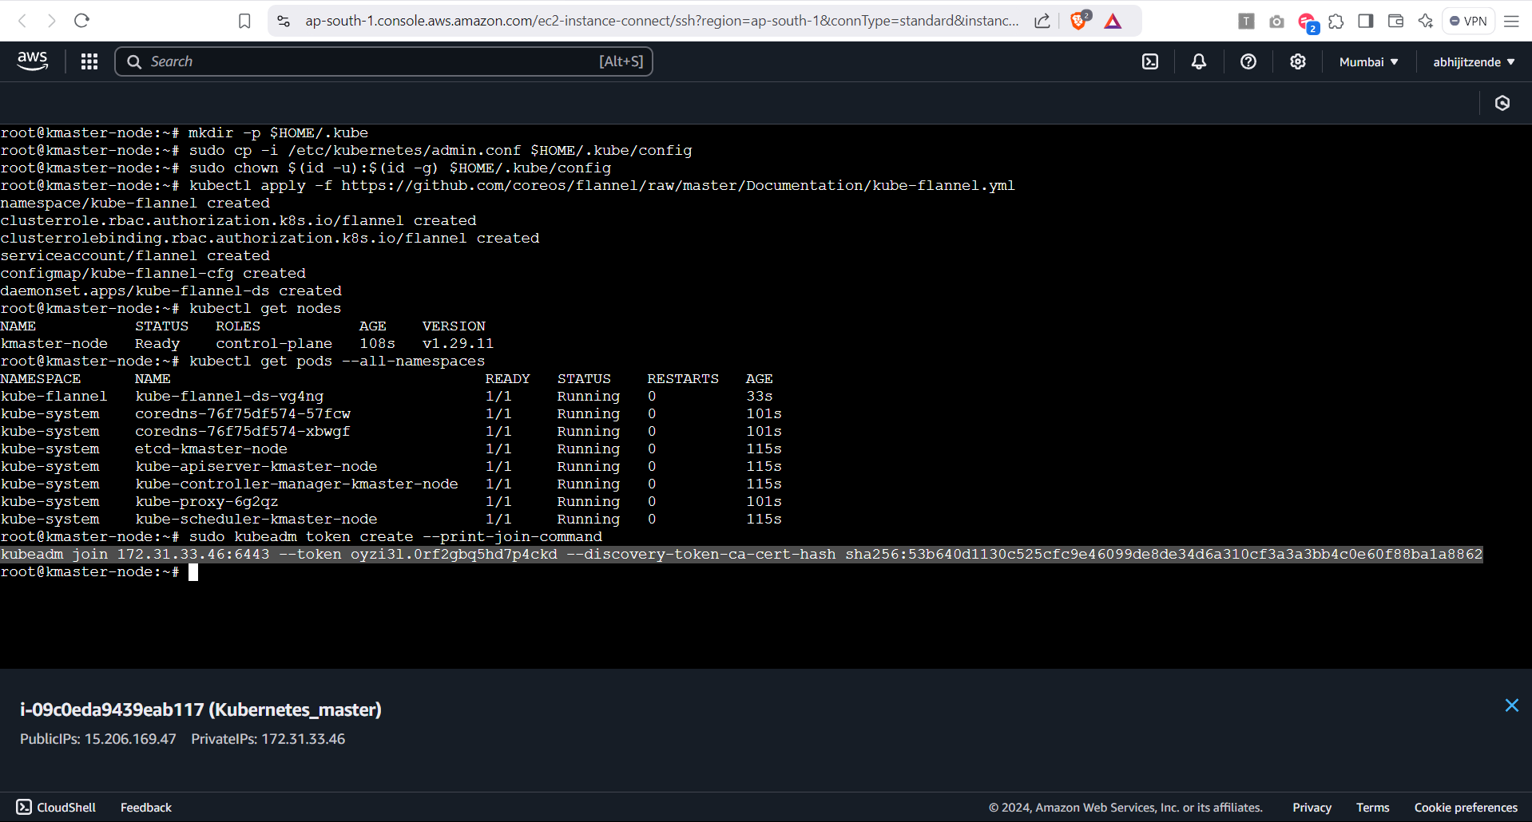

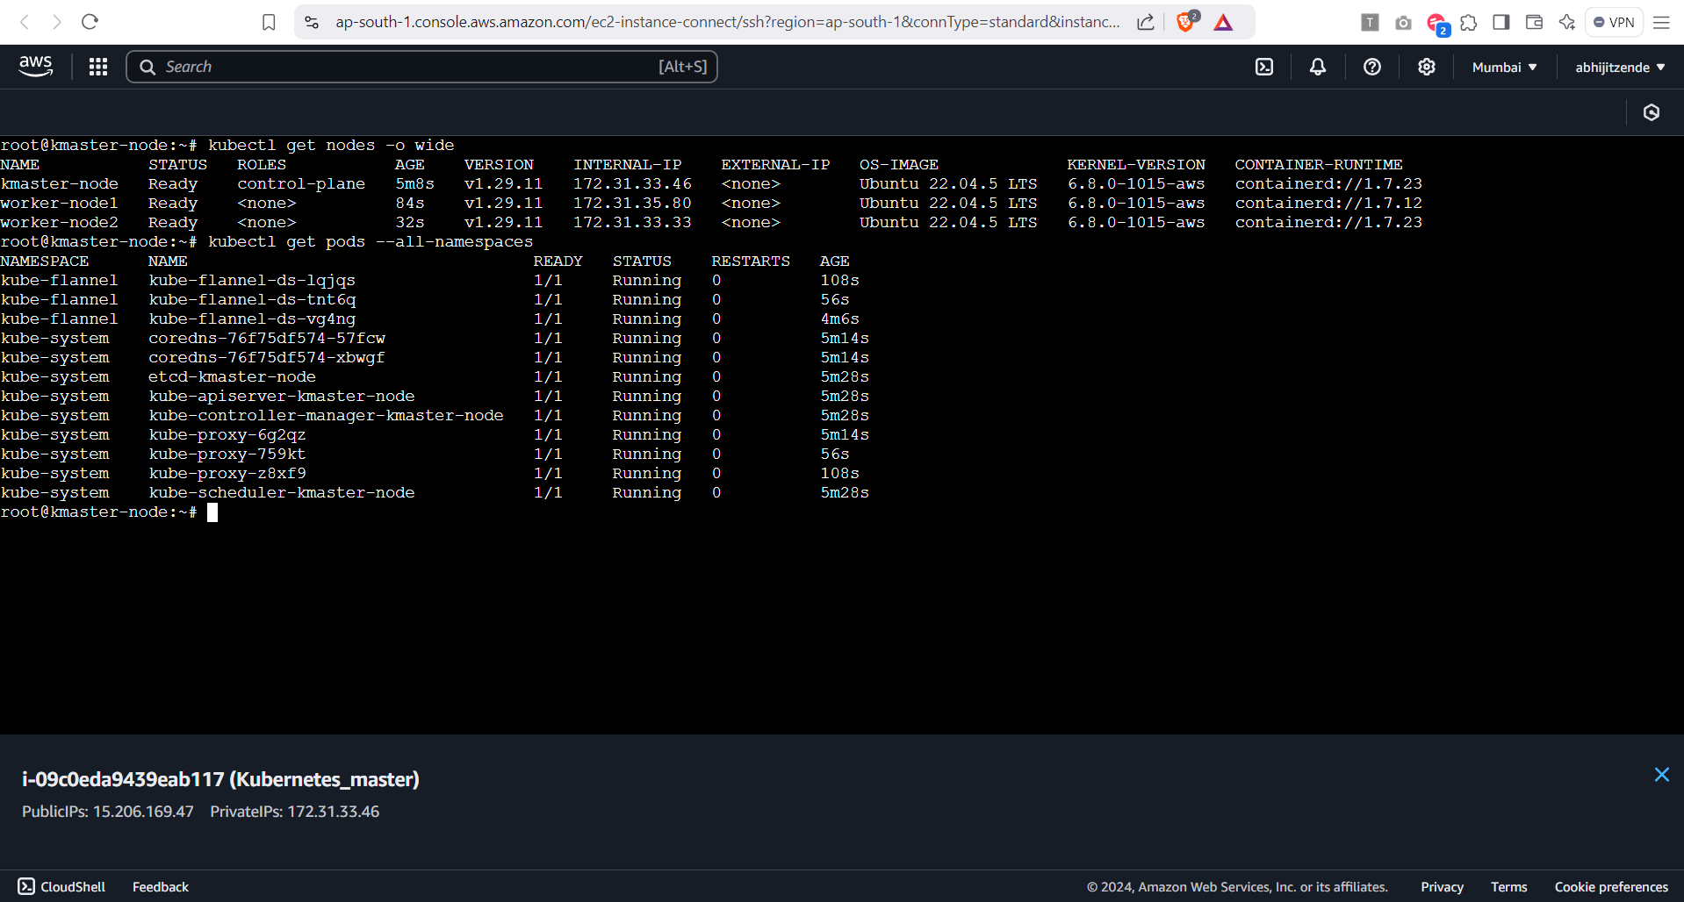

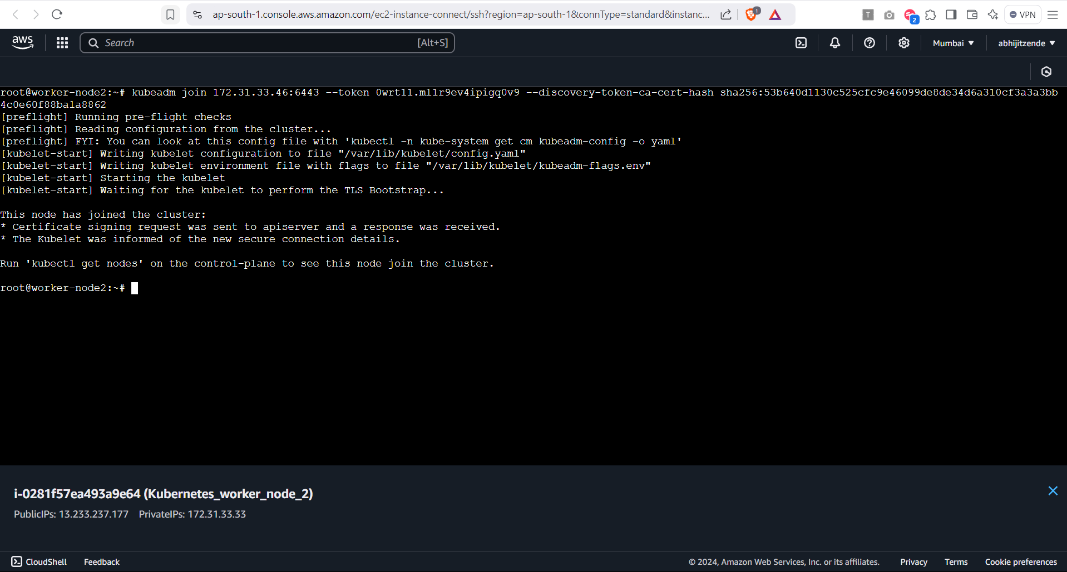

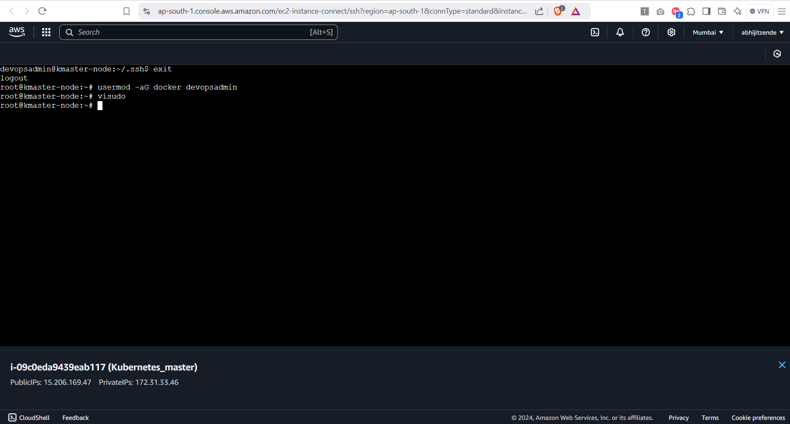

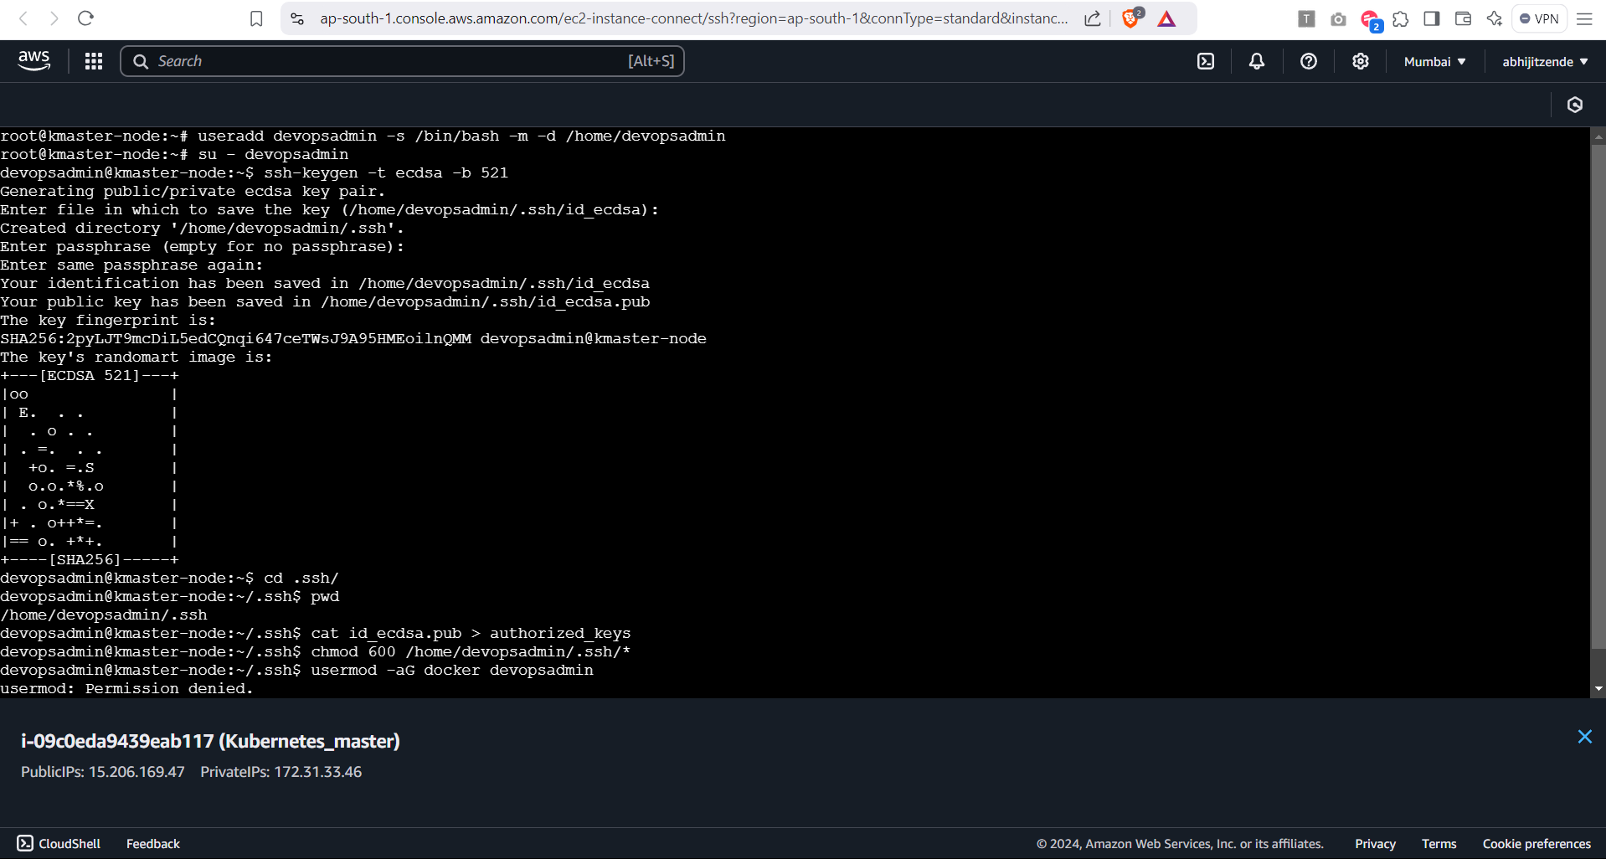

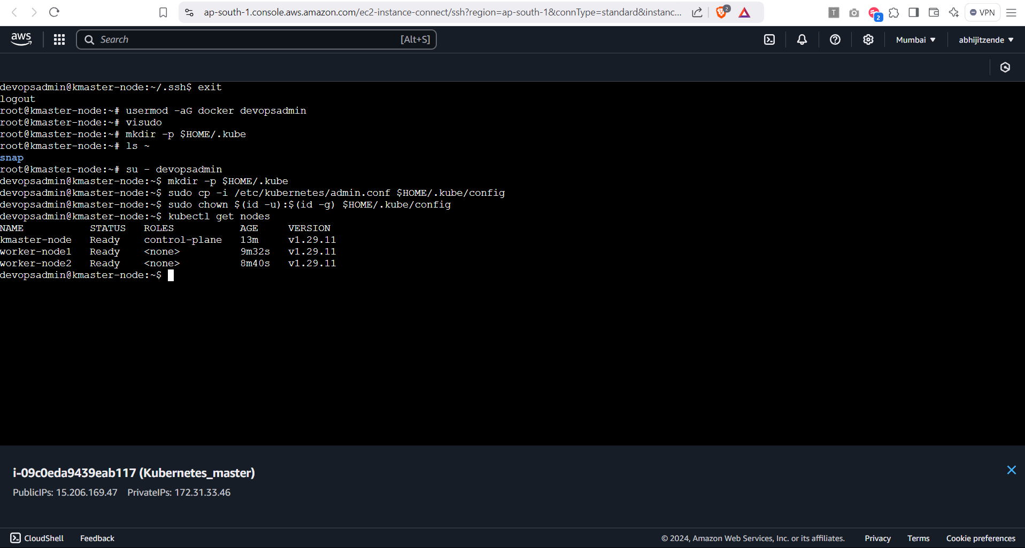

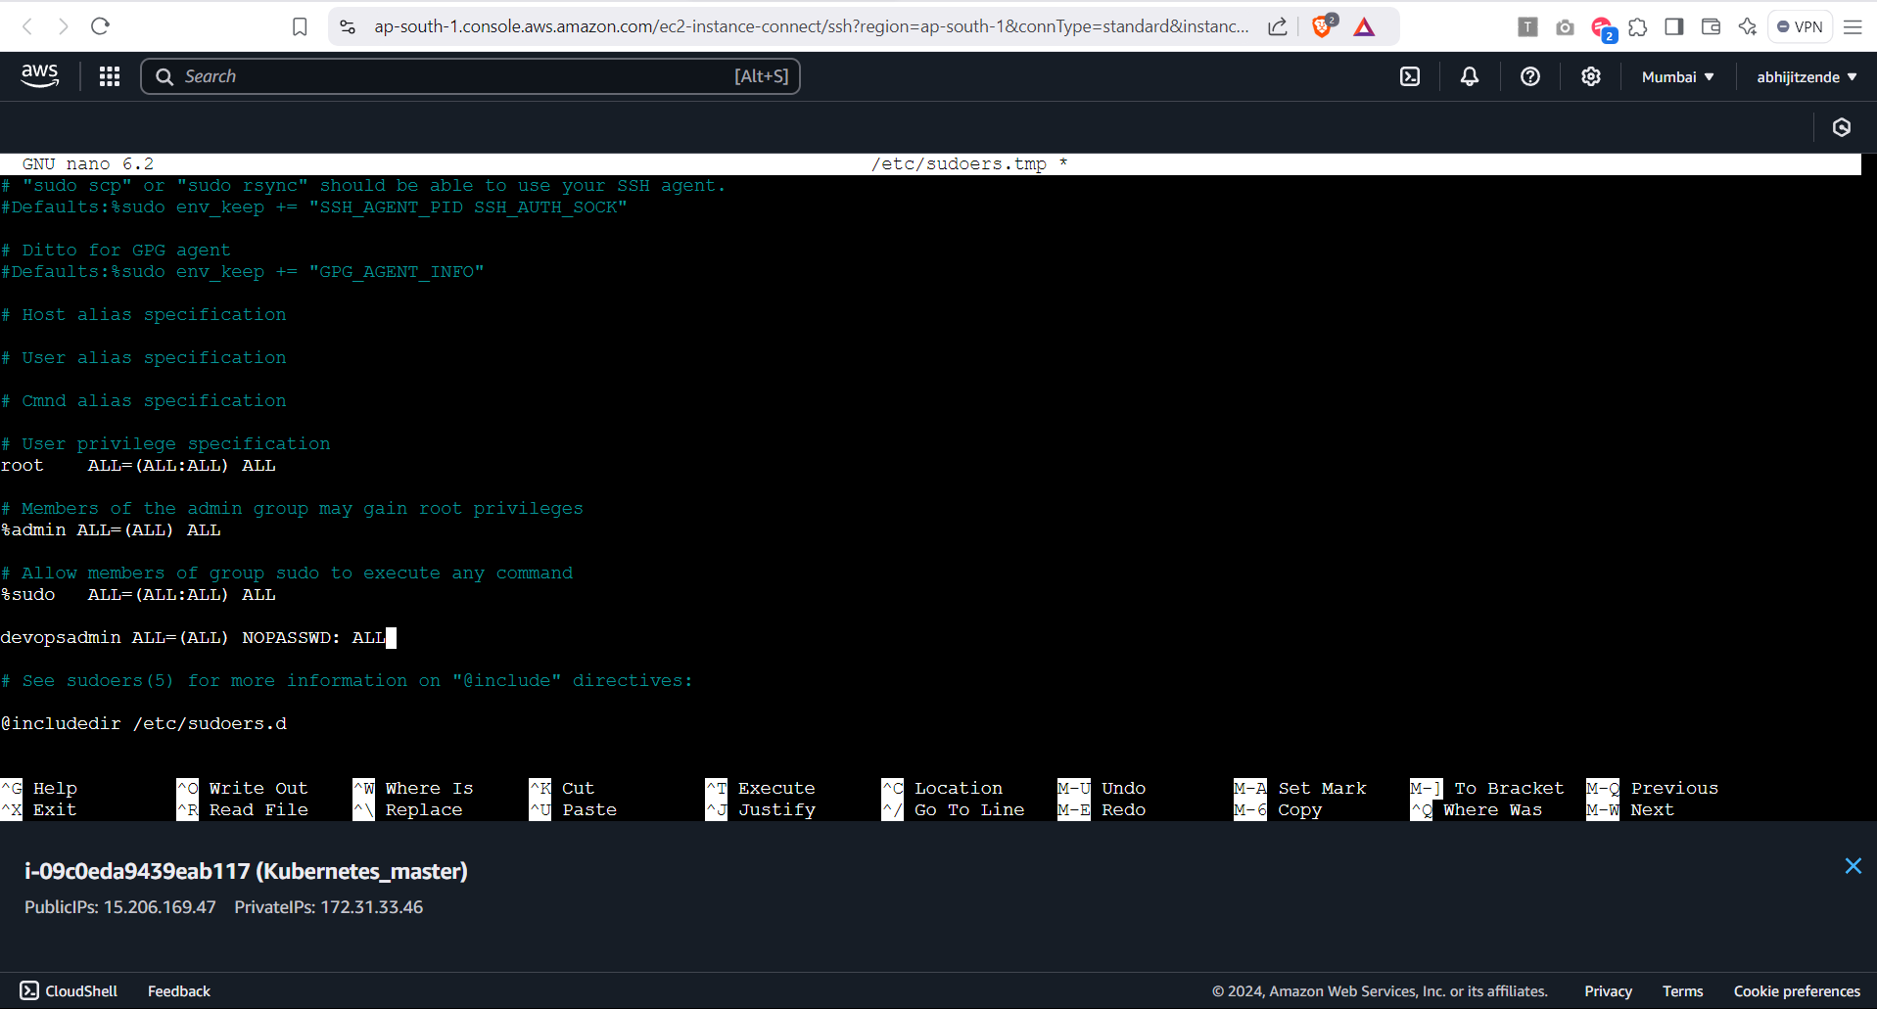

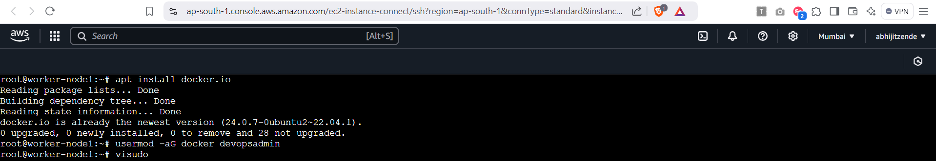

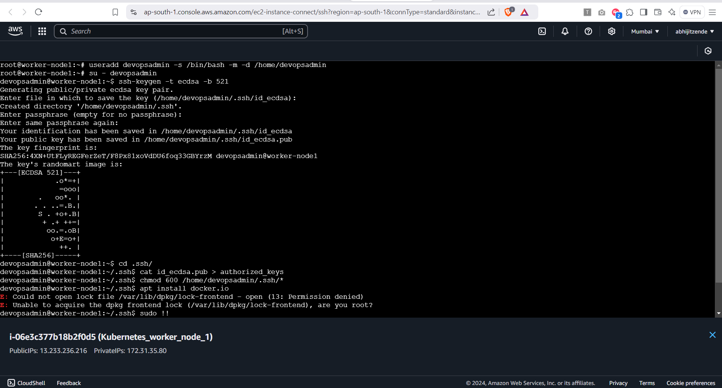

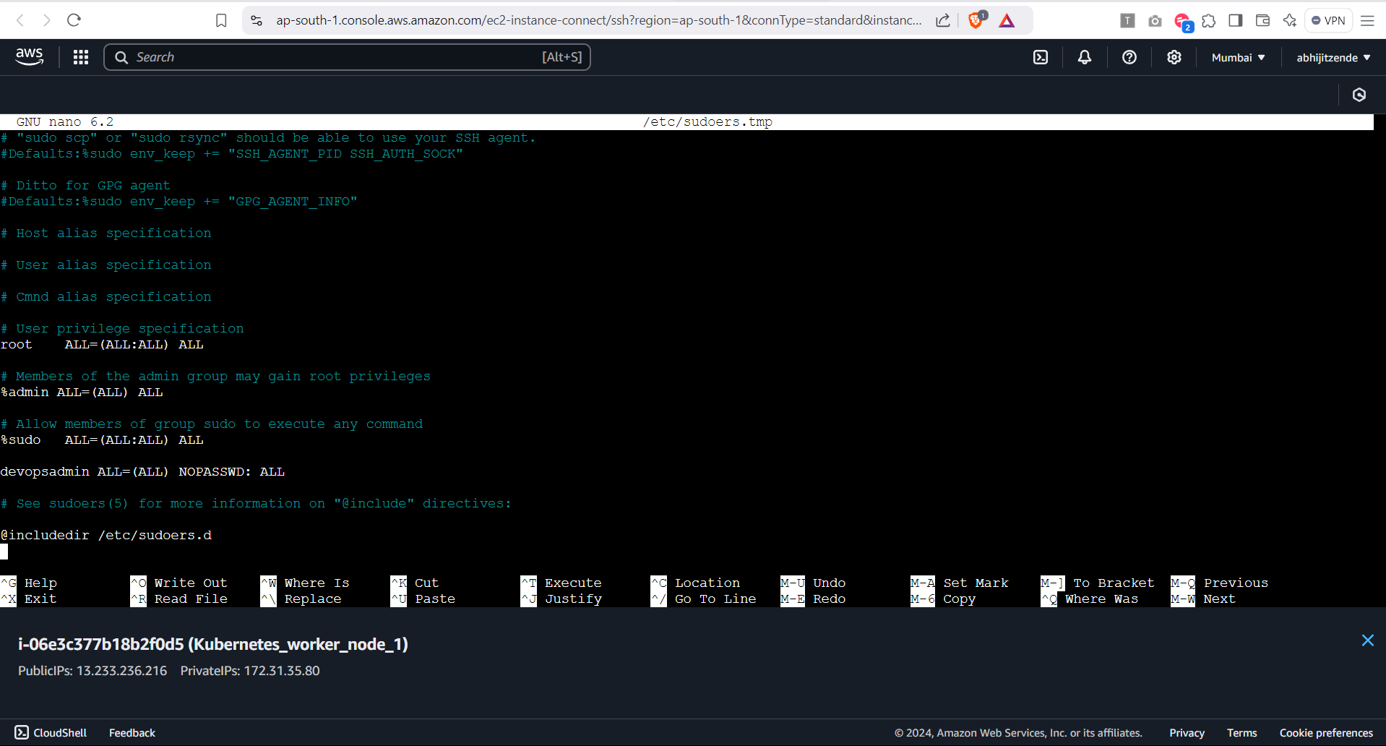

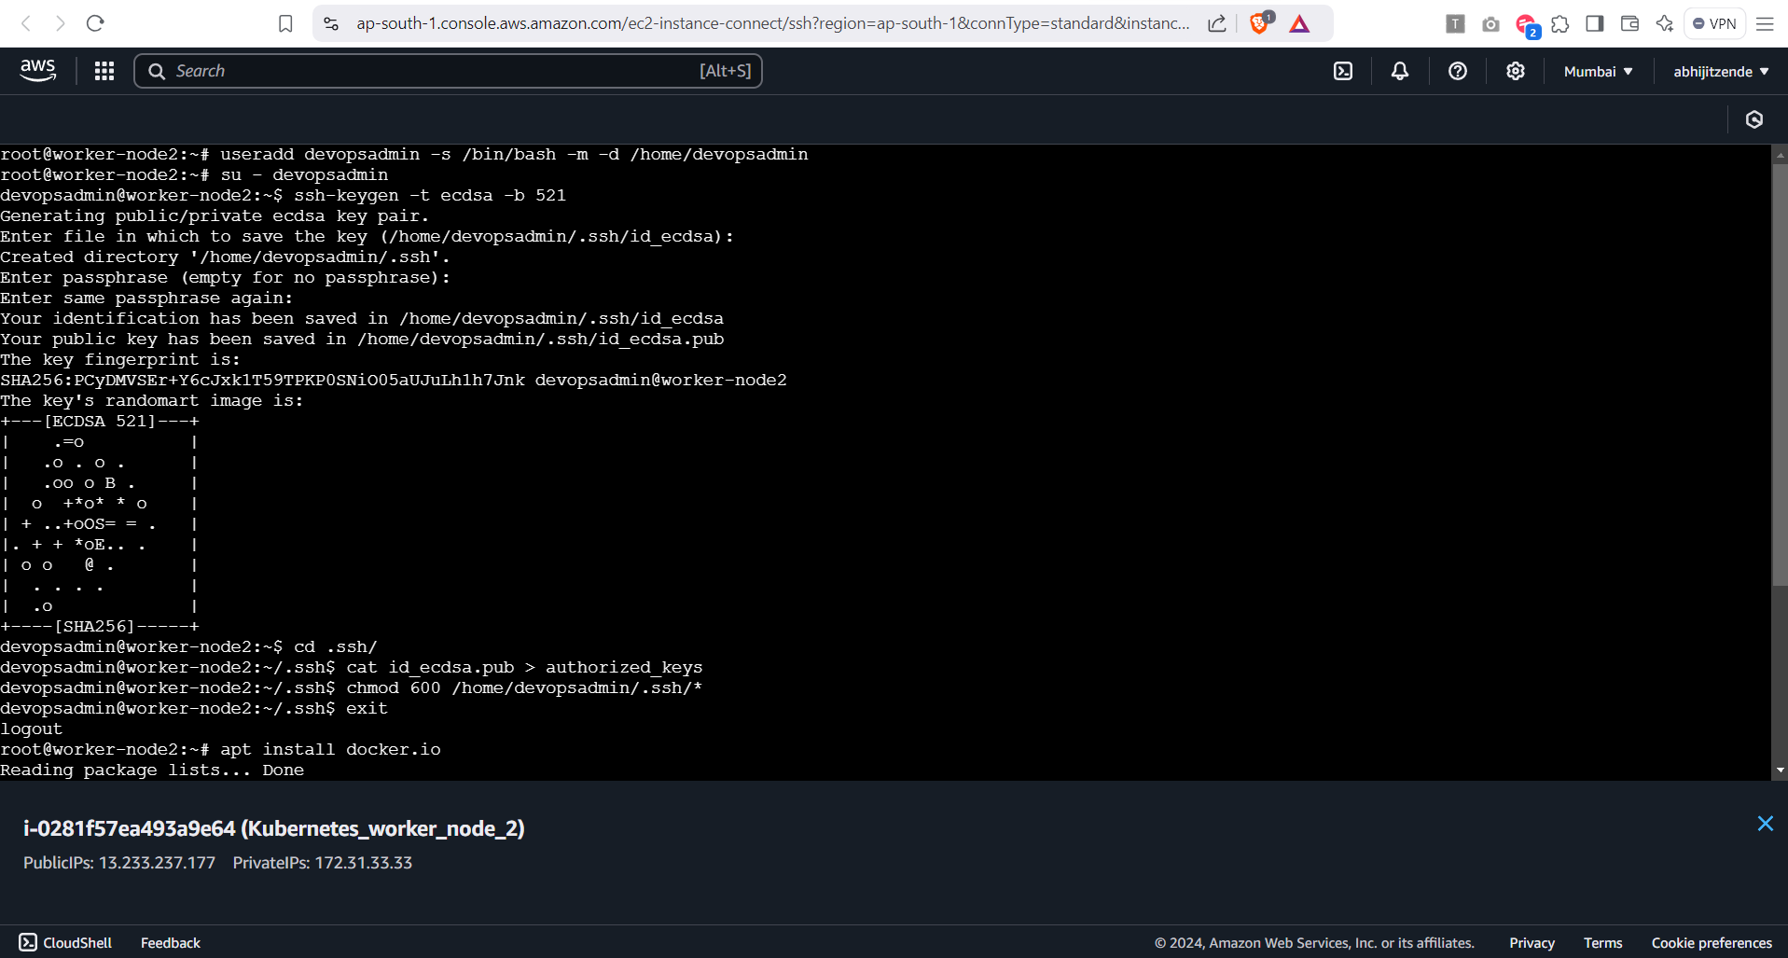

**2. L2 – Create Deployment Controller Object to Deploy the Application Image Created in Docker Module and Expose it to the Internet**

Ans.

Step 1: SSH into master node:

Step 2: Verify Kubernetes Nodes:

1. Check the status of your Kubernetes cluster nodes

```

kubectl get nodes

```

Step 3: Create a Deployment YAML File

1. Save the following as **deployment.yaml**

**```**

apiVersion: apps/v1

kind: Deployment

metadata:

name: tomcat-deployment

labels:

app: tomcat

spec:

replicas: 2

selector:

matchLabels:

app: tomcat

template:

metadata:

labels:

app: tomcat

spec:

containers:

- name: tomcat

image: abhiz2411/tomcat_web_img:7

ports:

- containerPort: 8080

**```**

Step 4: Apply the Deployment:

1. Deploy the application to your cluster

```

kubectl apply -f deployment.yaml

```

Step 5: Verify the Deployment

1. Confirm that the pods are running:

```

kubectl get pods

```

Step 6: Create a Service YAML File

1. Save the following as **service.yaml**

**```**

apiVersion: v1

kind: Service

metadata:

name: tomcat-service

spec:

type: NodePort

selector:

app: tomcat

ports:

- protocol: TCP

port: 8080

targetPort: 8080

nodePort: 30007 # NodePort to expose on the cluster

**```**

Step 7: Verify the Service

1. Check the service details

``` kubectl get service tomcat-service ```

Step 8: Access the Application

1. Open a browser and visit **http://<node-ip>:30007**. Replace **<node-ip>** with the IP address of any Kubernetes node.

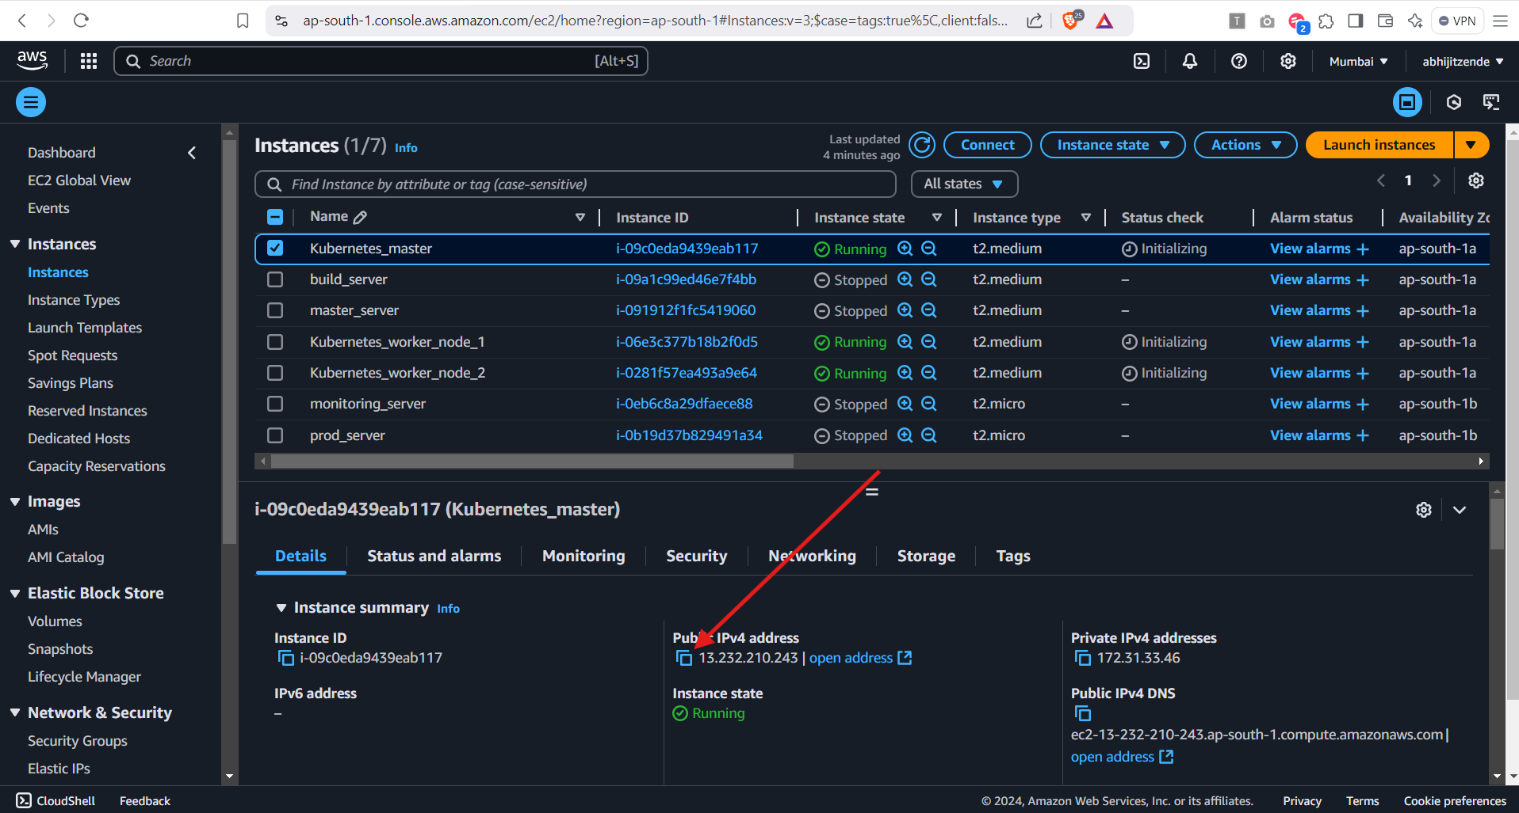

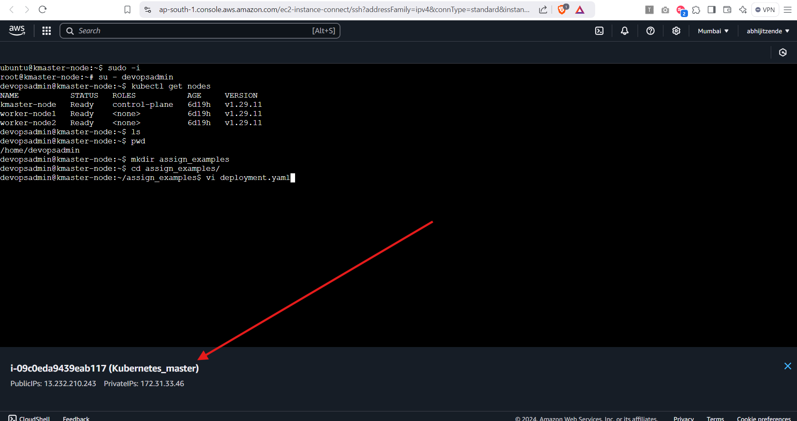

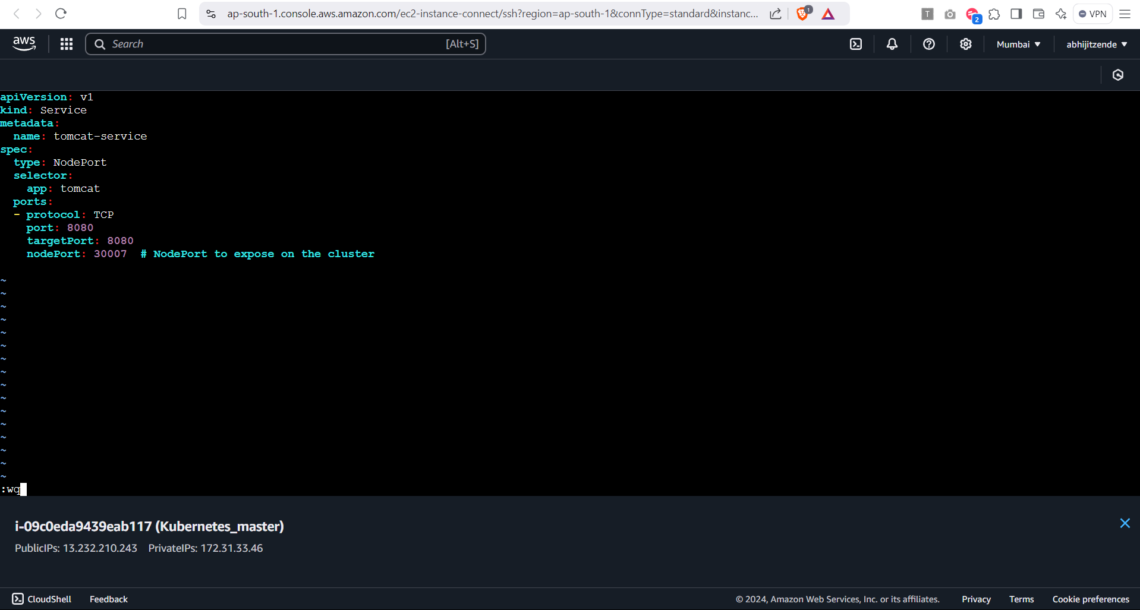

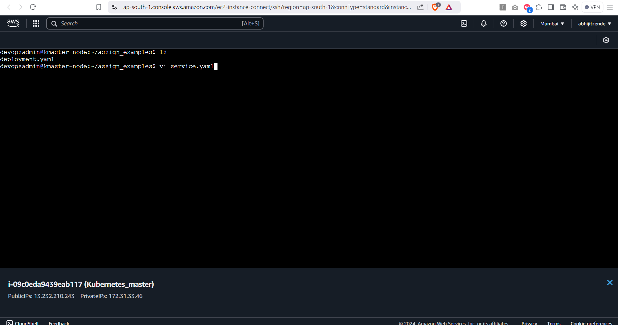

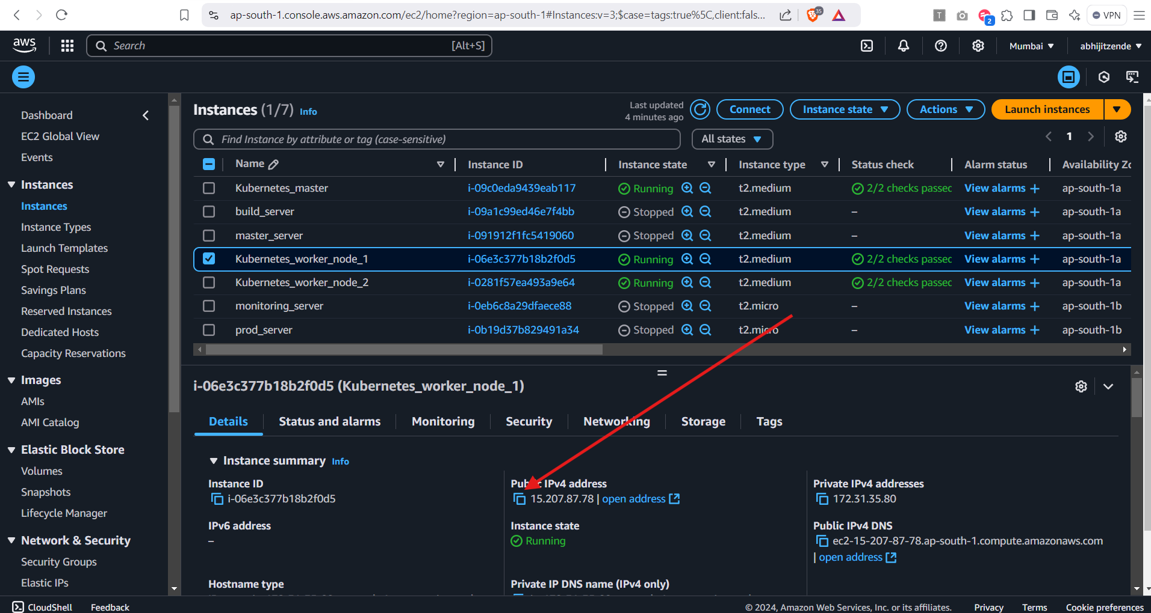

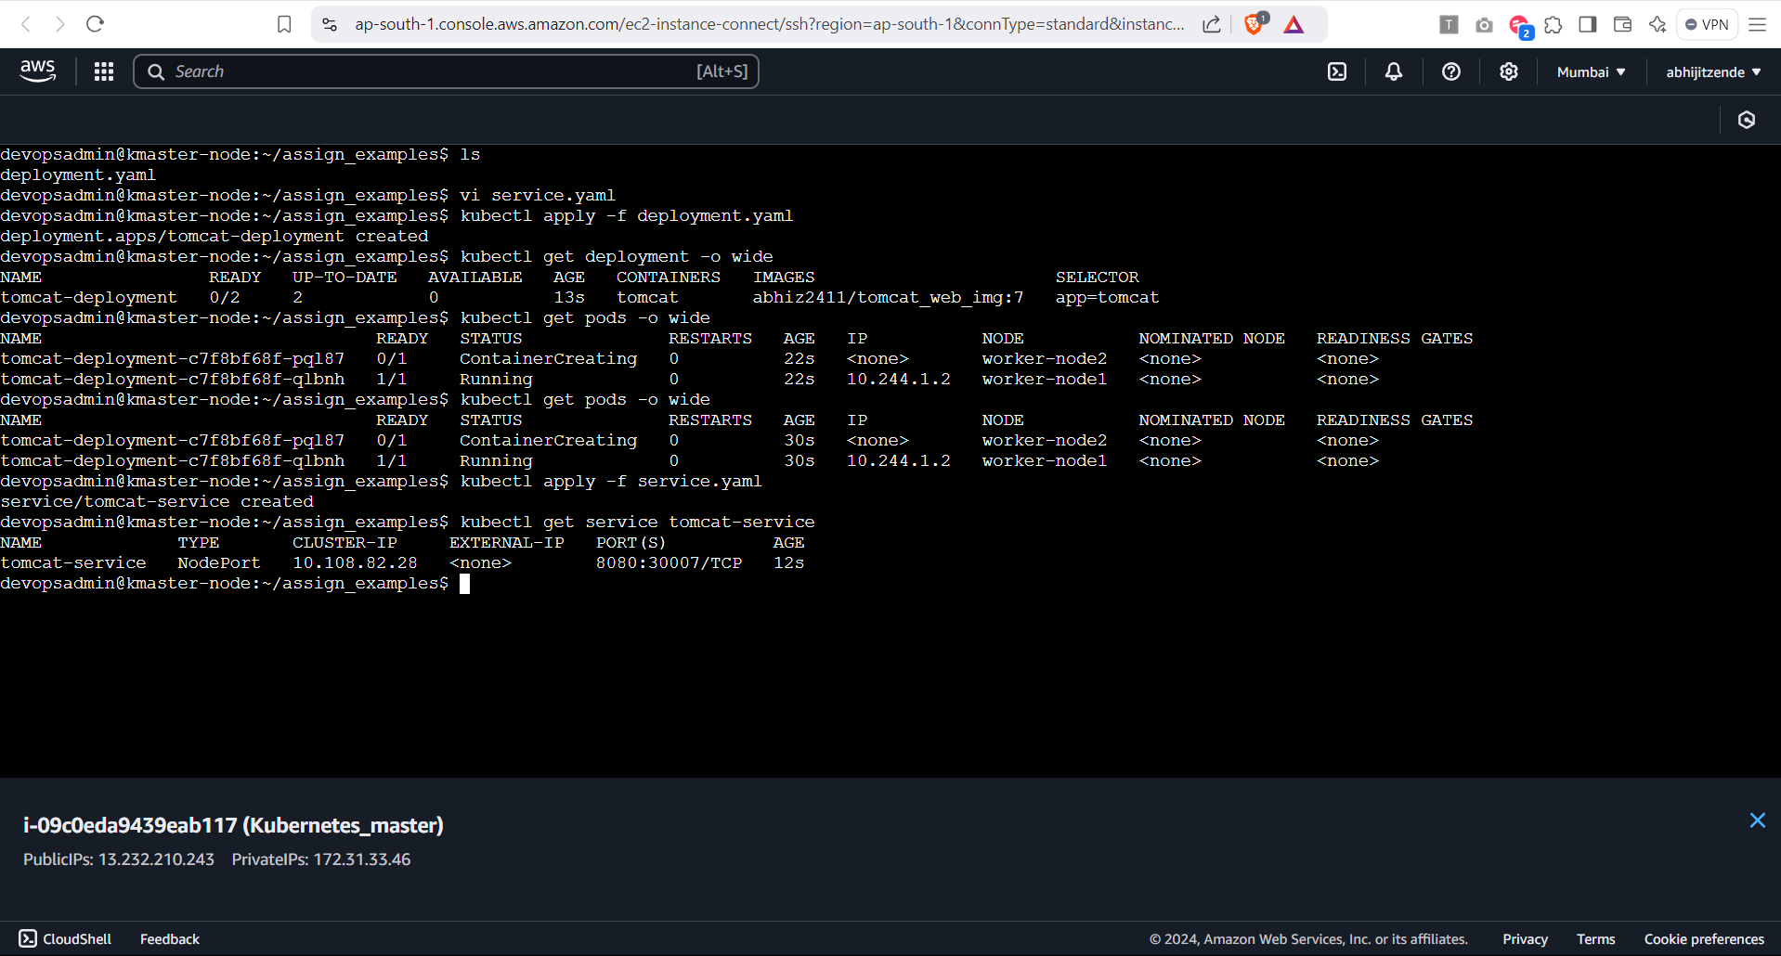

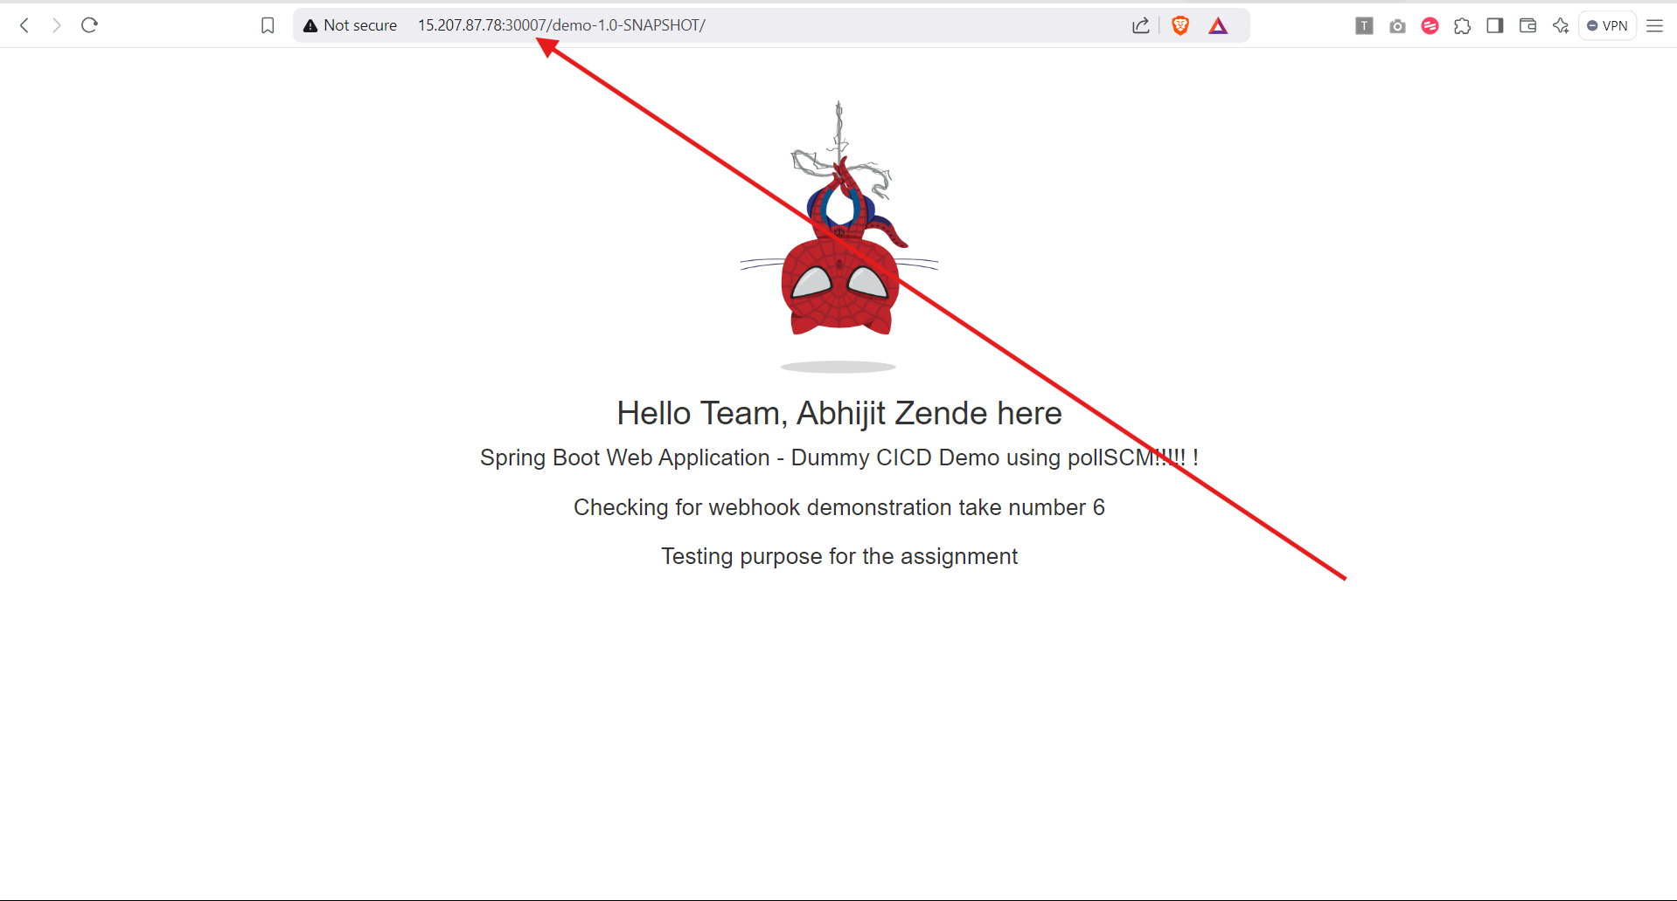

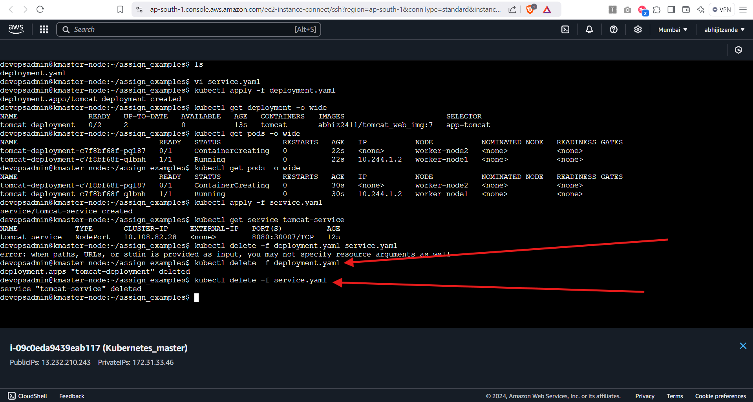

**3. L3 - Scale-up and Scale-Down the Pods Deployed**

Ans

Step 1 – Initial Deployed Pods and scaling up the pods and check scaling using

```

kubectl scale deployment tomcat-deployment --replicas=5

kubectl get pods -o wide

```

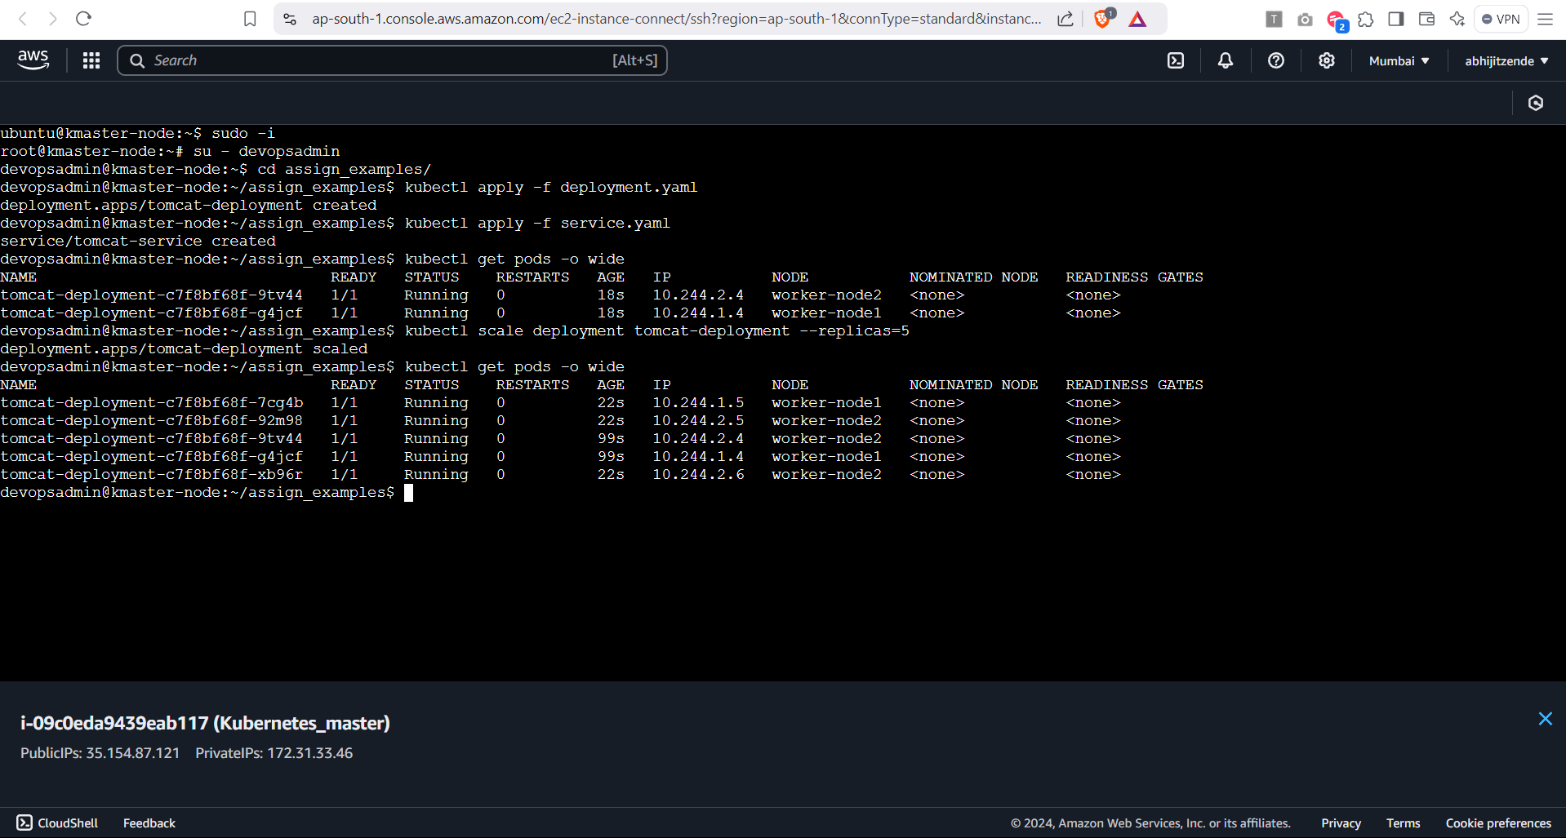

Step 2 – Scaling down the pods using command

```

kubectl scale deployment tomcat-deployment --replicas=2

kubectl get pods -o wide

```

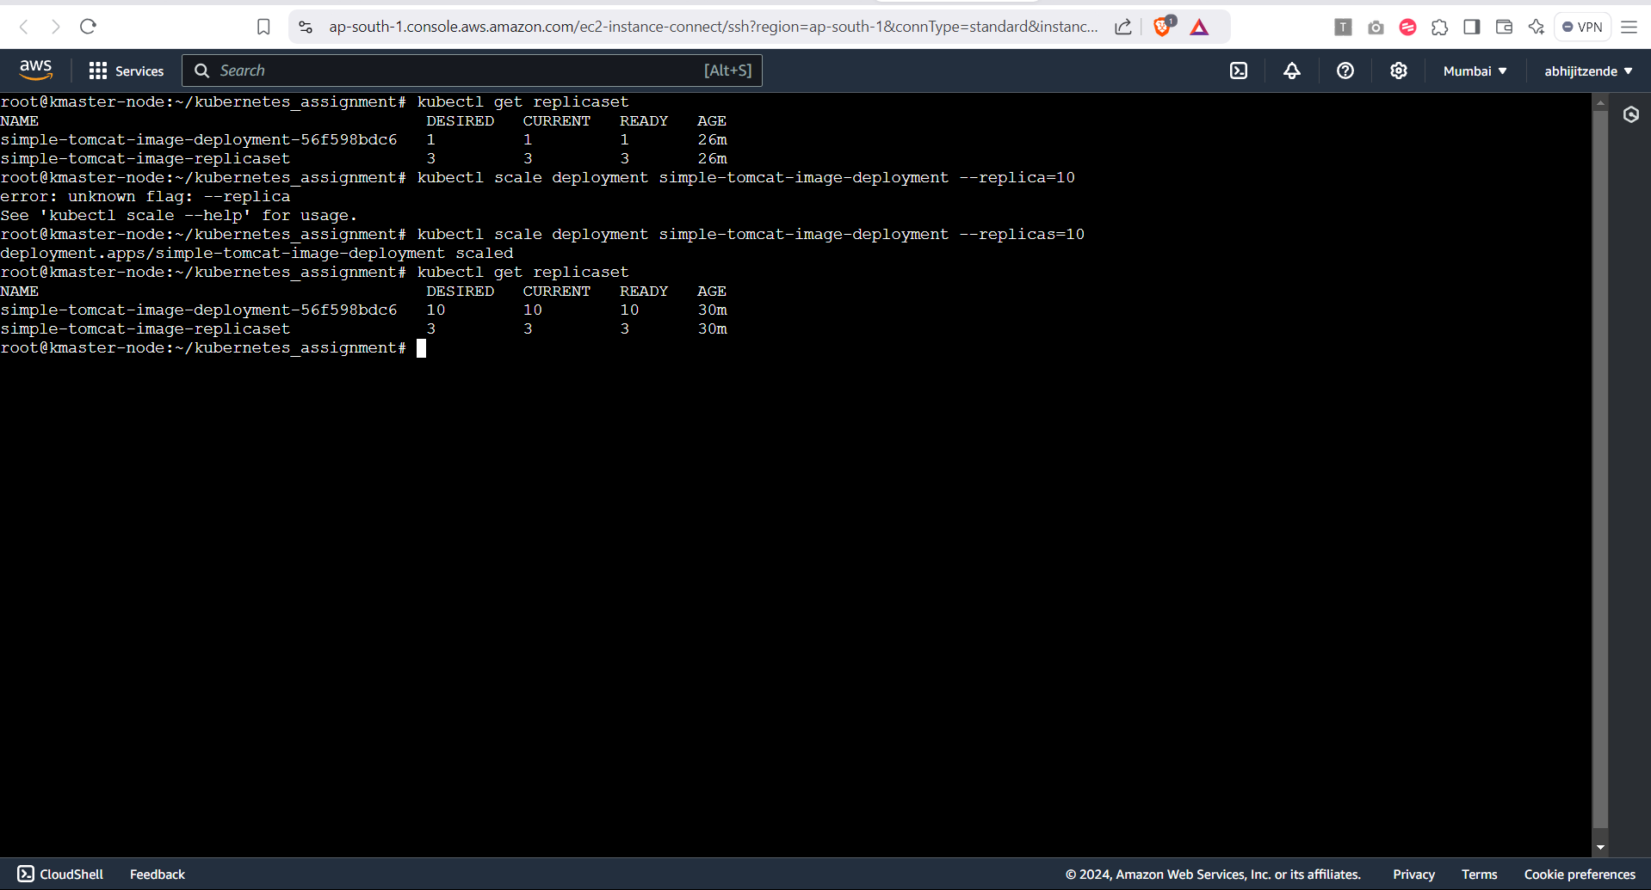

**4. L4 - Implement Rolling-Update Strategy to Upgrade the Application Image from V1.0 to V1.1**

Ans

Step 1: Verify the Existing Deployment and update the deployment with new image:

```

kubectl get deployment tomcat-deployment -o wide

kubectl set image deployment/tomcat-deployment tomcat=abhiz2411/tomcat_web_img:8

kubectl get pods

kubectl describe pod <pod-name>

```

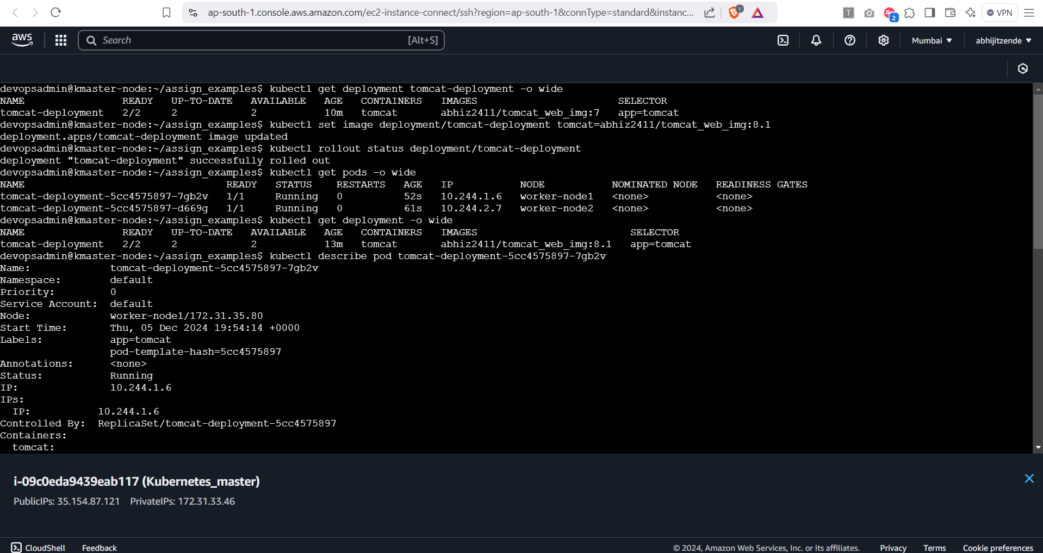

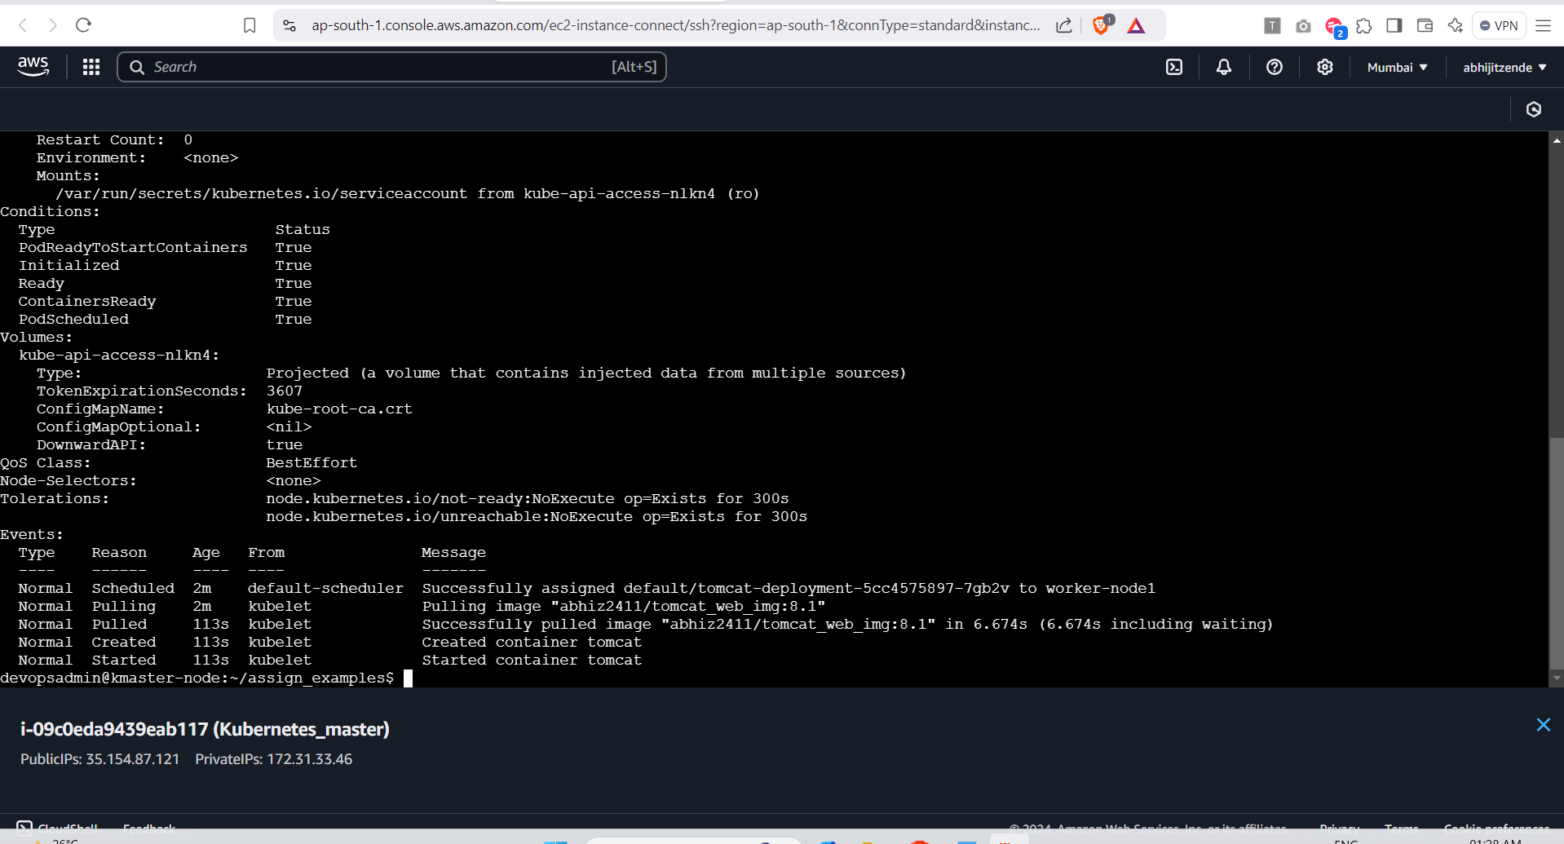

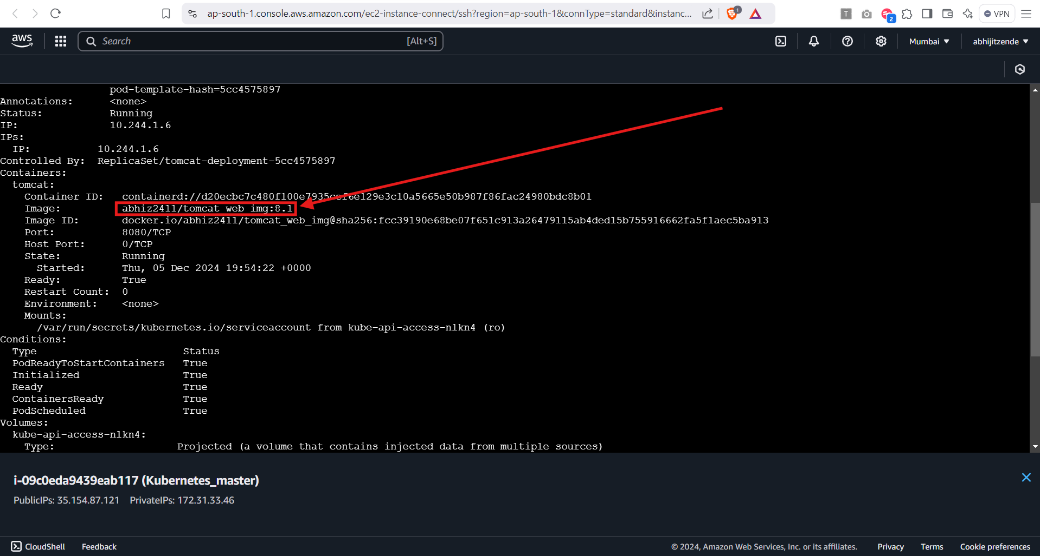

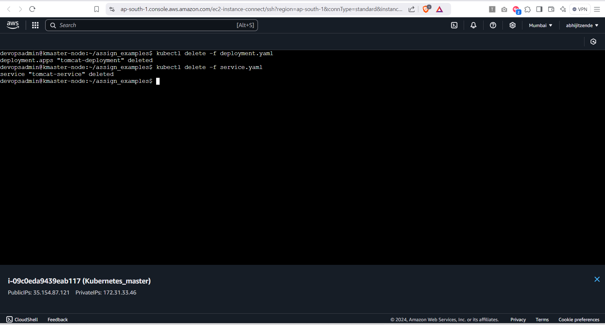

Step 2: Rollback if Necessary

